**Artificial Neural Network Analysis for Students’ Grade Prediction  
(A Comparative Study of Engineering Student, Pokhara University, Nepal)**



**Small RDI.2076**

**Submitted By**

**Yagyanath Rimal**

**Sakuntala Pageni**

**Submitted to**

**University Grants Commission**

**Sanothimi, Bhaktapur**

**Nepal 2021**

# **Preface**

We know that research is a scientific procedure for finding new knowledge. The classroom teaching procedure in the modern age is only completing after the evaluation of student. Therefore, teaching is always associated with the evaluation of student. The concept behind the using neural network in this research is that as in human body there were millions of neurons tissue cells which receive some information and transfer to the brain very quickly through various neuron with their respective weights then the human brain finally takes action to the specific parts, while doing so we use sigmoid activation function. However, this research queries far behind a search of their association between even school’s grade, intermediate plus to grades, major sciences subjects like Physics, Chemistry, Math’s and Bio subjects of intermediate level and their parent education and whether the student from the private school and public school were analyzed using machine learning techniques i.e. artificial neural network model for the prediction of 13 and 22 associative attributes (independent) with full and half model of (580 sample) Bachelor of Engineering student at constituent campus Pokhara University result 2019. The full model analyzed all the student whereas the half model used only successful student in university result in 2019. After data preprocessing with single neuron network model, multiple neuron model, and deep neural network model were being analyzed with setting different hyperparameter in each model design concludes prediction accuracy of each model to predict full(all) and half (only GPA) student using training and test sets. The training data were used for model development and testing data were used for validation purpose. The model result output of each neural network was further analyzed prediction test with accuracy. Similarly, the association of variable were tested with an ordinal regression and multinomial regression were tested for the purpose to achieve association between input variables to get model accuracy, scored 80 to 99 percent accuracy.

The output of a single neural network model produces 99-82% accuracy when 13 predictor variables were being used. When three hidden layers (7,4,2) are used produces the (92-98) percent accuracy. Similarly, when using backpropagation with the same model produces 90% accuracy of GPA prediction and when using a deep neural network model produces after hypermeter determined the accuracy of using the model (50,20, 7) produces the best among other models.

.

# **Acknowledgment**

I would like to express my sincere thanks and appreciation to the director of University Grant Commission, Nepal for supporting mini research grant support. This work would not have been possible without the constructive and insightful discussions with the faculty of science and technology Pokhara university. I gratefully thank to reviewer and UGC team for final discussion to get their valuable feedback on some recent results presentation and some new directions that I might explore in midterm and final research defense.

My earnest thanks also go to members of the faculty research committee for making constructive suggestions in virous stage of research completion. My sincere thanks and appreciation go to director office of Pokhara University for encouraging me to work on research problem, being always available to organized the program contents, and for his collaborations and invaluable comments and suggestions in most of my written manuscripts production. I would like to thank prof. Dr. Bharatendra Rai for his useful comments with interesting lectures notes for helping me to apply the procedures of machine learning data science, department at University of Massachusett, Dartmouth distantly constant encouragement. I would also like to express my gratitude to all the student respondents, data enumerators student, Ashesh, Anish, Rita Parajuli for collecting large sets of data collection of constituent students.

Finally, I would like to express my gratitude to my advisor and reviewer for pointing me toward the right path to starting a career in academia and for his encouragement and support. I would also like to take this opportunity to thank his constant encouragement and support during my few years at Pokhara University.

I cannot end without thanking my family, whose constant encouragement and love I have relied on during my thesis report design and complication of this research work.

## **Table of Contents**

Preface i

Acknowledgment ii

**Table of Contents** iii

**List of Table** v

**List of Figure** v

Executive Summary viii

CHAPTER 1. GENERAL INTRODUCTION 1

**Background** 1

**Problem Statement** 19

**Theoretical Framework** 23

**Objectives** 24

**Hypotheses** 24

**Research Question** 24

CHAPTER 2. METHODOLOGY 25

**The Study Area** 25

**Model Design and Setup** 29

**Random Forest Methodology for Large Feature Selection** 31

**Before Examination Grade Prediction** 40

**Plus, two Back Propagation Grade Prediction** 45

CHAPTER 3. RESULT and DISCUSSION 49

**Single Layer Neural Network Pass/Fail Prediction** 49

**Three Hidden Layers (7,3,2) Neural Network of Original Datasets** 52

**Three Hidden Layers (7,3,2) of Back Propagation** 54

**Four Hidden Layers Neural Network (25,12,6,3)** 56

**Ordinal Logistic Regression or Proportional Odds Logistic Regression** 58

**Multi-collinearity Test** 63

**Hypothesis Testing** 66

**Multi-nominal Logistic Regression** 67

**Hyperparameter Determines the Best Learning** 69

**Multilayer Deep Learning Neural Network Perception** 74

CHAPTER 4. CONCLUSION and RECOMMENDATION 85

**Performance Measures** 85

**Correlation and Linear Regression** 89

**Conclusion and Recommendation** 95

**Limitation and Delimitation of the Study** 96

**Ethical Consideration** 96

References 97

**Annex1: Research Questionnaire** 103

Annex2: Photo Gallery 104

Annex 3: Summary Statists of Sample Data Used 105

Annex 4: Program Code Snippet 106

## **List of Table**

Table 1: 2019 Result Summary Table 26

Table 2 : Final Grade Conversion Table 28

Table 3: Before Data Normalized Database Structure 30

Table 4: After Data Sets Normalized Sample 31

Table 5: Programs GPA Summary Table 62

Table 6: Neural Network Model Accuracy 86

Table 7: Summary Table of Full MLP 87

Table 8: Summary Table with Half Perception 88

Table 9: Summary Table By Program 94

## **List of Figure**

Figure1.1: Before and After Histogram of Math’s Variable 14

Figure1. 2: Single Hidden Layer Neural Network 15

Figure 1. 3: Histogram of Output Result 16

Figure1. 4: Neural Network with Passed Student 17

Figure1. 5: The Test and Training Output Histogram 18

Figure1. 6: Neuron of Human Cell 21

Figure1. 7: Conceptual Framework of Research Design 23

Figure 2. 1: Data Organization Diagram 29

Figure 2. 2: OOB Plot of Random Forest 32

Figure 2.3: Error Vs Trees and Mtry Plot 35

Figure 2. 4: Histogram of Nodes 37

Figure 2. 5: All Variable Ranking Plot 37

Figure 2. 6: Partial Dependency Plot 39

Figure 2. 7: Partial Dependency Plot 39

Figure 2. 8: MDS Plot of All GPA 40

Figure 2. 9: Mean Decrease Gini 41

Figure 2. 10: Partial Dependency Plots 42

Figure 2. 11: Mean Accuracy and Gini Decrease Plot 42

Figure 2. 12: Partial Plot of Internal Marks 43

Figure 2. 13: Partial Plot of Previous Grade 43

Figure 2. 14: MDS Plot 44

Figure 2. 15: Mean Accuracy and Gini Decrease Plot 44

Figure 2. 16: Partial Plot of Internal Grades 45

Figure 2. 17: Histogram of Bachelor and Plus two 46

Figure 2. 18: Number of Nodes and Variable Ranking Plot 47

Figure 2. 19: Histogram and Gini Decrease Plot 47

Figure 2. 20: Mean Accuracy and Gini Decrease Plot 47

Figure 2. 21: Partial Dependency Plot 48

Figure 3. 1: Neural Network Singe Neuron of All Result 49

Figure 3. 2: Histogram of Test and Training 50

Figure 3. 3: Histogram of Neural Network Model 51

Figure 3. 4: Neural Network Model of (7,3,2) with Original data 53

Figure 3. 5: Histogram of Training and Test Data 53

Figure 3. 6: Histogram of Neural Network 55

Figure 3. 7: Partial Plots of Input Data 56

Figure 3. 8: Neural Network of (13, 25,12,6,3,1) 57

Figure 3. 9: Histogram of Output Neuron 57

Figure 3 11: Confusion Matrix of 13 Independent Variables 65

Figure 3. 12: Model Loss Plot 71

Figure 3. 13: Loss and Accuracy Plot 72

Figure 3. 14: Loss and Accuracy Plot 73

Figure 3. 15: Two Hidden Layer Neural Network (10,5) 76

Figure 3. 16: Line Plot Loss and Accuracy 77

Figure 3. 17: Line Loss and Accuracy Plot 78

Figure 3. 18: Loss and Accuracy Plot 80

Figure 3. 19: Neural Network (50,25,8) Hidden Layers 81

Figure 3. 20: Loss and Accuracy of Model 82

Figure 3. 21: Loss and Accuracy of (10,7) MLP 83

Figure 3. 22: MLP with 100,50,25,7 Network 84

Figure 4. 1: A Full Model Comparison 86

Figure 4. 2: Deep Neural Network Model Comparison 89

Figure 4. 3: Correlation Plots 91

Figure 4. 4: Residual and QQ Plots 91

Figure 4. 5: Residual and QQ Plot 93

**Keywords:** Correlation; Assignments; Final Examination; Lowest Marks; Highest Marks; Grade Marks Prediction; Educational Data Mining (EDM), Neural Network Analysis.

## **Executive Summary**

Data analysis and statists prediction of student performance before final examination can help the student, faculty, and ultimately parents to make timely decisions. Here the researcher would like to predict student grade before the final examination and then respective grade comparison between internal grade and final grade with their background information. Finally, researcher proposed the best artificial neural network model to predict their upcoming grade based on training and test data sets of 580 sampled students of Pokhara University Nepal based on final university result 2019. The internal assessment, the high school information, plus two, and subjects like physics, math’s, chemistry and bio scored and their parents education status are feed to the artificial neural network model, which ultimately produces unit output weight is further evaluated to predict student bachelor grade were significantly analyzed using 15 neural network models.

Machine learning offers one of the most cost-effective and widely used approaches to develop the prediction model of student grade. In the last few years, several advances in machine learning research have emerged. The researcher utilizes recent advances in neural network machine learning research to provide GPA prediction with improved predictive performance in early stage of student. First, the researcher used the Boruta algorithm to separate large independent variables for the prediction of final GPA, and secondly, the Random Forest methodology is used for predicting GPA prediction are apply at data preparation stage and then single, multiple hidden learned models for prediction of GPA of student model with their respective accuracy will be analyzed and explain with its reason. The matrix, histogram, confusion matrix, and regression analysis were being highly used for the of machine learning neural network model in predicting, validation to final grade accuracy. Finally, we formulate the problems of qualitatively and quantitatively predicting and recommend model to access complex of student grade using multiple instance regression.

The model development and reliability learning neural network model data sets with test and training includes both passed student and final student grades and their association between their previous performance. However, the neural network model for GPA prediction demonstrates the pitfalls of these commonly used data sets for evaluating the performance of machine learning approaches to GPA prediction using forward and backward neural network.

# **CHAPTER 1. GENERAL INTRODUCTION**

## **Background**

Learning is the process of getting known from the unknown concept, which requires the more practical and appropriate theoretical concept of brain development which ultimately facilitate learning, acquisition of knowledge, skills, values, beliefs, and habit of human learning. Learning methods include storytelling, discussion, teaching, training, and directed research practices exchange between receiver and providers. The methodology of teaching is called pedagogy facilitates to learn new knowledge. Similarly, the evaluation is the process of characterizing and appraising some aspect of an educational process of learning achievement outcomes in grade. Educational institutions usually require evaluation data to demonstrate the effectiveness of stakeholders and to provide a measure of performance for management purposes. The students on their class performance and activities to continue for improving their performance is an integral part of every instruction. Although there were many practices are applying to measure students’ quality in education. Most of the western international quality assurance sets out various criteria to accreditation committee standards are used as tools that directly setout of the procedure of adaptation of practical activities of learning evaluating the teaching process in the universities in the new approach of mechanism for determining their grades. An evaluation like tests, interviews, questionnaires, problem-solving, case study, quiz are various tools were being used to standardized the learning process globally. However, the formative evaluation focus on the implementation of the program whereas summary evaluation test with various measures (Yahya, Mohamed, & Abdelfatah, 2011) evaluates students grade properly. On the other hand, the teaching and learning process through eastern education philosophy stresses the major outcomes from the teachers which means that teachers are completely responsible for their class to make effective planning all the activities for their students. The knowledge measurement is another key important milestone of learning institution term as grade the pass/failure. The assessment preferences inventory which measured students’ preferences as a pre-test and perceptions as a post-test (Filip, 2008) are always positive for learning achievement. There are two major grading system are still available in worldwide, one is percentage system which ultimately grades students as first grade, second grade, third grade and pass / failed graded with equivalent score with different grade points margins. Generally, there are 9 grades, which includes A+, A, B+, B, C+, C, D, E, and F. The A+ refers to ‘outstanding’ will be given to students scoring between 100 and 90, A to students scoring between 80 and 89, B+ to those scoring between 70 and 79, B to scores between 60 and 69, C+ to scores between 50 and 59, and C to scores between 40 and 49 worldwide practices which may vary according to each university system rules. While grade point calculation (GPA) is weighted by credit hours, multiply each numeric grade value by the number of credits the course was worth. The sum of these numbers together and divide by the total number of credits of each student scored is another grading system also emerging smoothly.

Student grade prediction research had been carried out in The Islamic University of Bahawalpur (Muhammad & Aijaz Ahmed, 2007) concluded that 16 students got more than 80 marks in internal assignments but they failed in the final examination because they did get least 40 marks in the final examination, this study covers master in education student only. Similarly, the study had been carried out department of educational research and development, University of Maastricht (David, Rijt, Filip, & Janine, 2008) concluded that there are no relationships were found between students’ perceptions of assessment and their assessment scores. Although students preferred written tests, including take-home exams and papers, in which they are allowed to use supporting materials such as notes and books, as well as papers or projects. The oral tests and the other modes of alternative assessment mentioned in the questionnaire, i.e., computerized tests and portfolios, are not amongst the students’ preferences procedures.

Similarly, (Patel, 2017) suggests that the internal examination pattern must be in university standard with three tests of any subject should be conducted properly used one algorithm is better to have good predictive accuracy among a large class of data. Similarly, (Brijesh Kumar & Saurabha, 2011) apply the ID3 algorithm used sample of 50 students to identify various attributes to perform the best score. (Naqui, 2006) Used linear regression of 300 students from affiliated colleges of Panjab University. The study (John & Manabete, 2015) surveyed 1847 students and 130 lecturers in Nigerian University concluded that the internal consistency reliability of was 0.86 that different university was found on heterogeneous classes modeling. They applied the Naive Bayes method to predict student performance from the student data. The research collected records of 220 students out of which 175 records are considered as training data, 45 records were considered as test data achieve 86.66% accuracy (Sorour, Mine, & Hirokawa, 2014) claims to achieve 82 percent accuracy using artificial neural network using decision tree algorithm based on J48 and multiple linear regression to predict student performance using regression analysis with the correlation between of 181 students’ marks.

Similar findings were reported by (Brijesh Kumar & Saurabha, 2011) using Naïve Bayesian classification of 300 student. (Pandey & Pal, 2012) Investigated sample of 600 students using Bayes classification algorithm. Similar (Cohen, 1995) conducted research to predict student performance of 778 Portuguese students through using different machine learning algorithm and found that tree algorithm was the best, to predict whether the student would pass or fail in mathematics and Portuguese language courses. Similarly, (Ramaswami & Rasthnasbapathy, 2010) applied the Bayesian belief network and CHID algorithm of 5560 students and tried to predict the performance of higher secondary students based on 35 contributing attributing variables.

There are many studies in the learning field that investigated various machine learning techniques for various educational purposes. (Havan & Harshil, 2015) studies that investigated the application of machine learning techniques in distance learning for dropout used Bayesian classification for their dropout student. Similarly, (Nikolopoulos, 2009) research conducted national institute of Athens conducted a survey on student drop out survey use of Naive Bayes indeed performed better used machine learning algorithm. However, the crucial contribution of this study was that time-invariant features may be detrimental to the machine learning process. He also concluded that instead of demographic characteristics of students, using initial attendance and homework grades produces a better prediction rate at earlier stages. (Brijesh Kumar & Saurabh, 2012) conducted a study on the student performance-based by selecting 300 students from 5 different degree college conducting BCA in Dr. R. M. L. Awadh University, Faizabad, India used Bayesian classification method on 17 attributes, found that the factors like students' grade in the senior secondary exam, living location, medium of teaching, mother's qualification, students another habit, family annual income, and student's family status were highly correlated with the student academic performance. In the present study, those variables whose probability values were greater than 0.70 were given due considerations and the highly influencing variables with high probability values. These features were used for prediction model construction. For both variable selection and prediction, model construction used MATLAB environment.

The origin of the neural network can be traced to the 1940s when two researchers Warren McCulloch and Walter Pitts, tried to build a model to replicate how biological neurons work. Though the focus of this research was on the anatomy of the brain, it turns out that this model introduced a new approach for solving technical problems outside biological science. Although there were two types of machine learning techniques i.e., supervised and unsupervised which could be selected based on problem definition and prediction. In general, there were four categories; classification techniques are carried out when there is a new category will be predicted after having various attributes being contributed in different attributes of input data. For example, after having some temperature, wind, humidity, wind speed, seasons, monsoon data sets attribute it can easily predict today or tomorrow’s weather, in various categories sunny, windy, rainy, cloudy, etc. Similarly determine if the loan application is a high, medium, or low risk of IPO use regression analysis always predicts fixed numeric values after setting out various input data attributes. The price of the stock is always in numeric increment or decrement, not a category. The cluster analysis techniques are applying when organizing similar items into various groups, the resulting grade of the student in a single class will be A, A-, B+, B, B- C+, C- D category. Association analysis is the rule to capture the association between items and events which may be applied to test the association with non-similar products like of the Friday supermarkets sold beer and diapers. Therefore, supervised learning only applies to different labels whereas unsupervised techniques apply on unlabeled data items where the target is not available.

Similarly, (Rushika, Juilee, Pooja, Sachee, & Priya, 2018) farmers' crop prediction in Maharashtra crop suits their soil quality, soil nutrients and soil composition used Multiple Linear Regression (MLR) technique for crop analysis prediction. The decision tree algorithm and classification are used to perform analysis of over 362 datasets and provide result. The training dataset classified as organic, inorganic, and real estate for predicting the type of soil. The backpropagation network with hidden layer helps in better performance in predicting soil properties. The two-regression supervised machine learning methods are used Support Vector Machine (SVM) and Relevance Vector Machine (RVM) to show effectiveness in soil quality prediction used smart wireless device for sensing soil moisture and meteorological data. The wireless device gives an error rate of 15% and 95% accuracy. However, it has not been tested for real-time data. Which used three methods includes Decision tree, Naive Bayes classifier, and KNN classifier which analyses soil and predicts crop yield, (El-manzalawy, 2008) use Support Vector machine to identify the B cell antigenic sequences is critical for understanding disease pathogenesis, for identifying potential autoantigens, and for designing vaccines and immune-based cancer therapies for predicting linear B-cell epitopes and flexible length linear B-cell epitopes, respectively, using string kernel-based support vector machine (SVM) classifiers. Likewise, (Verdes, Granitto, Navone, & Ceccatto, 2010) predict frost prediction for horticultural with considering various methodological variables temperatures frost protection of fruits and vegetables of machine learning techniques usually employed in regression and classification problems, including artificial neural networks, simple Bayes classifiers, and k-Nearest Neighbors algorithm. The results obtained in this preliminary study reveal a very noisy structure of the data (Shoon Lei, Zaw Zaw, Faridah, & Ibrahim, 2014) entropy-based gene selection approach to select relevant prognostic genes were directly responsible for recurrence prediction. This proposed system has achieved an average accuracy of 98.9% in predicting cancer recurrence over 3 cancer datasets of deadliest diseases in the world and found 13 % responsible of all deaths worldwide. The cancer incidence rate is growing at an alarming rate in the world Naive Bayes, which is fundamentally built on the strong independence assumption, used classifier in machine learning due to its simplicity, efficiency, and efficacy (Fisher, 2014).

(Kalejaye, Folorunso, & Usman, 2015) at the Federal University of Agriculture, Abeokuta, Nigeria used artificial neural network (ANN) model for predicting students’ academic performance in a University System, based on the previous datasets consists of sixty (60) students in the department of computer and information science, Tai Solaria University of education in Ogun state, who have completed four academic sessions from the university. The codes were written and executed using MATLAB format.

The test data evaluations showed that the ANN model can predict correctly, the final grade of students with 91.7% accuracy for CGPA prediction. In this work, various demographic features (age, gender, and race), as well as college entrance examination results, were used to train a neural network to predict student programmed completion final grade the final grades of students in e-learning courses using multiple feed-forward neural networks and multiple-choice test data administered to the students of National Technical University, Athens, Greece as input. Engineering course of the University of Ibadan using various influencing factors such as unlevel scores, matriculation exam scores, age on admission, parental educational background, and others as input variables. The results indicated that the neural network was able to correctly estimate the performance of more than 70% of prospective students at University Malaysia, Pohang using a fuzzy logic system and predictive factors such as secondary school results in strength, number of sittings, mode of entry, parent literacy and others. This study suggested that AI techniques are capable to handle the uncertainty that is associated with students’ performance, to determine their strengths and weaknesses. Four machine learning models learning tree, bagging, random forest, and boosting have been used to predict the academic performance of students by Hudson and Christian (2014) with results showing high prediction accuracy.

A feed-forward neural network (FFNN), is a backpropagation network that allows the signal to flow one way only, from input to output layer. No feedback mechanism tends to be a straightforward network that connects inputs with outputs. Besides, FFNN consists of one or more hidden layers of neurons in which neural connections, called synapses, do not form a directed cycle. The information moves only forward, from the input to the final output node. During its learning phase, the network is presented with a set of examples called the training set. Each example consists of an input vector and the corresponding output vector. This type of learning is known as supervised learning. The goal of the FFNN training is to minimize the sum of square error (SSE) or more recently, mean square error (MSE) between its actual and target outputs, by adjusting the network synaptic weights and neuron biases more particularly, these network parameters are adjusted based on the backpropagation algorithm discussed later. Inspired by the structure of the brain, a neural network consists of a set of highly interconnected artificial neural units, called processing elements. Each unit is designed to mimic its biological counterpart and accepts a weighted set of inputs and responds with an output. The neural networks address a problem that is often not easy for traditional computers to solve, typically, speech and pattern recognition, time-series forecasting, scheduling, regression, and function approximation. An artificial neural network is the area of science that deals with methods and systems for information processing using a neural network is called neuro computation (Adepoju, Ogunjuyigbe, & Alawode, 2007). To address these constraints, (Karamouzis, 2000)reported the development of a prototype electronic system called (Final Grade Model). This study evaluated FIG’s predictive power model. (Miranda & Martin, 2013) conducted a study to identify the various impacting factors of student performance using 120 students of mathematical and tutorial classes.

Similarly, (Yang & Brinton, 2017) conduct research on massive online courses (MOOS) of pre-student performance prediction found 60 percent accuracy of average performance using neural networks. The predictive learning networks that predict learning outcomes in different points ultimately informed poor student attention from an instructor and cause dropout in early attention (Brinton & Chiang, 2016). However, the greatest challenges of grade prediction are many students may choose a single alternative answer in multiple type questions. And learning process may depend on many personalized motivations which largely increased due to online materials increases 61% more RMSE and on average more than 10 percent importance in grade performance. The methodology used a time series neural network that makes a partition of training and test data sets in the input feature stage, prediction stage, and estimation stage.

Similarly, (Mubarak & Umar, 2019) conduct a higher student grade prediction of 61 computer network data set using WEKA software predicts 73.68 percent of student prediction whose 66.6 percent were likely to drop out before graduating. However higher education institute's goal is to tards improving higher education quality, the success of human capital creation is a continuous issue (Osmanbegović & Suljić, 2012). Thus, knowledge of data mining to extract hidden knowledge useful not only to the student but also to teachers, administrations, and academic institutions. (Romero & Ventura, 2010). The data mining, machine learning and statistical methods used decision tree and genetic algorithm to develop the performance of each subject predict secondary school student failure by applying and comparing four data mining algorithms decision tree, random forest, neural network, and support vector model. This model has to make early score prediction even before the semester starts for the final examination of engineering courses (Saleem, Kathiry, Al-Osimi, & Badr, 2015) which use logistic regression and discriminant analysis for student failure. The most of analysis use the neural network method to discover potential data pattern of student marks. However, this study tries to used past student grades their association with current internal grades to predict and classification student marks. Similarly, according to (Zacharis, 2016) research conducted with a multilayer perception neural network to predict student performance on blended learning courses. Which predicts 93% accuracy of classification of the potential student of the first year. And (Wongkhamdi & Seresangtakul, 2010) achieve 86 percent of student prediction accuracy. (Shahiri, Husain, & Rashid, 2015) study the effectiveness of artificial neural network in forecasting graduate student outcome with 93.3 as compared discriminant analysis 81.3 percent. The research found that 98% of accuracy in neural network and 91% accuracy on decision tree prediction whereas 76 percent on k nearest and 76 percent accuracy using naïve biased prediction matches of educational data mining.

Similarly, (Sidath, 2018) defines that a classification model as a model or classifier that is constructed construct to predict categorical labels whereas the prediction model as predictor predicts a continuous-valued function of ordered value. In recent years education data management has significant attraction has emerged as a core research area due to its large potential for prediction. Therefore, it is very necessary to analyzed internal marks its association with the final grade prediction of the student in SOE Pokhara University. Besides the subject prediction, this study tries to find out factor’s hindrances of internal examination management of SOE. In many cases, human behavior of previous experiences makes decisions for future design. This concept will be predicted for the improvement of higher education in bachelor of engineering their class performance and motivating them to continue to improve student performance is an integral part of every instruction may replicate this type of model for other institution.

**What is Neural Network**

A neural network used in deep learning consists of different layers connected on the structure and function like human brain. It learns from huge volumes of data using complex algorithm to train the neural event with past remembrance. When data with multidimensional input are feed to the network for the prediction of two images of dogs, the information of dogs are in vectors of information were feeding through hidden layers for prediction. While forwarding network the past information did not remember while forming another layer, while weight and output form each node sequentially. The feed-forward network used regression and classification problems of predictor variables. Where convolution neural network is used in image recognition. The deep neural network is used for acoustic modeling and deep belief network is for cancer detection and the recurrent neural network for speech recognition.

According to (Woodford, 2017) neural network works like brain neuron computer programs assembled from hundreds, thousands, or millions of artificial brain cells that learn and behave in a remarkably similar way to human brains with100 billion neurons. In fact, neurons are so tiny that could pack about 100 of their cell bodies into a single millimeter transmitted the axon to the node. The neural network is to simulate lots of densely interconnected brain cells inside a computer so it can get it to learn things, recognized patterns and decisions in human-like ways. The best thing about the neural network is it learns itself like the brain is sometimes called an artificial neural network which millions of artificial neurons called units arranged in a series of layers, each of which connects to the layers on either side. Input, hidden and output units are together connected fully connected design. This means each input and output network was connected one unit to other units and the weight that represents its weights. the higher weights influence to another aggregates. A richer structure is called a deep neural network for tackling more complex problems however it requires more training speed data so that the pattern is validate accurately.

**Feed forward Neural Network**

The information process in a neural network flows in two ways when data are feed into another layer using training the pattern is feed into the network via input singles which are activated using bios terms for the next layers this unidirectional flow is known as forwarding network. Where each unit received the inputs from, the other units are multiplied by its weights of connection they travel along. Using sigmoid and threshold value triggers another weight unit of its for next successive node. The neural network learns the things using feedback while doing so it modifies its weight-reducing the weight actual and prediction intended output where two exactly coincide. In this type of network, the information is only moving forward using activation function with constant bios to another layer. The input layers pass to hidden layers to output layers.

Network activation flows in one direction only: from the input layer to the output layer, passing through the hidden layer. Each unit in a layer is connected in the forward direction to every unit in the next layer.

**Gradient Descent**

When the matrix of input N weights as a point in an N-dimensional space for the calculation to the neural network is a computational model that simulates some properties of the human brain use error terms the connections and nature of units determine the behavior of a neural network.

The perceptions are feed-forward networks that can only represent linearly separable functions.

The learning with an ANN from preceding node to another node in fully connected nodes used 1-sigmoid function of previous node output which ultimately calculated another weight connection weights on current focus can simulate the first node to another node. An artificial neuron network popularly known as a neural network is a computational model based on the structure and functions of biological neural networks. It is like an artificial human nervous system for receiving, processing, and transmitting information to another node.

There are 3 different layers in a neural network:

The input layer (All the inputs are fed in the model through this layer)

Hidden layers (There can be more than one hidden layer that is used for processing the inputs received from the input layers)

Output layer (The data after processing is made available at the output layer)

The input layer communicates with the external environment that presents a pattern to the neural network. Its job is to deal with all the inputs only.

This input gets transferred to the hidden layers which are explained below. The input layer should represent the condition for which are training the neural network. Every input neuron should represent some independent variable that influences the output of the neural network

The hidden layer is the collection of neurons that has an activation function applied to intermediate layer found between the input layer and the output layer. Its job is to process the inputs obtained by its previous layer. So, it is the layer that is responsible for extracting the required features from the input data. Many types of research have been made in evaluating the number of neurons in the hidden layer but still, none of them was successful in finding the accurate result. Also, there can be multiple hidden layers in a neural network.

The output layer of the neural network collects and transmits the information accordingly in the way it has been designed to give. The pattern presented by the output layer can be directly traced back to the input layer. The number of neurons in the output layer should be directly related to the type of work that the neural network design. To determine the number of neurons in the output layer, first consider the intended use of the neural network. Our brain has a large network of interlinked neurons, which act as a highway for information to be transmitted from point A to point B. To send different kinds of information from A to B, the brain activates a different set of neurons, that essentially uses a different route to get from A to B after adjustment weights.

**Back Propagation**

The concept of backpropagation described by Arthur E. Bryson and Yu-Chi Ho in 1969, but it wasn't until 1986, through the work of David E. Rinehart, Geoffrey E. Hinton, and Ronald J. Williams, that it gained recognition, and it led to a “renaissance” in the field of artificial neural network research.

As the algorithm's name implies, the errors propagate backward from the output nodes to the inner nodes is used to calculate the gradient of the error of the network for the network's modifiable weights This gradient is almost always used in a simple stochastic gradient descent algorithm to find weights that minimize the error. The backpropagation is used in a more general sense, to refer to the entire procedure encompassing both the calculation of the gradient in stochastic gradient descent. Which usually allows quick convergence on satisfactory local minima for error in the kind of networks to which it is suited.

Backpropagation is a multilayer feed-forward network with one layer of z-hidden units. The Y output units have b(i) bias and the z-hidden unit has b(h) as bias. It is found that both the output and hidden units have a bias. The bias acts like weights on the connection from units whose output is always 1. The input layer is connected to the hidden layer and the output layer is connected to the output layer using interconnection weights. The architecture of backpropagation resembles a multi-layered feed-forward network. The increasing number of hidden layers results in the computational complexity of the network. As a result, the time taken for convergence and to minimize the error may be very high. The bias is provided for both the hidden and the output layer, to act upon the net input to be calculated.

The training algorithm involves four stages. The initialization of weights some small random values are assigned. The feedforward each input unit (X) receives an input signal and transmits this signal to each of the hidden units Z1, Z2, Zn. Each hidden unit calculates the activation function and sends its signal Z1 to each output unit. The output unit calculates the activation function to form the response of the given input pattern. The errors of each output unit compare activation Yk with its target value TK (1) to determine the associated error for that unit. Based on the error, the factor δ K (k=1, m) is computed and is used to distribute the error at output unit Y k back to all units in the previous layer. Similarly, the factor δ j (j=1, p) is compared for each hidden unit Z j. Updating of the weights and biases respectively.

STEP 1: Initialize weight to small random values.

STEP 2: While the stopping condition is false, do step 3-10.

STEP 3: For each training pair do step 4-9.

STEP 4: Each input unit receives the input signal x I and transmits this signal to all units in the above i.e., hidden layer.

STEP 5: Each hidden unit (z h, h=1, p) sums its input signals.

Z inj = V oj +∑x i v ij Applying activation function

Z j =f (Z in j) And send this signal to all units in the layer above i.e., output units.

STEP 6: Each output unit (Y k, k=1,.m) sums its weighted input signals.

Y ink =W ok +∑Z j W ij and supplies its activation function to calculate the output signals. Y k =f (Y ink)

STEP 7: Each output unit (Y k, k=1, m) receives a target pattern corresponding to an input pattern, error information term is calculated as δ k = (t k -Y k) f (Y ink)

STEP 8: Each hidden unit (Z j, j=1, n) sums its delta inputs from units in the layer above δ inj =∑δ j W jk the error information term is calculated as δ j = δ inj f (Z inj)

STEP 9: Each output unit (Y k ,k=1,…,m) updates its bias and weights (j=0,…,n) The weight correction term is given by ∆ W jk =αδ k ZjAnd the bias correction term is given by ∆ W ok =αδ k Therefore jk(new) =W jk(old) + ∆W jk W ok(new) =W ok(old) + ∆W ok Each hidden unit(Z i ,j=1,….,p) updates its bias and weights (i=0,…..n) The weight correction term ∆ V jk =αδ j x i The bias correction term ∆ V oj =αδ j Therefore, V ij(new) =V ij(old) +∆V ij , oj(new) =V oj(old) +∆V oj STEP 10: Test the stopping condition. The stopping condition may be minimization of the errors, number epochs etc.  The mathematical formula used in the algorithm can be applied to any network. It does not require any special mention of the features of the function to be learned. The computing time is reduced if the weights chosen are small at the beginning. A batch update of weights exists, which provides a soothing effect on the weight correction terms.

Slow and inefficient can get stuck in local minima resulting in sub-optimal solutions. A large amount of input/output data is available, but not sure how to relate it to the output. The problem appears to have overwhelming complexity, but there is a solution. It is easy to create several examples of the correct behavior. The solution to the problem may change over time, within the bounds of the given input and output parameters can be or non-numeric.

Feature’s extraction method limits or dictates the nature and output of the preprocessing step and the decision to use gray-scale versus binary image, filled representation or contour, thinned skeletons versus full-stroke images depends on the nature of the features to be extracted. For training the neural network, backpropagation with momentum training method is followed. This method was selected because of its simplicity and because it has been previously used on several pattern recognition problems. The recognition of the isolated handwritten digits, but also to the recognition of the handwritten numeric chains constituted of a variable number of digits.

The calculate the gradient of the cost function in a neural network used by gradient descent optimization algorithm to adjust the weight of neurons also known as backward propagation of errors as the error is calculated and distributed back through the network of layers.

**Neural Network Model Works with Example Case**

The neural network is the best tool for large noisy data however it has less interpretability as compared to other models of machine learning. Here the researcher tries to explain clearly elaborate its working modality and hypermeter designed on sample research data example. After loading the neural network library, the data sets of student record are loaded using read.csv command as the input data variable on r console. The str command is used for to describe database demonstrates and its properties however, the database value needs to be normalized using universal min and max procedures. Here researcher just selects 16 independent variables for prediction student marks final output of 580 observations in 16 columns variables with their normalized values in r console. Although researcher tries to explain with all students’ cumulative output model with GPA as explanatory variables having "0" "1" "2" "3" "4" "5" "6" "7" levels of final scored grades indicates 0 for fail,1 for A,2 for A-,3 for B+ and so on GPA grades scored bachelor student in 2019 university result as.

$ GPA: int 2 3 1 3 2 5 5 2 2 2 ...

$ SLC: num 0.69 0.792 0.583 0.833 0.861 ...

$ School: num 1 1 0 0 0 1 0 1 1 1 ...

$ Plus: num 0.833 0.722 0.694 0.778 0.778 ...

$ Physics: num 0.811 0.568 0.541 0.676 0.676 ...

$ Math: num 0.519 0.75 0.577 0.865 0.865 ...

$ Chemistry: num 0.789 0.553 0.763 0.395 0.395 ...

$ Bio: num 0.924 0.815 0.761 0.761 0.761 ...

$ Parent1: num 0 1 0.667 0.333 0.333 ...

$ Parent2: num 0.667 1 1 1 1 ...

$ X1: num 0.88 0.94 0.98 0.8 1 0.84 1 0.88 0.9 0.92 ...

$ X2: num 0.78 0.78 0.88 0.82 0.82 0.72 0.82 0.88 0.88 0.9 ...

$ X3: num 0.542 0.375 0.542 0.917 0.917 ...

$ X4: num 0.88 0.82 0.86 0.72 0.76 0.72 0.76 0.92 0.84 0.9 ...

$ X5: num 0.84 0.96 0.78 0.72 0.9 0.92 0.9 0.78 0.84 0.78 ...

$ X6: num 0.84 0.8 0.82 0.64 0.84 0.68 0.84 0.64 0.94 0.94 ...

The data GPA single dependent variable with 15 independents associative of variables whose values in integer type of all independent variables’ measurement in primary survey. The student marks SGPA could be converted with a respective categorical factor with 10 levels of A, A-, B+ B, B-, C+, C, C- D+, D, D- and Fail grade, as supervised machine learning needs classification of neural network with numerical representation. The normalization data are presented above of data needs whose histogram plotted with using best normalization function for all database or each column with normalized help of the concept of substation of minimum and divides by max and subtraction of minimum of each record of observation. The summary statists present in the annexed table at the end of the report. The dependent variables GPA produce10 categories using factor type to be determined then its properties should be converted numeric type.

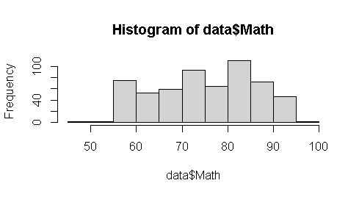 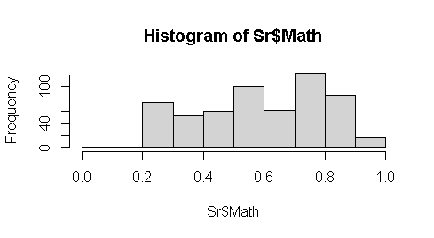

Figure1.1: Before and After Histogram of Math’s Variable

After setting seed value for the purpose to get similar output from the model after more execution. The tidyverse package filtered the selected subset data for the explanation how the neural network works. The data partition use sample function divides the selects 15 variables into two samples with 70% and 30% for training and test testing and validation purpose. After loading neural network package, the model of neural network use as n=neuralnet (p~SLC+School+Plus+Physics+Math+Chemistry+Bio+Parent1+Parent2+X1+X2+X3+X4+X5+X6, data=training, hidden=c (1), err.fct="sse, linear. output=FALSE) function. The hyperparameter like sse is selected for error calculation purpose and single hidden layer whose linear output is set as false to get conversed single out model. The differential function for calculation of errors "ce" cross entropy or "sse" sum of the square could be selected. The plot(n) displays the output depends on the dependent variable GPA of numeric or factor with repetition minimum errors choose plot (n, rep=1) while printing selection in case more repetition in design. The hidden hyperparameter 1 indicates a single hidden layer whose mathematical explanation here.

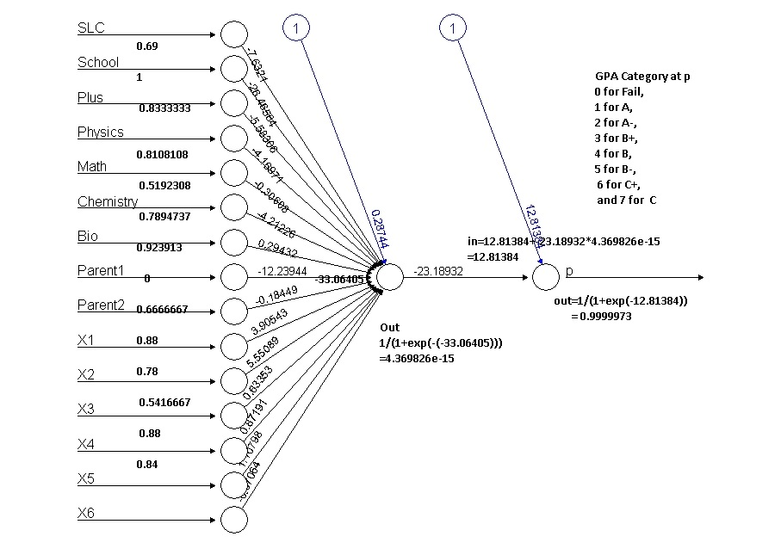

Figure1. 2: Single Hidden Layer Neural Network

The model output with original value is calculated using compute function as output=neural net: compute (n, training [, -1]) command to display the output as 0.4812963, 0.4812963 0.4812963 and 0.4812963 so on values of all 580 sample variables of student data. The head (training [1,]) describes first records 0.3907611 and GPAX SLC Plus Physics Math Chemistry Bio Parent1 X1 X2 X3 X4 X5 and X61 whose respective weights are 0.7916667, 0.7222222, 0.5675676, 0.75, 0.5526316, 0.8152174, 1 0.94, 0.78, 0.375, 0.82 ,0.96 and 2 0.8 describes respectively the input produced another hidden layer. The hidden parameter could be set out more if multiple layers need to converse to the GPAX predicator variable. Another hyperparameter err.fct="see" is for only when the data sets with having more than two categories either true or false type if so err.fct=” ce” is applicable for design the model. The first figure received first 15 input nodes and hidden layer 16 node is calculated with the sum of first bios and sum of each weight of previous input neuron and stored its value in16 = 0.28744+(-7.6321*0.69) + (-26.465584*1)+(-5.58306*0.8333333) + (-4.16971*0.8108108) + (-0.30608 * 0.5192308) + (-4.211226* 0.7894737) + (0.29432 *0.923913) + (-12.23944*0) +(18449 * 0.6666667) + (3.90543 *0.88) + (5.55089 *0.78) + (0.63353 *0.5416667) +(0.87191 *0.88)+ (1.10798 * 0.84) +(-0.07064 *0.84) this produce the value of (-33.06405) after calculation is again input to node 17th node and produced the output from using sigmoid function as 1/ (1+exp (-in14)) is 4.369826e-15 is always lines in between 1 and 0 because when used sigmoid function that indicates association and the 17th node input become to calculated its weight using 12.81384+(-23.18932*4.369826e-15) produces the value -12.81384 ultimately to 18th again calculated using sigmoid function 1/(1+exp (-(-12.81384))) produces 0.9999973 which is shown in figure matched with head first records using result command whose output is display in histogram for prediction the GPA grade.

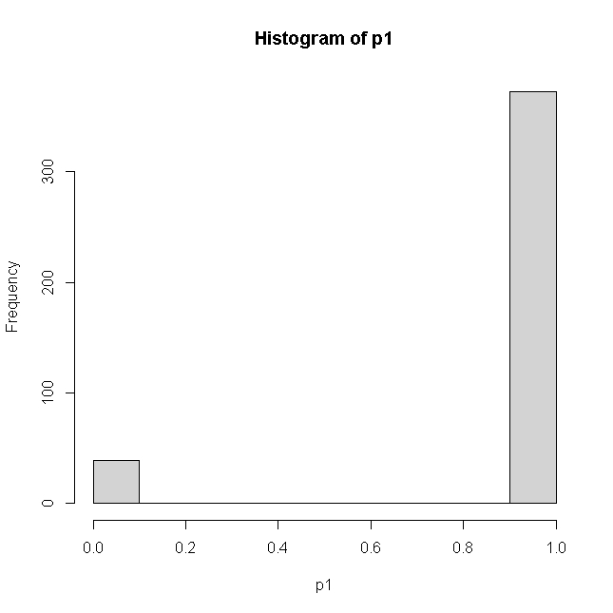

Figure 1. 3: Histogram of Output Result

1 0.99996886

8 0.99996885

9 0.99996864

11 0.99996871

12 0.99996874

13 0.99996881

576 0.01189466

578 0.99996886

580 0.99996886

This is our inquiry of prediction of grade of eight scale graded whose histogram predicated on seven scale grades model are 0 for Fail, 1 for A, 2 for A-, 3 for B+ 4 for B 5 for B- 5 for C+ and 7 for C-. The model testing and validation using confusion matrix of model could be calculated using compute function compute (n, training [, -1]) function with excluding its dependent variable GPA. Whose head result could plot in histogram for further grading plotted for the proper prediction of accurate grade. Whose prediction and accuracy could be calculated based on predicted values with pred1=ifelse(p1>=0.88,1, ifelse(p1>=.75, 2, ifelse(p1>=.65,3, ifelse (p1 >=0.55,4, ifelse(p1>=0.30,5, ifelse(p1>=0.2,6, ifelse(p1>=.15,7,0))))))) and table of predicated and training data describes as.

pred1 0 1 2 3 4 5 6

0 38 0 1 0 0 0 0

1 177 30 66 42 32 22 4

The accuracy is calculated using formula as 1-sum (diag (tab1))/sum(tab1) become 0.8349515 is the final accuracy of the model indicates more than 83 percent of total data could predict accurately from the model using single hidden layer. Similarly, the test prediction produces confusion matrix as.

pred2 0 1 2 3 4 5 6 7

0 4 0 1 1 1 0 0 0

1 70 19 28 22 6 13 1 1

3 1 0 0 0 0 0 0 0

Whose test accuracy is further calculated using formula 1-sum (diag (tab2))/sum(tab2) is 0.8630952 more than training set of machine learning.

The above accuracy indicates these data need to be more data correction to get a more accurate result. If this model uses 22 predictor/ independent variables using final grade the accuracy will be around 50 percent and when the dependent variable only has two categories this model produces 97 percent accuracy too. However, due to many dependent variables with eight prediction category this model did accuracy around 85 percent is good enough.

Similarly, the prediction of neural network with only passed student model after selecting of same data sets of above 15 input data sets with the only passed student whose scored final grade of categorized A for 1, A- for 2, B+ for 3, B for 4, B- for 5, C+ for 6, and C- for 7 seven category result of 2019 school of engineering students. After normalized of predictor variable to explanatory variables the training and testing data separation of 70 and 30 percent of only 290(half model) students records. The model n=neuralnet (GPA~SLC+School+Plus+ Physics+ Math+Chemistry+Bio+Parent1+Parent2 +X1+X2+X3+X4+X5+X6, data=training, hidden=c (1), err.fct="sse”, linear. output=TRUE). Here error factor is used as a sum of the square with a single hidden neural network as.

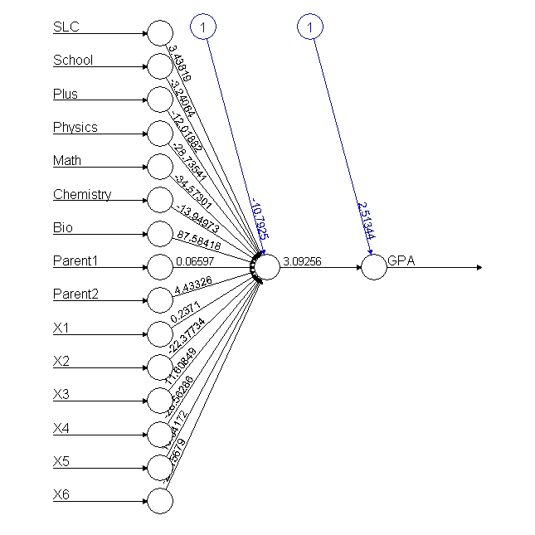

Figure1. 4: Neural Network with Passed Student

From the above output conversion of neuron, the input to in14th node is calculated 2.39998+ (2.08578*0.69) + (4.64526*1) + (0.25413*0.8285714) + (2.83408*0.8108108) + (1.0983 *0.4047619) + (2.69845*0.7894737) + (1.2807*0.923913) + (0.65258*0) + (4.74991* 0.6666667) + (0.31636*.7777778) +(0.93483*0.56) +(0.29306*0.5217391) +(0.63501* 0.7777778) +(0.59444 * 0.7575758) +(1.36278*0.7647059). Which produce the input to 14th node is 20.82648 and is again passed to sigmoid function input to another node 1/(1+exp(-in14)) is 1 and again input to 15th node is 1 must always lines between 1 and 0 because we used sigmoid function then output from that node is again calculated with 0.21029+(2.43648*out14) is 2.64677. Thus, the final SGPAO=1/(1+exp(-SGPI)) and final output from the last neuron is 0.9338116 this matched with head first records of net$result value of model. The after formation of output with net. neuron result is calculated of 290 records of passed students. The both test and training histogram model produces as.

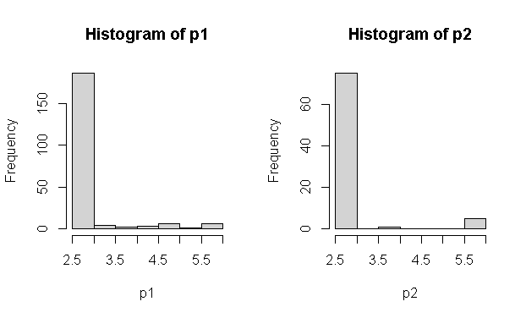

Figure1. 5: The Test and Training Output Histogram

The prediction after calculating compute function the respective values of each grade is further categorized assuming ifelse(p1>=5.5,1, ifelse(p1>=5,2, ifelse(p1>=4.5,3, ifelse(p1>=4.0,4, ifelse(p1>=3.5,5, ifelse(p1>=3,6,7)))))) formed table (pred1, training$GPA). The confusion matrix of test and training data as bellow indicates the accuracy of model.

pred1 1 2 3 4 5 6 7

pred2 1 2 3 4 5 6

1 0 1 2 0 2 0

5 0 1 0 0 0 0

7 14 25 13 12 9 2

1 0 0 0 1 3 0 2

2 0 0 0 0 0 1 0

3 0 0 0 1 5 0 0

4 0 0 0 2 1 0 0

5 0 0 1 1 0 0 0

6 0 0 3 1 0 0 0

7 38 66 48 19 15 1 0

Whose prediction is again calculated using 1-sum(diag(tab1))/sum(tab1) is 0.9904306% in training data sets of 209 records of the test set and the testing result accuracy is 0.8271605 percent of model design is more than 86percent presents is a quite good model prediction. However, the model predicts more accurately than full model although needs some improvement of selecting independent variable before final model of GPA prediction.

## **Problem Statement**

We know that the teaching-learning process always requires continuous assessment of all-day classroom activities which finally meets curriculum is a difficult task when grading categorization among learners. The curriculum is the formal activities offered to the learner through the educational institution. When Oxford University first held an examination in 1958, it was assumed that examination would give stimulus to scholars and teachers (Ranjita, Sushobhan, Ananya, Nina, & Patralekha, 2014). The continuous internal assessment and evaluation system are the core process of teaching learning system (Nnodium, 1992) that enhance student activities. Similarly, study conducted (Lima, Mohanan, & Harichandran, 2017) in medical student with 40 sample study conclude that there was a positive correlation between student attendance and marks scored in all the internal theory and practical examination. The examination always measures the knowledge level of the student whose progress is always required for university management. Therefore, effective teaching management depends on the ability to assess the quality of services provider in the education sector. According to (Lykourentzou, Mpardis, & Nikolopoulos, 2009), learners’ performance prediction can help to identify the weak learners at early stages and properly assist them to cope with their study performance betterment.

Although, this study concludes that students with highest mean 88.07 shows that the students are getting highest marks in assignments, while the final examination scored least mean 49.57 shows that students are getting lowest marks in the final examination. Based on the literature review and empirical study, on importance-performance analysis, the study identifies the strengths and weaknesses of neural networks (Silva, 2018). Similarly, (Daguang & Xie, 2017) suggested to measure student performance is assessed in terms of written and verbal communication skills, ability to innovate, analytical problem-solving skills, group management ability, self-study skills, adaptability, performance under pressure, workplace comportment, ability to work with others, and sense of work responsibility. Preparedness for examination is assessed in terms of professional knowledge, fundamental knowledge, extra-curricular knowledge, English proficiency, computer proficiency, and research ability which only measure the total quality of the student. If student performance can be predicted before the final examination, it could help all stakeholders, as a student, to make better timely decisions. Before the semester-end examination, the management has to decide which courses to offers visiting scholars’ precautions. So that students can prepare better teaching materials which ultimately leads to reduce the dropout ratio of students. This creates an atmosphere of uncertainty and frustration for management and student too. Timely counseling can help the student to make extra effort to avoid drop-out in the final examination.

There are various applications of neural networks in artificial intelligence and solving various business problems like classification includes pattern recognition, face recognition feature extraction image processing matching signature in the bank, prediction of historical pattern and largely applicable in noise reduction of large input data. The supervised learning is the machine learning task of finding a function with label data the labeled class can also be called dependent variables whereas age, gender, parent occupations are termed as independent features variables. Likewise, unsupervised learning task of exploring the data of deriving some inference from data sets. When the prediction of data was not used to design the model used unlabeled type data structure is known as unsupervised learning. Which tries to find out the patterned of relationship from the relationship defied its prediction based on training and test. When the target variables are continuous variables it will apply to the regression model. Whereas the prediction variables with more categories are used classification algorithm. When data without header fall under unsupervised techniques supports dimension reduction techniques PCA and factor analysis and clustering association analysis prediction automatically referred another product of student bias product. Therefore, unsupervised predicts values but could not develop the model for future analysis just clustering categories.

The neural network which has to mimic the neuron simulation like the brain is known as an artificial neural network. In our brain, we get signals to form external receptors cell which transmits an impulse from sensors to the receptors which enable us to receive mechanical, thermal chemical to stimuli receiver neuron signals that process of signals finally send them to corresponding executive organs so-called effectors as shown below.

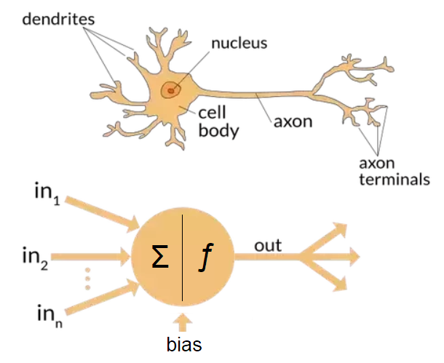

Figure1. 6: Neuron of Human Cell

A neuron cell is an electrically excitable cell that processes and transmits information through electrical and chemical signals. The human brain is made of about 100 billion neurons. These signals neurons occur via synapses, specialized connections with other cells. Neurons can connect to form main neural networks. Each neuron can connect with 5000 other neurons. The human brain has a massive parallel connection with quick fault tolerance, the capability of adapting to surroundings, the generalized form of collective behaviors renter than individual behaviors. The final grade prediction based on the limited initial data of students and courses is a challenging task because, at the beginning of undergraduate studies, most of the students are motivated in the first semester but as time passed there might be a decrease in motivation and performance of the students. Their study showed that in-class exams were better predictors of the overall performance of a student than the homework assignment. The study also demonstrated that timely prediction of the performance of each student would allow instructors to intervene accordingly. (Meier, Xu, & Van, 2016) According to their findings, the undergraduate performance of the students could explain 54% of the variance in graduate level performance.

(Agoritsa & George, 2019) argues that the performance that a student achieved in a subset of the earlier courses can be used to predict how well he/she will perform in future courses. With this motivation, this study tires to developed a grade prediction method, called course-specific regression that predicts the grade of student will achieve in a specific course as a sparse linear combination of the grades and past student courses performance. The historical student-course grade information to accurately estimate how well students will perform in future relies on the neighborhood-based collaborative iterative model. Some scholars proposed low-rank matrix factorization the best performing scheme, which is based on course specifics regression, achieves an RMSE across the different courses of 0.632 whereas the best competing method achieves an RMSE is 0.661 accuracy. However, the researcher used only three-semester grades of students of 2,949 students, records. Similarly, (Yupei, Yue, Huan, Jiaqi, & Xuequn, 2020) used a majorization minimization algorithm to analyzed 1325 students and 832 courses of higher education data sets. This research used decision tree logic regression and support vector machine algorithm. This process used non-negative matrix factorization (NMF) was used to integrate the nonnegativity of student grade matrix for implicitly low rank, low-rank matrix factorization (LRMF) was investigated in data sets from the online learning platform in the work (Lorenzen, Pham, & Alstrup, 2017). The family background, such as the economic situation and educational level of their parents, influences the scope of student knowledge (Brecko, 2004). (Emaan Abdul, 2016) machine-learning approaches we predict student marks and grades before the final examination for 2500 student course records of an institute of higher education suggest that the grade of more than 96% of students can be accurately predicted. Similarly, (Tair & Alaa, 2012) conducted a study to identify the attributes impacting student performance the most. They used only a genetic algorithm on a sample of 120 students. Their analysis model considers quantitative factors such as theoretical, mathematical, practical, and other departmental marks. They applied only the ID3 algorithm on a very small set of 50 students to identify the attributes that affected the performance of the students (Hijazi & Naqvi, 2006) used linear regression on a sample of 300 students (225 males, 75 females) from a group of colleges affiliated with University of Punjab. They used social and demographic variables alongside the grades of the students and found that the mother’s education and student’s family income were highly correlated with the student's academic performance. A similar finding was reported by using Naïve Bayes classification on a similar sample of 300 students course records of eight semesters are obtained for the undergrad programs from Fall 2009 to Spring 2013 semester. For each semester, they have a record of 25 to 30 courses with an aggregate enrolment of 800 to 1000 students. Before they delved into the techniques and results, it needs to be mentioned that it was unrealistic to get a hundred percent accuracy on this data set because the weightage of the final exam varies from 25% to 50% of the total marks, which is quite a high weightage cannot model these types of variables, therefore it is unrealistic to predict the final grade with 100% accuracy (Maghari, 2017).

(Bhardwaj, 2011) proposed a research work to find out pattern could be useful as the strongest prediction for students’ performance at the UNWE university based on pre-university and characteristics of personal information. The results showed that the decision tree performs the best accuracy, followed by KNN classifier whereas the Bayes classifiers had the lowest accuracy. The authors analyzed the data gathered from colleges and applied classification techniques for student performance prediction by using MATLAB tools. Their study showed that the performance of the students does not always depend on the student effort, but, other factors can affect the student’s performance.

Recently, other researchers (Hamsa, Indiradevi, & Kizhakkethottam, 2016) conducted a study to predict the performance of academic students in both master's and bachelor's degrees using different classification algorithms and different subjects. However, a few efforts applied classification algorithms on educational datasets of secondary schools in the Gaza Strip. This study applied major kinds of classification techniques KNN and Naïve Bayes to help the ministry of education to predict the performance of new students, and improve results for the next year. (Agoritsa & Karypis, 2016) presents future course grade prediction methods based on linear and low-rank matrix factorization models that are specific to each course or student–course tuple.

## **Theoretical Framework**

Substantial studies based on neural networks have been conducted on data from schools, colleges, and distance-education courses, aiming to predict student achievement. (Junemann, 2007) employed neural networks to estimate future student performance based on students’ family, social, and wealth characteristics as inputs too. However, this study tries to explore the Bachelor of Engineering student grade of Pokhara University constituent with six programs with 13 classes composed 290 successful and 290 fail students.

SGPA

Gender, GPA,

parent’s education status

Unit test score

Assignment mark

Internal score

Attendance

Extracurricular activities

SLC, +2 Grades

Machine learning Model

Verification

Actual

Predicted

Figure1. 7: Conceptual Framework of Research Design

As the teaching-learning process is a mixture of various dimensions this research tries to find out neural network grade prediction of various input variables who’s predicated SGPA will again further validated with university final result for further validation of 580 sampled student so that model produces minimum errors and misclassification accuracy.

## **Objectives**

The general objective of this study is to validate machine learning prediction of SGPA grade performance using an artificial neural network of bachelor of engineering university student.

The specific objectives are to:

Transform input data factors to a suitable form for a machine learning model.

Develop the artificial neural network model that predicts grade performance.

To compare miss classification errors of predicated and actual SGPA.

## **Hypotheses**

H1: there is no significant difference between subject grades with continuous assessment of the student.

H1: there is a significant difference between pass ratios of different batches of students.

## **Research Question**

What are the strategies which can be adopted to reduce the consistency of internal and final grade of the student?

Are there similarities among internal grades and final similar among various subjects?

# **CHAPTER 2. METHODOLOGY**

## **The Study Area**

The semester-end result of engineering students of various programs is notified to the student but the analysis on them will not been carried out since establishment of program since 2009 batch of engineering student. Out of 11 programs of engineering programs in Pokhara university, the five programs are currently being running in SOE constituent campus. There are 624 (13*48) regular students currently being studying in constituent campus although there are 288 enrolment in each year new admission. After final examination result of 2019 held, out of 1326 total students appears in this examination, 290 students were being completed with CGPA. The total pass percentage of this year is 47.44 in central campus. However, the overall university pass ratio of these programs was lesser is 11.25 percentage with considering regular or retake examinations in the fall 2019 examination. When considering the percentage of Civil VIII regular program has highest 52.38 percentage whereas Civil III Elex V had the lowest pass ratio 11.62 and 8 percentage respectively. The Electrical I semester students have a better result among electrical and semester students. The newest program of computer, software and civil and rural had average and computer I has highest among new program.

For data analysis using machine learning 290 pass/fail student’s records, were being collected and verified from the school of engineering administration office records where 580 questionnaire surveys were collected from five enumerator for neural network model design.

|  |  |  |  |  |  |  |  |
| --- | --- | --- | --- | --- | --- | --- | --- |
| Program | Total | Pass | Percentage | SOE | PASS | Percentage | Total sample |
| Civil I | 2818 | 232 | 8.232789 | 156 | 24 | 15.38462 | 48 |
| Civil III | 2788 | 162 | 5.810617 | 172 | 20 | 11.62791 | 40 |
| Civil V | 2320 | 154 | 6.637931 | 176 | 46 | 26.13636 | 92 |
| Civil VII | 1743 | 208 | 11.93345 | 148 | 40 | 27.02703 | 80 |
| Civil VIII | 1269 | 458 | 36.09141 | 147 | 77 | 52.38095 | 154 |
| Computer I | 1012 | 136 | 13.43874 | 47 | 17 | 36.17021 | 34 |
| Civil/Rural I | 94 | 12 | 12.76596 | 48 | 6 | 12.5 | 12 |
| Software I | 340 | 59 | 17.35294 | 47 | 9 | 19.14894 | 18 |
| Elex I | 327 | 33 | 10.09174 | 82 | 12 | 14.63415 | 24 |
| Elex III | 328 | 28 | 8.536585 | 96 | 13 | 13.54167 | 26 |
| Elex V | 302 | 20 | 6.622517 | 75 | 6 | 8 | 12 |
| Elex VII | 218 | 20 | 9.174312 | 64 | 8 | 12.5 | 16 |
| Elex VIII | 210 | 28 | 13.33333 | 68 | 12 | 17.64706 | 24 |
|  | 13769 | 1550 |  | 1326 | 290 | 21.87029 | 580 |
| 13*48 |  | 11.257 |  | 624 | 0.464744 |  |  |

Table 1: 2019 Result Summary Table

This study design includes a mixed (Retrospective, Non-interventional) study including quantitative and qualitative aspects of research design.

Study setting: This study was conducted in the Pokhara University under the School of Engineering where there were 8 groups of Civil Engineering program and 4 groups of Electrical and Electronic, one group of each Civil and Rural, Computer and Software classes are running in constitute college under the director of the school of engineering comprises total universe. Whose current results of fall 2019 were collected as the first-year first part, the second-year first part, the third-year first part, and fourth-year first part only even semester students were in sampling units.

Study population: Regarding internal marks prediction of all groups of Civil and Electrical and Electronics, Computer, Software and Civil and Rural student groups composite (48*13~624) composite the study population universe. However, the current result of odd semesters (I, III, V, VII, and VIII) results with CGPA will be collected as the equal number of pass and fail students of each program.

Duration of the study: May 2019 to May 2020.

Sample size: Although 13 classes were being running under bachelor program in faculty of science and technology in constituent campus in two blocks, out of them all sample cluster were selected (4 Civil and 4 Electrical and Electronic, 1 Civil and Rural and 1 from Computer and 1 from Software programs) with the consideration of each batch representation inclusive.

Sampling techniques: Stratified random sampling procedure was selected among 13 groups of SOE where all batch successful student in their final examination results in 2019 were selected randomly in the same ratio of fail student were selected by random order, no repetition subject will be taken as sample marks prediction for the design of full model and half neural network model.

Data collection tools and techniques: Vermiculated structured questionnaire was being used to collect the data regarding the internal management of each program and their previous information like high school, parents’ education and their plus to grades with physics, math chemistry and bio total scored were collected with the help of five enumerators. Besides, a focus group discussion with CR with guidelines was also being used as data collection tools. Data were collected through the individual questionnaire of the sampled student. Informed consent was taken from each of the participants before the data collection. The principal investigator and class representative involved in data collection. The filled questionnaires were verified with office records from administration office of directors’ offices.

Data management and analysis: Collected data were managed carefully by taking the consideration of safety. Editing, coding, and data cleaning were done in various label of internal, final results and prepared with vlook function in excel after converted pdf to excel of all program. Data were analyzed using R software. Appropriate descriptive statistics such as percentage, standard deviation, max, and min were applied to conclude research. Similarly, regression analysis, performance measures, decision tree classification, random forest algorithm, and Boruta algorithm were analyzed to predict data internal marks data to final grade point data normalization before final artificial neural network model design. Thematic analysis was done for the qualitative data.

Therefore, this study tries to apply supervised machine techniques i.e., decision tree classifiers, neural network classifiers to predict dependent variables. Similarly, the correlation coefficient of internal and final marks calculated using R programming. The relationship between each sample unit was analyzed and compared sufficiently.

Validity and reliability: The validity and reliability of the study were maintained by the following techniques:

A structured and pretested questionnaire was used for the data collection first level.

Expert’s advice was explored. Pretesting of the tools was carried out amongst 10% of samples before real questionnaire collection.

**Data Acquisition and Preprocessing**

This primary study used 580 student data sets of Pokhara University constituent engineering students, whose final grade points were collected from an online result sheet published in 2020. Similarly, the second part of the internal marks of respective sample students was being collected from the school of engineering internal examination sections of all 13 sampled groups of students. The 50/50 (Pass/ Fail) records were collected from primary datasets from the enumerator completes its datasets in csv format. The data were carefully reviewed preprocessed and organized in excel data based before loading into r console. The incomplete and irrelevant data were being eliminated filled after verification. The respective GPA of all semester student records of first, third, fifth, seventh, and final eight semesters of each respective course comprised datasets. This final dataset includes internal marks of their respective subjects of which six subjects were collected in each row tuple. The student information of each program was collected as an equal sample of pass-fail students for full and half model design. The student's school-leaving grades and their +2 grade were collected with primary Math, Science (Physics, Chemistry, and Biology and their final grade point average in separate column. Similarly, the student background information of the institution from they were learned from past i.e., government school or private boarding schools were collected. The GPA and marks of each student were converted and uniformly organized based on the following table. The parent highest education level was collected in 1 for SLC completion, 2 for Pluto completion 3 for Bachelor completion, and 4 for Master and above level completion in questionnaire survey.

|  |  |  |  |  |  |  |
| --- | --- | --- | --- | --- | --- | --- |
| SLC and +2 Grading | | | | Bachelors | | |
| Grade | Grade Point | % | Description | Grade | Grade Point | % |
| A+ | 3.6-4 | >=90 | Outstanding | A | 4.0 | >=90 |
| A | 3.2-3.6 | >=80&&<90 | Excellent | A- | 3.7 | >=85 |
| B+ | 2.8-3.2 | >=70&&<80 | Very Good | B+ | 3.3 | >=80 |
| B | 2.4-2.8 | >=60&&<70 | Good | B | 3.0 | >=75 |
| C+ | 2.0-2.4 | >=50&&<60 | Above Average | B- | 2.7 | >=70 |
| C | 1.6-2.0 | >=40&&<50 | Average | C+ | 2.3 | >=65 |
| D+ | 0.8-1.6 | >=30&&<40 | Billow Average | C | 2.0 | >=60 |
| D | 0-0.8 | >=20&&<30 | Insufficient | C- | 1.7 | >=55 |
| E | Null | >=0&&<20 | Very insufficient | D+ | 1.3 | >=50 |
|  |  |  |  | D | 1.0 | >=45 |
| Table 2 : Final Grade Conversion Table | | | | F | 0.0 |  |

Note: The cumulative grade point is the average grade point of all the semester which is calculated as CGPA= cumulative total honor points earned/ cumulative total number of credit hours taken.

The high school studied of sampled student were stored in school column with 1 for private school and 2 for government school and the parent education of each sampled student were stored in 1 for SLC, 2 for +2, 3 for Bachelor and 4 for Master degree completion categorical data. Altogether there were 36 columns of records with 580 composed 2080 cells record of database.

## **Model Design and Setup**

The R programming application powerful opensource tools offer a wide variety of classification and prediction methods was used to build the test the student marks prediction with accuracy after validation test. A neural network algorithm implementation of the bachelor degree grade prediction algorithms of full and half model were analyzed with different neural network model design corelates their outputs in each step. Each classifier was evaluated using the holdout approach i.e., train the model 70% of the data while evaluate it on the remaining 30% which is referred to as the testing data or the unseen data. This is done to avoid overfitting, a phenomenon that arises when evaluate the model on the same set of records learn it from. Similarly, the Boruta algorithm and random forest model were sufficiently analyzed to separate unwanted columns of research 48 columns final database.

Classification

Model

Dataset

Testing

Training Data

Data mining

Algorithm

Results

Figure 2. 1: Data Organization Diagram

|  |  |  |  |  |  |  |  |  |  |
| --- | --- | --- | --- | --- | --- | --- | --- | --- | --- |
| 1 | 2 | 3 | 4 | 5 | 6 | 7 | 8 |  | 49 |
| SN | Prog | SLC | School | Plus | Physics | Math | Chemistry | FinalGPA |
| 1 | Civil I | 79.84 | 1 | 78 | 85 | 72 | 85 | 80 |
| 2 | Civil I | 83.5 | 1 | 74.2 | 76 | 84 | 76 | 75 |
| 3 | Civil I | 76 | 2 | 73.35 | 75 | 75 | 84 | 85 |
| 4 | Civil I | 85 | 2 | 76 | 80 | 90 | 70 | 75 |
| 5 | Civil I | 86 | 2 | 76 | 80 | 90 | 70 | 80 |
| 6 | Civil I | 87 | 1 | 74 | 76 | 78 | 70 | 65 |
| …………… | | | | | | | | | |
| 578 | ELEX VIII | 55 | 2 | 65 | 55 | 58 | 75 |  | 0 |
| 579 | ELEX VIII | 55 | 1 | 55 | 75 | 80 | 75 | 0 |
| 580 | ELEX VIII | 60 | 1 | 55 | 85 | 90 | 85 | 0 |

Table 3: Before Data Normalized Database Structure

|  |  |  |  |  |  |  |  |  |  |
| --- | --- | --- | --- | --- | --- | --- | --- | --- | --- |
| SN | 2 | 3 | 4 | 5 | 6 | 7 | 8 |  | 49 |
| 1 | Prog | SLC | School | Plus | Physics | Math | Chemistry |  | FinalGPA |
| 2 | Civil I | 0.69 | 0 | 0.833 | 0.810 | 0.519 | 0.789 |  | 1 |
| 3 | Civil I | 0.791 | 0 | 0.722 | 0.567 | 0.75 | 0.552 |  | 1 |
| 4 | Civil I | 0.583 | 1 | 0.694 | 0.540 | 0.576 | 0.763 |  | 1 |
| 5 | Civil I | 0.833 | 1 | 0.777 | 0.675 | 0.865 | 0.394 |  | 1 |
| 6 | Civil I | 0.861 | 1 | 0.777 | 0.675 | 0.865 | 0.394 |  | 1 |
|  | Civil I | 0.888 | 0 | 0.722 | 0.567 | 0.634 | 0.394 |  | 1 |
|  |  |  |  |  |  |  |  |  |  |
| 578 | ELEX VIII | 0 | 1 | 0.472 | 0 | 0.25 | 0.526 |  | 0 |
| 579 | ELEX VIII | 0 | 0 | 0.194 | 0.540 | 0.673 | 0.526 |  | 0 |
| 580 | ELEX VIII | 0.13889 | 0 | 0.194 | 0.810 | 0.865 | 0.789 |  | 0 |

Table 4: After Data Sets Normalized Sample

As we know machine learning model always recommended to prepare data in such a way that computer process data quickly and reliable after normalized. These above table describe the structure of cumulative database used for GPA artificial neural network analysis.

## **Random Forest Methodology for Large Feature Selection**

Random forest is tree aggregating methodology which can be applied in both classification as well as a regression for avoiding overfitting large features selection which can deal with large numbers of features selection based on the importance of features for model contribution and user friendly because of only two parameters would be given tree and mtry variable as hypermeter externally. The default tree is 500 and mtry is 4. The hyperparameter mtry is sampled as a parameter at each split default sqrt(p) features for classification and p/3 for regression based on predictor variable numbers. Where p is features draw ntree bootstrap sample where each bootstrap sample grow on an unpruned tree by choosing the best split based on a random sample of mtry predictor at each node and predict new data using majority votes for classification and average for regression based on ntree for final prediction of the model. After loading library caret, random forest in r console the database was again selected using data=read.csv ("D:/dataanalysisfinal/SOE/rcode/ Dataanalysiscsv.csv") command and split its required data-based into the working table using tidyverse packages. While doing the ss=S %>% select (GPA, GPAA, GPAAA, SLC, School, Plus, Physics, Math’s, Chemistry, Bio, Parent1, Parent2, X1, X2, X4, X5, X6, X111, X222, X333, X444, X555, X666) %>% filter (GPA>0) is used for filtering only records of passed student 290 of result 2019 final result of engineering student. Then after omitting na values the and converting response variable with factor category as table command describes as the table(S$GPAA) produces as A (49) A-(96)B+(65)B(39)B-(35)C+(5) and C-(1). Similarly, the table(S$GPAAA) a real factor data of student grade of 2019 describes with their groups as.

A A- B+ B B- C+ C

49 96 65 39 35 5 1

After making seed and data frame of selected data items of 70 and 30 percent split from selected data sets with test and training data sets split into 211 and 79 data sets of passed students using sample (2, now(S), replace=T, prob=c (.7,.3)), train=S[ind==1,]211 for a pass only and test=S[ind==2,] 79 out of 290 passed student. For model validation and testing accuracy purposes. The random forest provides only two free parameters for the segregation of a large number of features of 22 variables for full model. The rf22=randomForest (GPAAA~., data=train, nodesize=5, ntree=500). Here the GPAA a categorical variable with a numerical representation of all student grades 1 for A,2 for A-,3 for B+,4 for B,5 for B-,6 for C+,7 for C- and 8 for Fail categories in GPAA and vice versa in GPAA variable. All variables model prediction and confusion matrix were based on OOB (Out of Bag) indicates error rate with 2.37% indicates 97 % accuracy of the model. The print(rf22) commands plot in mtry chart which indicates the errors has drastically decreased after 32 steps iteration.

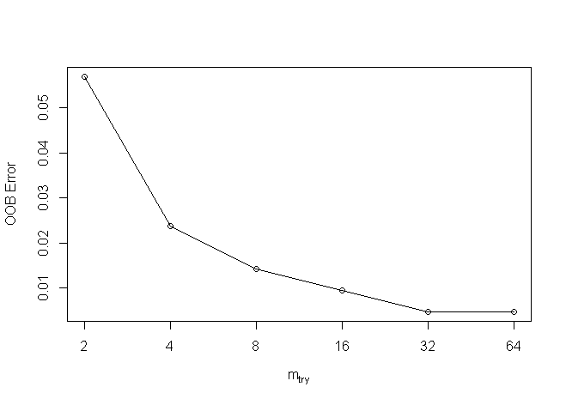

Figure 2. 2: OOB Plot of Random Forest

Type of random forest is a classification with several trees at 500 steps variables, tried at each split is 4 and OOB estimate of error rate is 2.37% indicates confusion matrix with errors as.

Confusion matrix:

A A- B B- B+ C C+ class. error

A 34 0 0 0 0 0 0 0.00

A- 0 70 0 0 0 0 0 0.00

B 0 0 30 0 0 0 0 0.00

B- 0 0 1 24 0 0 0 0.04

B+ 0 0 0 0 48 0 0 0.00

C 0 0 0 1 0 0 0 1.00

C+ 0 0 0 3 0 0 0 1.00

From the above confusion table, the prediction of result in Grade A A-, B, C, and C- has no missing values whereas C+, B- and C has only five-grade prediction values were miss classified from the model. After loading the caret package, the prediction of the model with train data produced p=predict (rf22, train) the head(p) 100% accurately when matching using first values.

1 3 6 7 9 10

A- A B- B- A- A-

Therefore, this model predicts more accurately in eight levels A, A-, B, B-, B+, C, C+ when applying confusion matrix with train data confusion matrix and statistics as.

Reference

Prediction A A- B B- B+ C C+

A 34 0 0 0 0 0 0

A- 0 70 0 0 0 0 0

B 0 0 30 0 0 0 0

B- 0 0 0 25 0 1 0

B+ 0 0 0 0 48 0 0

C 0 0 0 0 0 0 0

C+ 0 0 0 0 0 0 3

Overall statistics accuracy is 0.9953 percent when 95% confidence interval is ranged from (0.9739 to 0.9999) percent accuracy is the very strong model. The information rate is 0.3318 is p-value is less than 2.2e-16(0.05) indicates the model has significance this is similarly explained by using Kappa test is 0.9939 percent validate the similar output. The sensitivity and specificity values in each grade column were calculated based on the confusion matrix as the accurate prediction divided by total misclassification in each grade cluster. However, the grade C prediction has found some errors in the model.

Class: A Class: A- Class: B Class: B- Class: B+ Class: C Class: C+

Sensitivity 1.0000 1.0000 1.0000 1.0000 1.0000 0.000000 1.00000

Specificity 1.0000 1.0000 1.0000 0.9946 1.0000 1.000000 1.00000

Pos Pred Value 1.0000 1.0000 1.0000 0.9615 1.0000 NaN 1.00000

Neg Pred Value 1.0000 1.0000 1.0000 1.0000 1.0000 0.995261 1.00000

Prevalence 0.1611 0.3318 0.1422 0.1185 0.2275 0.004739 0.01422

Detection Rate 0.1611 0.3318 0.1422 0.1185 0.2275 0.000000 0.01422

Detection Prevalence 0.1611 0.3318 0.1422 0.1232 0.2275 0.000000 0.01422

Balanced Accuracy 1.0000 1.0000 1.0000 0.9973 1.0000 0.500000 1.00000

As compared OOB errors for each bootstrap iteration and related tree prediction error using data not in bootstrap sample is called OOB that estimated classification accuracy and regression RMSE were selected. Similarly, the confusion matrix and prediction of test data with grade is calculated as confusionMatrix (pp, test$GPAAA) function as.

Reference

Prediction A A- B B- B+ C C+

A 15 0 0 0 0 0 0

A- 0 26 0 0 0 0 0

B 0 0 9 0 0 0 1

B- 0 0 0 10 0 0 1

B+ 0 0 0 0 17 0 0

C 0 0 0 0 0 0 0

C+ 0 0 0 0 0 0 0

This output implies similar type results with accuracy is 0.9747 percent due to two testing grades were miss classification in C grade with 95% confidence interval in between (0.9115 to 0.9969) percent.

Having an information rate is 0.3291 is good with a significant p-value is less than 0.05(< 2.2e-16) of model performance.

Class: A Class: A- Class: B Class: B- Class: B+ Class: C Class: C+

Sensitivity 1.0000 1.0000 1.0000 1.0000 1.0000 NA 0.00000

Specificity 1.0000 1.0000 0.9857 0.9855 1.0000 1 1.00000

The plot model describes the overall model normalization when it goes more than 200 trees it will normalized constantly then after.

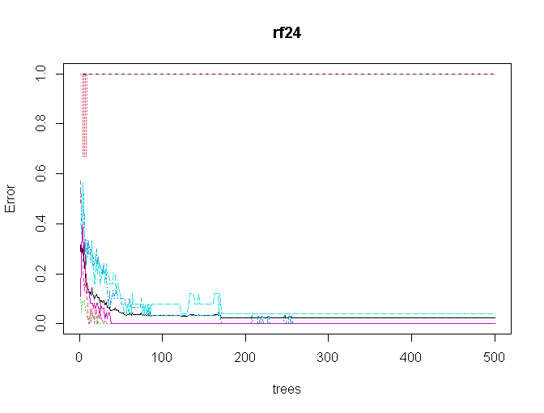 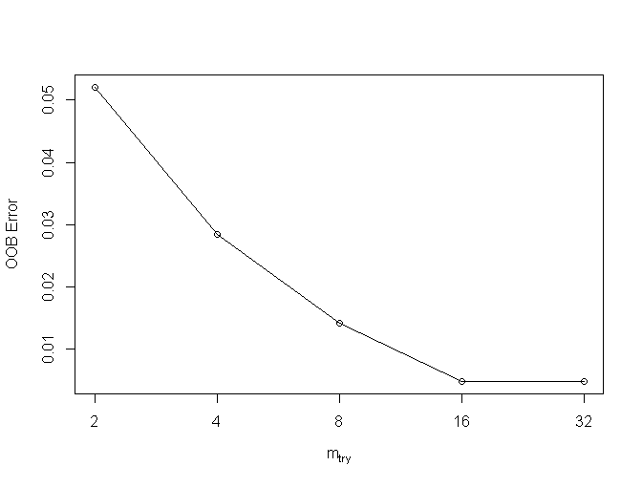

Figure 2.3: Error Vs Trees and Mtry Plot

Choosing the mtry value using finetune using tuneRF (train [, -1, -2], train [,3], stepFactor = 0.5

plot =TRUE, ntreeTry = 300, trace = TRUE, improve=0.05). The improve factor improves in each tree into out-of-bag errors and the mtry will be inflicted either positive or negative association which produces the same result when after 200 trees. The second tune plots determine the final value of mtry should be best fitted after 16 steps for getting normalization of output of this data.

Therefore, from the above model, the random forest model becomes more accurate for final prediction at ntree when more than 200 and mtry become after 16 with proximity true for the final model. The rff= randomForest (GPAAA ~., data = train,ntree = 200, mtry =16, importance = TRUE, proximity = TRUE). This is finally printed as print(rff) produces the OOB estimate of error rates is 0.47% has largely improvement than previous whose confusion matrix as confusionMatrix (p, train$GPAAA)

Reference

Prediction A A- B B- B+ C C+

A 34 0 0 0 0 0 0

A- 0 70 0 0 0 0 0

B 0 0 30 0 0 0 0

B- 0 0 0 25 0 0 0

B+ 0 0 0 0 48 0 0

C 0 0 0 0 0 1 0

C+ 0 0 0 0 0 0 3

This confusion matrix predicts 100% accuracy on training data with a 98% confidence level with a test p-value is less than 0.05 significant.

Class: A Class: A- Class: B Class: B- Class: B+ Class: C Class: C+

Sensitivity 1.0000 1.0000 1.0000 1.0000 1.0000 1.000000 1.00000

Specificity 1.0000 1.0000 1.0000 1.0000 1.0000 1.000000 1.00000

Pos Pred Value 1.0000 1.0000 1.0000 1.0000 1.0000 1.000000 1.00000

Neg Pred Value 1.0000 1.0000 1.0000 1.0000 1.0000 1.000000 1.00000

Prevalence 0.1611 0.3318 0.1422 0.1185 0.2275 0.004739 0.01422

Detection Rate 0.1611 0.3318 0.1422 0.1185 0.2275 0.004739 0.01422

Detection Prevalence 0.1611 0.3318 0.1422 0.1185 0.2275 0.004739 0.01422

Balanced Accuracy 1.0000 1.0000 1.0000 1.0000 1.0000 1.000000 1.00000

Similarly, the test confusion matrix is calculated using confusionMatrix (pp, test$GPAAA) function produces the confusion matrix with more accuracy.

Reference

Prediction A A- B B- B+ C C+

A 15 0 0 0 0 0 0

A- 0 26 0 0 0 0 0

B 0 0 9 0 0 0 0

B- 0 0 0 10 0 0 0

B+ 0 0 0 0 17 0 0

C 0 0 0 0 0 0 0

C+ 0 0 0 0 0 0 2

Which again produces more than 95 accuracy prediction with 95% with confidence interval is (0.9544, 1) when it’s no information rate is 0.3291 when p is less than 0.5 percent < 2.2e-16. However, in grade C prediction there were some errors.

Class: A Class: A- Class: B Class: B- Class: B+ Class: C Class: C+

Sensitivity 1.0000 1.0000 1.0000 1.0000 1.0000 NA 1.00000

Specificity 1.0000 1.0000 1.0000 1.0000 1.0000 1 1.00000

Pos Pred Value 1.0000 1.0000 1.0000 1.0000 1.0000 NA 1.00000

Neg Pred Value 1.0000 1.0000 1.0000 1.0000 1.0000 NA 1.00000

Prevalence 0.1899 0.3291 0.1139 0.1266 0.2152 0 0.02532

Detection Rate 0.1899 0.3291 0.1139 0.1266 0.2152 0 0.02532

Detection Prevalence 0.1899 0.3291 0.1139 0.1266 0.2152 0 0.02532

Balanced Accuracy 1.0000 1.0000 1.0000 1.0000 1.0000 NA 1.00000

After complecting the final model, the histogram of number of nodes could plotted using hist (tree size(rff), main="Number of Nodes”, col="green") describes that data of nodes of 290 students.

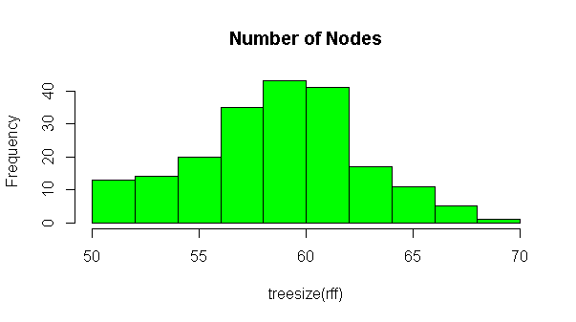 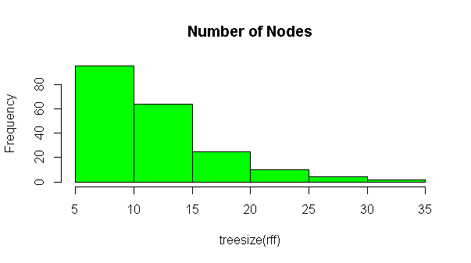

Figure 2. 4: Histogram of Nodes

This histogram describes the number of trees in 6 to 8 trees with 80 nodes whereas there are 4 to 6 trees with 40 nodes and few trees were 14 to 16 nodes there are overall 290 nodes of tree distributed in between 4 to 18 nodes of passed students in 2019 of university student.

The varImpPlot (rff, sort=T, n.var=21, main="Variables Weights ") function plots two plots with explains the overall variable importance for the model are very significant of variables with their contribution percent accuracy so that researcher may deselect the variable in model forming due to very little contributing for model design.

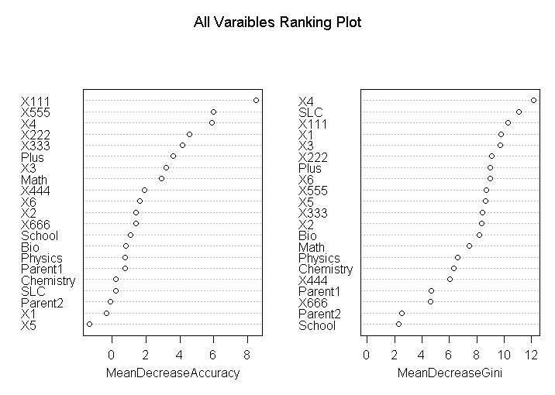

Figure 2. 5: All Variable Ranking Plot

This first plot describes the total accuracy due to the presence of specific variables and the second plot describes its meaning decreases individual percentage of independent variable. This plot output describes similar type results as Boruta algorithm that tentatively rejected the X5, X1, and Parent2 variables are in very low rank has zero significance results. However, the first plot describes its contribution for model wastage. When considering without final GPA of each 6 grade the X4 and Plus2 and X3 variables have the significance with less than 4 percent weightage of a single variable contribution. Therefore, it is concluded that GPA bachelor's grade is based on the final grade of the first subject mathematics has very significant to other grade of plus two results. The grades X111(Math’s) and X555(programming) subjects of final grade have the better role secured best grade in Bachelor. When considering with internal grade, X4 core engineering subject X3 has the greatest role for scoring Bachelor grade. Similarly, the SLC grade has less significant than Plus two grade and the Mathematics score in plus two has highest then other subjects Chemistry, Bio, and Physic scores have low contribution for bachelor’s grade prediction. Similarly, the next plot describes the Gini how pure increased or decreased in tree decreased when removing single associative variables. The X4 internal grade and SLC his significant association for decreasing gini from the model. Whereas school information and parent qualification have no much association for predicting bachelor grade.

Similarly, the importance(rff) model describes its percentage of all associative variables after model designed. The importance(rff) produces the table with the percentage that could describe and chosen the associative variables respectively as shown below.

A A- B B- B+ C C+ MeanDecreaseAccuracy MeanDecreaseGini

SLC -0.222953 1.045989 -0.85129 0.751304 -0.72162 0 0.0000 0.18854 11.0624

School -0.317582 1.803325 2.08448 0.308938 -1.02065 0 0.0000 1.07695 2.3114

Plus -0.351939 4.043537 -0.82929 1.345535 1.02309 0 -1.0025 3.61981 00269

Physics 0.796682 0.889672 1.56792 -0.770135 -1.33302 0 1.0025 0.77283 6.6280

X555 8.907967 1.248824 0.18731 0.23283 1.37419 0 1.0025 5.96817 8.6822

X666 0.617318 0.283206 -0.19839 2.49528 0.1725 0.0000 1.39306 4.6537

Similarly, the function varUsed(rff) describes more occurrences value of contribution in the model of all variable. The times produced as 709 187 607 534 545 509 598 361 248 715 667 698 722 654 669 643 597 552 452 521 362 indicates the iteration to formed the model. These highest values indicate its highest associativity to model i. e SLC and Plus to variables had highest as compared school information and parent qualification to predict of higher education scoring good grade. The partial dependency plot describes the marginal effect of each category of special class could be easily plotted using partialPlot (rff, train, SLC,"A") partialPlot (rff, train, SLC,"B") partialPlot (rff, train, SLC,"C") predicts the probability value when individual input varaibles. The first plot implies that it is more chance when SLC score is 75 he/she could score grade A in Bachelor of engineering final grade. Likewise, when SLC grade is below 80 could score B in bachelor degree similarly when SLC grade is in-between 60 to 75 he or she could score C grade in bachelor degree prediction. This model plots the output prediction to all 22-independent variable for analysis individual variable.

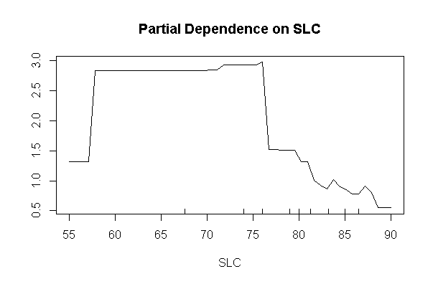 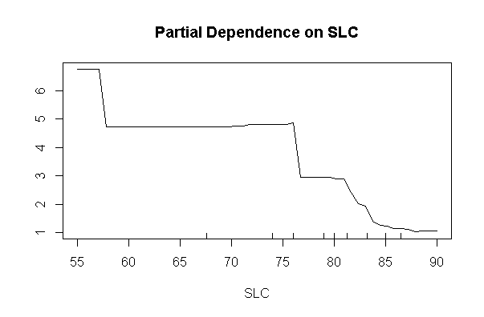 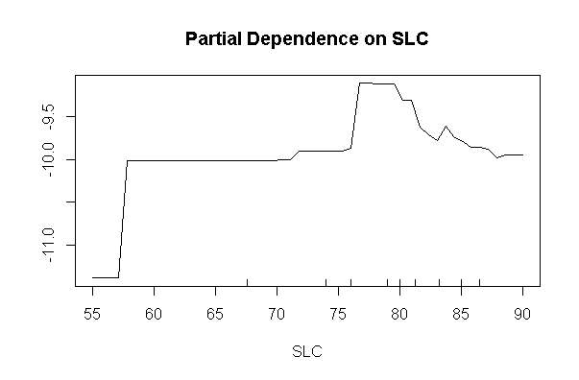

Figure 2. 6: Partial Dependency Plot

Similarly, the highest important variable of final grade of mathematics subject has different partial plots to indicates bachelor grade as partialPlot (rff, train, X111,"A") partialPlot (rff, train, X111,"A-") could plots to scored bachelor grade.

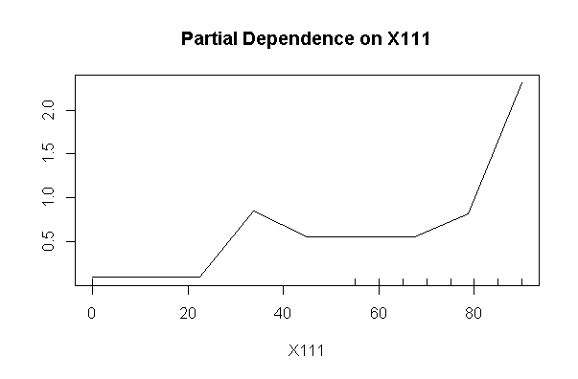 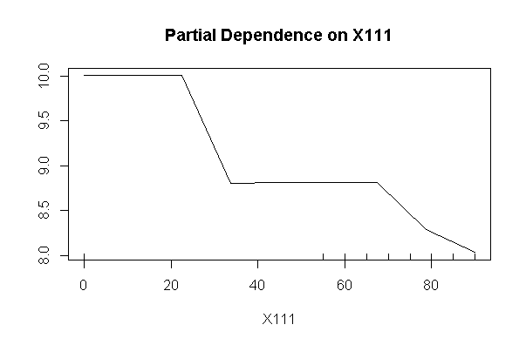

Figure 2. 7: Partial Dependency Plot

These two plots describe the role of mathematics marks to final grade scored have greater than 80 percent chance to scored in grade A in bachelor final result whereas when the same value to predict A- might less probability of scoring another A- bachelor grade.

Similarly, the random forest terminal node could be visualized using as getTree(rff,1,labelVar= TRUE) function. The first tree started at -1 status indicates terminal node whose left daughter and right daughter were absent and then increase sequentially of each node side as shown below table to all dependent categorical grades.

left daughter right daughter split var split point status prediction

1 2 3 GPA 3.710 1 <NA>

2 4 5 GPA 3.305 1 <NA>

3 0 0 <NA> 0.000 -1 A

4 6 7 GPA 3.005 1 <NA>

5 0 0 <NA> 0.000 -1 A-

11 0 0 <NA> 0.000 -1 B

14 0 0 <NA> 0.000 -1 C+

15 0 0 <NA> 0.000 -1 B-

The random forest clearly describes their left and right nodes of GP. The first top node started with -1 then their position indicates then after child respective of all 580 sample.

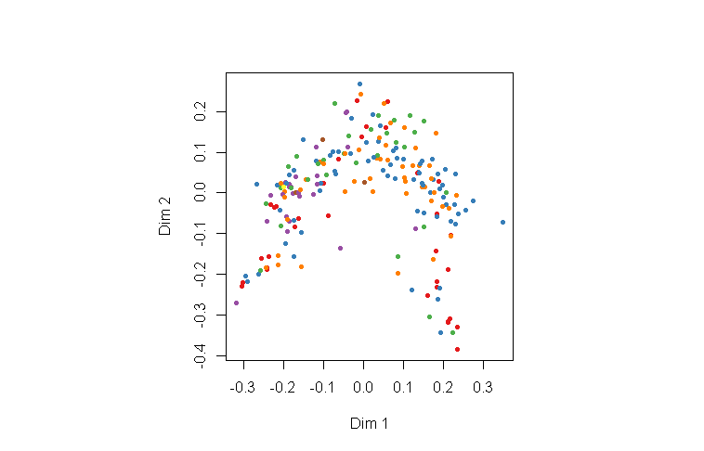

Figure 2. 8: MDS Plot of All GPA

Similarly, the MDSplot (rff, train$GPAAA) plot describes the whole values in plot with differ colors of differed scatter plots of GPA grade of all students. A good way data visualization of different categorical dependent variable.

## **Before Examination Grade Prediction**

As we know that the new examination is the common efforts of previous grade and course taken before a holistic grade of student. This means the internal and previous related academic achievement may either play a positive role in the upcoming grade. This study eagerly tries to find out the association of SLC grade, Plus2 grade, either school from private or government, their major score grade of plus two like physics, bio, chemistry, and mathematics association with internal score grade score of their six ongoing subjects. Therefore, the new random forest model tries to predict with categorical variables. While doing so the sub-setting the database those who were passed results in the final examination. Then its training and test splits were designed for before model execution. The label command of dependent variables with (“A” “A-" "B” “B-" "B+" "C” “C+"). The first model final=randomForest (GPAAA~., data=train) produces the accurate prediction. After loading the caret package, the training prediction predicts the accuracy of 97 percent on training data sets with significant and 98 percent confidence interval. Reference

Prediction A A- B B- B+ C C+

A 37 0 0 0 0 0 0

A- 0 62 0 0 0 0 0

B 0 0 23 0 0 0 0

B- 0 0 0 23 0 0 0

B+ 0 0 0 0 50 0 0

C 0 0 0 0 0 2 0

C+ 0 0 0 0 0 0 2

Similarly, the test data confusion matrix produces a similar 96 percent accuracy with a 90 to 99 percent confident interval. However, the grade C prediction with some minimum mismatched C grade prediction. The tune function predicts at 10 mtry and total trees taken at 400 trees. Similarly, the histogram and tree size indicate there were 55 trees of 80 nodes maximum and minimum fitted trees in each predicator variables of before examination to predict GPA. The variimpplot describes all variables associated to form the before examination variables model. 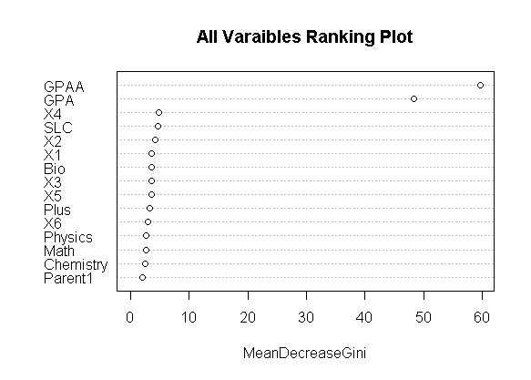

Figure 2. 9: Mean Decrease Gini

The importance model describes in its percentage of increase probability however this model needs to exclude with GPAA and GPA variable for final prediction to get accurate exactly matched with var used model. Similarly, the partial plot describes each prediction to achieve prescribed final model of bachelor’s degree.

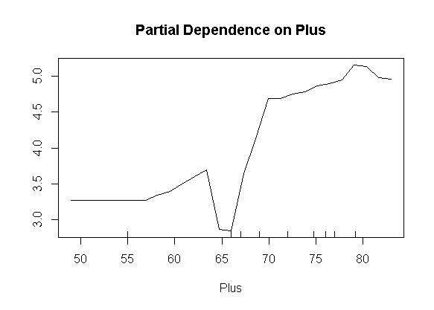 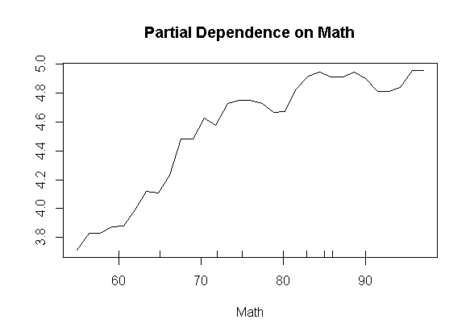

Figure 2. 10: Partial Dependency Plots

From the first partial dependency plot has positive association to predict grade A in bachelor of engineering degree and Plus to mathematics has more potential to predict grade with A grade and so on. Similarly, the get tree function describes the root and left and right daughter of each node of GPA. However, the final model after removing the unimportant columns using randomForest (GPAAA~SLC+School+Plus+Physics+Math+Chemistry+Bio+Parent1+Parent2+X1+X2+X3+X4+X5+X6, data=train, ntree=500, mtry=4, importance=TRUE, proximity=TRUE). Its confusion matrix of training sets with 98 percent accuracy significant however the test accuracy has not significant with accuracy is 26 percent. Whose mtry become 10 with 80 nodes tree with in top level of 80.

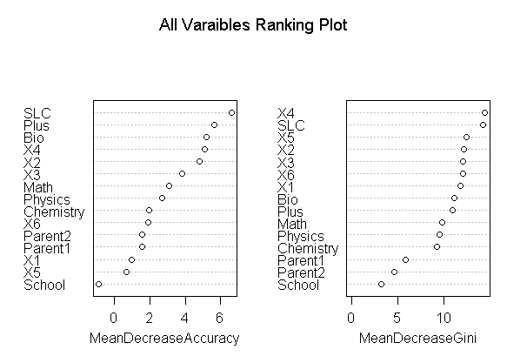

Figure 2. 11: Mean Accuracy and Gini Decrease Plot

The varimpplot describes the highest to lowest association to formed the final model with percentage of decreasing accuracy when eliminate each predator variable to the model. Therefore, it is concluded that the internal grade of SLC, plus two, Bio X4, X3, Math has significant contribution to formed final model. Whereas student from private school and government has the least role to predict bachelor grade in backward prediction. Thus, the student school and parent2 education could be remove for better prediction in second run. Similarly, the partial plot of six internal grade plots describes each internal mark and their potential prediction to final student greed as.

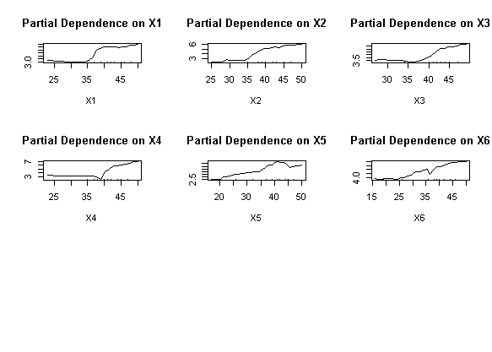

Figure 2. 12: Partial Plot of Internal Marks

The first partial plots predict with scored A grade in final grade has positive association when internal marks are greater than 35. Similarly, the column of X5 internal marks could score A grade when internal marks with 40 has accurately predict with bachelor grade.

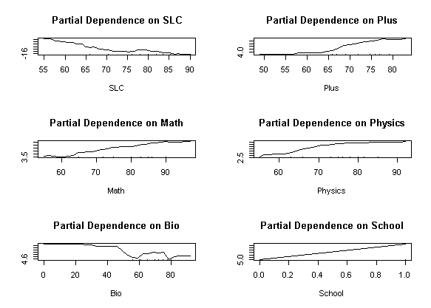

Figure 2. 13: Partial Plot of Previous Grade

Similarly, the SLC grade to predict bachelor A has -ve association whereas plus two, Math, Physics, have the most remarkable bachelor grade prediction however the Bio and school of private and government schools have less predictable bachelor grade. Similarly, the MDSplots display all variables used accordance with bachelor grade.

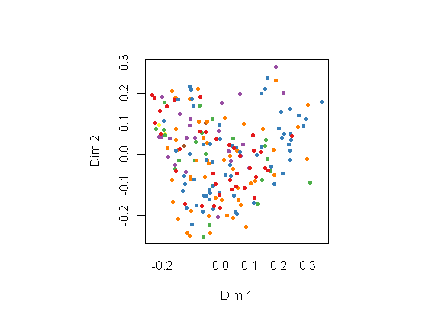

Figure 2. 14: MDS Plot

Similarly, the internal marks with rank ("1" "2" "3" "4" "5" "6" "7") score produces similar output using final=randomForest (GPAA~., data=train) the original model and another final=randomForest (GPAA~SLC+School+Plus+Physics+Math+Chemistry+Bio+Parent1 +Parent2+X1+X2+X3+X4+X5+X6, data=train, ntree=500, mtry=4, importance=TRUE, proximity= TRUE) with correction more than 95 percent accuracy produces significant result. However, the second corrected model produces 98 % percent final accuracy of both test and training data. Similarly, the varimp plots compared with important percentage of each independent variables. The internal marks, plusto grade and SLC, Math have highest predictability than parent education for the bachelor of engineering grade.

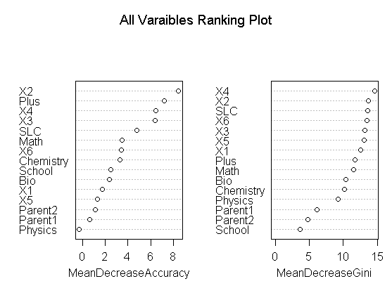

Figure 2. 15: Mean Accuracy and Gini Decrease Plot

This time also model predicts School and physics marks of internal evaluation has least accuracy to contribute where as x2 plus 2 grade has highest contribution to formed the model. The prediction of values

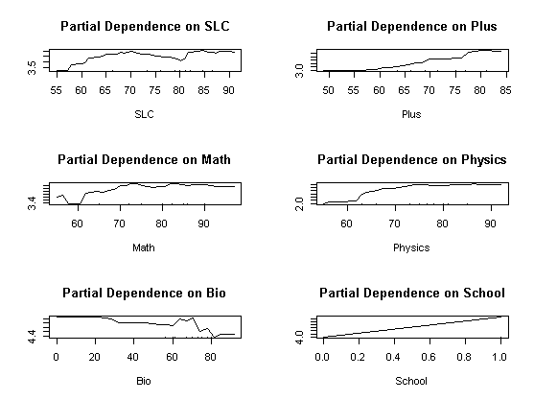 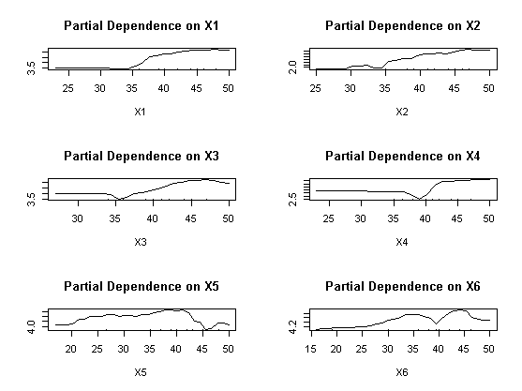

Figure 2. 16: Partial Plot of Internal Grades

From the above partial plot predict the second grade A- bachelor grade has linear association after 60 % percent of SLC, plus2 math and physics marks however bio of internal marks has better A- prediction when scored less than 20 in their high school. Similarly, the mathematics second major subject of internal, has positive association when marks is 40. This map concludes that those whose scored internal in 40 predicts A- grade largely accurate.

## **Plus, two Back Propagation Grade Prediction**

The random forest methodology is used for prediction of student grade here researcher tries to predict old plus to results using random forest with including bachelor intergrade before for model validity as the concept of back propagation methodology. The plus to marks has less category as compared bachelor 10 grade point in Nepal. After converting respective grade marks into grade point using grade if (grade >90 A, if(grade>80, if (grade, A- if(grade>70, B+, if(grade> 60, B, if (grade >50, C+ if(grade>40, C, if(grade>25, D else E. according to higher school center board grading criterial. The plusto grade is the predicator variable has fewer grading points as compared bachelor passed student of university in Nepalese system.

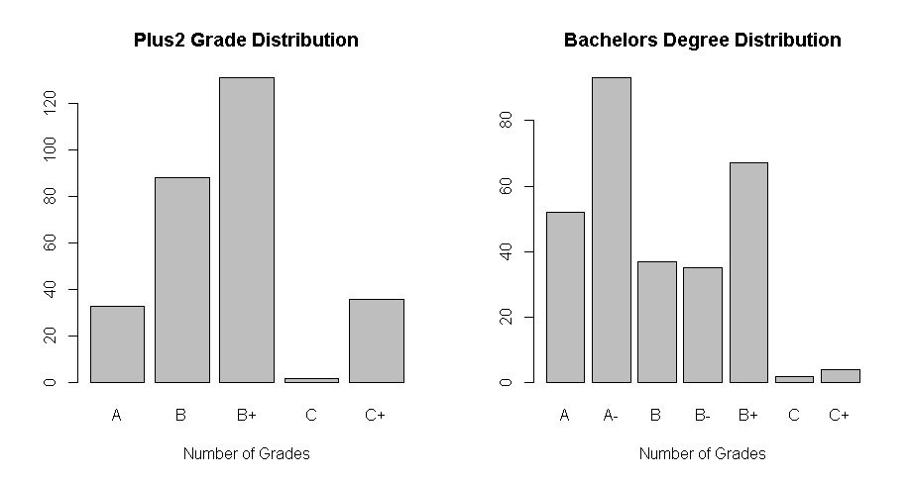

Figure 2. 17: Histogram of Bachelor and Plus two

According to Nepalese plus to grading points letters grading A, B, B+, C, C+ and D+ student could not enrollment in the engineering program. Similarly, the grade points of Bachelor of engineering student have 10 scale grade points like (A, A-, B+, B, B-, C+, C, C-, D+, D- and F grades. However, in our sample there were not score student in their final bachelor students. The backward propagation of internal marks of bachelor degree to predict Plus to is apply for model validation.

A A- B B- B+ C C+

A 3 17 3 4 6 0 0

B 20 23 9 9 24 1 2

B+ 24 46 17 14 29 0 1

C 0 1 0 0 1 0 0

C+ 5 6 8 8 7 1 1

This cross tabulation presents the records of Bachelor final grade and Plus to grade. After sub setting selected columns of those information who scored grade in final examination of plus to and their respective final grade for random forest model with test and training split of 70 30 percent of 290 students. When using final=randomForest (Plantigrades~., data=train) model produces to its 79 to 98 percent accuracy.

Reference

Prediction A B B+ C C+

A 7 0 1 0 0

B 0 14 5 0 0

B+4 6 35 0 2

C 0 0 0 0 0

C+ 1 1 0 0 13

The final plots determine the trees after 200 is constant. Similarly, mtry become 3 for the final model. The histogram is perfectly bell shaped of data.

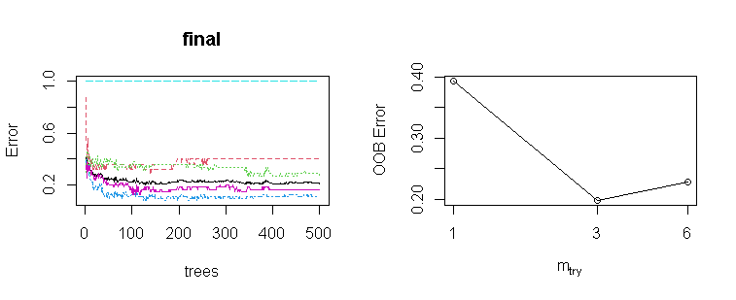

Figure 2. 18: Number of Nodes and Variable Ranking Plot

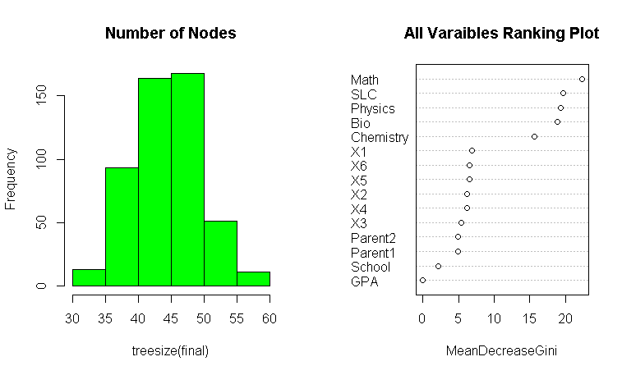

Figure 2. 19: Histogram and Gini Decrease Plot

From the mean decrease Gini plot the Math and SLC, Physics has greatest dominant attributes for prediction to plus to grade where as Parent education, schools and final GPA has not significant important to formed model. Thus, final model final=randomForest (PlustoGrade~SLC+School+Physics+Math+Chemistry+Bio+Parent1+Parent2+X1+X2+X3+X4+X5+X6, data=train, ntree=500, mtry=3, importance=TRUE, proximity=TRUE) with 97 and 77 percent accuracy which suggest mtry with 3 and variable importance plot

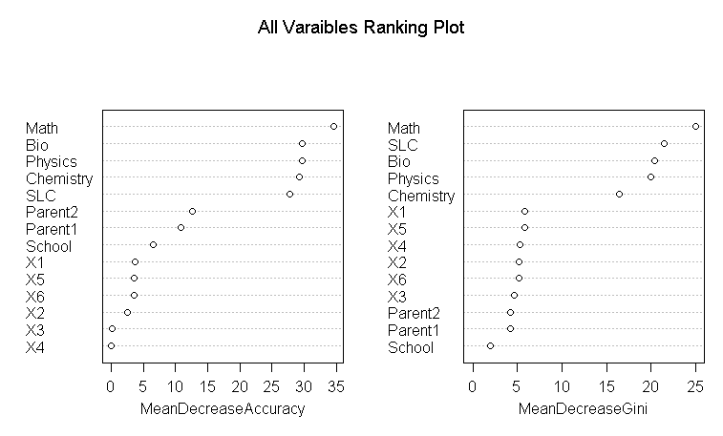

Figure 2. 20: Mean Accuracy and Gini Decrease Plot

This importance plot clearly indicates the bachelor’s internal marks would not have least significant than 5 percent for prediction Plus to grade.

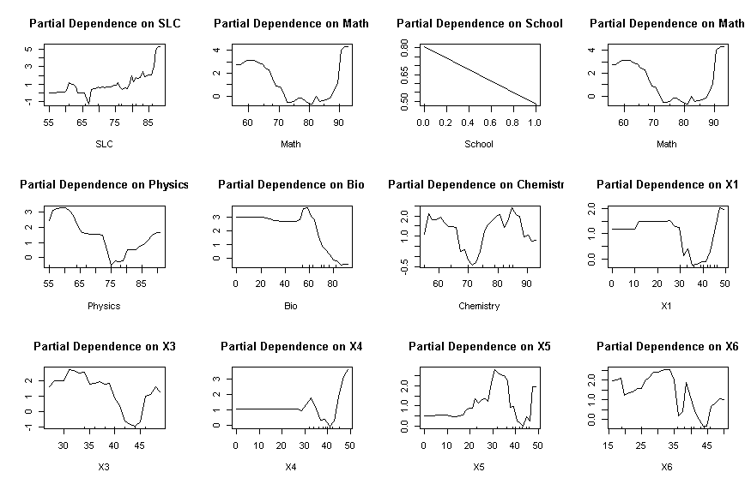

Figure 2. 21: Partial Dependency Plot

This partial plot finally implies that the plus to grades prediction have mixed association. The Math, SLC Physic, Bio and Chemistry scores have mixed perdition to predict plus to various grade prediction using backward traversed. The physics marks of plus to has lowest prediction to A when students scored in 75 percentage in their plus to grade. Similarly, when assumption with bachelor internal marks association to predict plus to grade prediction have unique association with x4 implies that those students who scored more than 40 scored A grade in their plusto grade in backward manner.

# **CHAPTER 3. RESULT and DISCUSSION**

## **Single Layer Neural Network Pass/Fail Prediction**

As we know neural network works in numeric dependent variable, the GPA represents 0 for Fail,1 for A-grade,2 for A- Grade, 3 for B+ grade, and so on having 8 categories respectively. The 22 predictor independent variables predict single GPA. Based on predictor variable type this model used error factor as cross-entropy with the large number of dependent variables which includes high school score plus two marks, school either from private or government, their parent1 and parent2 education of their parents and six internal grades score in their bachelor degree scored are the independent inputs for prediction to final grade GPA.

After loading libraries neural net, tfruns, keras and tensorflow, dplyr packages in r console. The read csv command is used to load data in programming area. The tydeverse package is used to select dependent and independent variables for the purpose of selecting 22 independent variables. Here the explanatory result GPA variables having eight final grades score categorical grade of result. After excluding predicator variable all other independent variables are normalized using universal min max function and whose output is again converted into data frame for analysis purpose to another variable as Sr=not significant. frame (apply (ss [-1, 1:20], 2, function(x) (x - min(x))/(max(x)-min(x)))). After setting seed value for future repeatability, the two samples of training and test are determined using sample of 70 and 30 percent sample partition respectively data as ind=sample (2, nrow (Sr), replace=T, prob=c (.7,.3)) and training=Sr[ind==1,1:20] and test=Sr[ind==2,1:20]. Here twenty-two predicator variables in normalized numerical values. The neural network model is determined with n=neuralnet (pf~ SLC+ Plus+ Physics+ Math+ Chemistry+ Bio+Parent1+ Parent2+ X1+X2+X3+X4+X5+ X6+X111+X222+X333+X444+X555+X666, data=training, hidden=c (1), err.fct="sse”, linear. Output=FALSE) generate conversed GPA output.

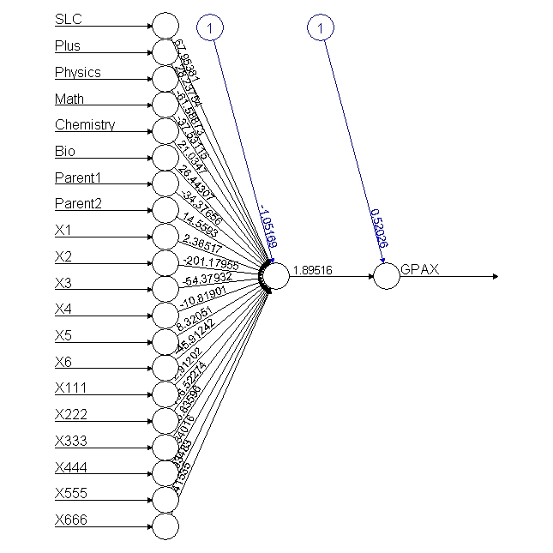 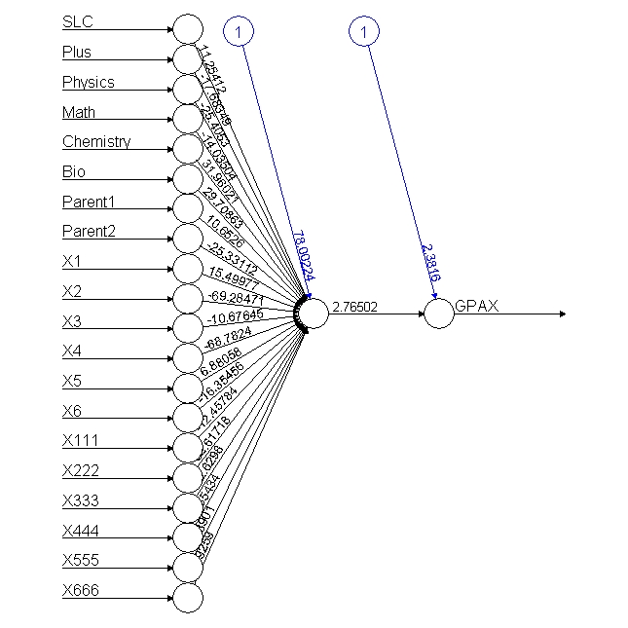

Figure 3. 1: Neural Network Singe Neuron of All Result

This first neural network full model is designed using training data of with single hidden layer and the second is half model used only passed students. Similarly based on categorical predicator variable error factorial is chosen as cross- entropy when linear out become false for accurate prediction. The plot n function prints the network diagram. The names’ function displays all the independent variable name to formed such model. After computing training data with model data usingred1=ifelse (p1>=2.2,1, ifelse (p1>=1.83,2, ifelse (p1>=1.5,3, ifelse(p1>=1.2,4, ifelse(p1> =.80,5, ifelse(p1>=.5,6, ifelse(p1>=0.1,7,0))))))) of all grades for the appropriate grade prediction with consideration with output of following grade points of GPA. The model output of result in histogram is further categorized with respective GPA having eight grade levels.

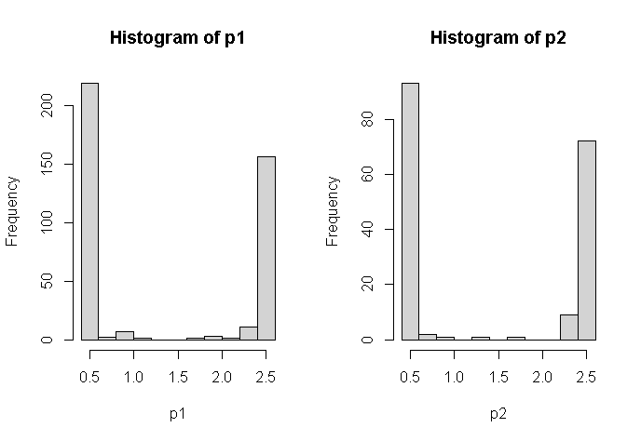

Figure 3. 2: Histogram of Test and Training

While doing so the independent variables like school information are not included according to random forest model suggestion. Thus, there 22 predictor variables predict whether the student has passed or fail grade using a single middle neuron. While conversing to final node its input value and its network weight of every single input using for various input weight which values forward using the sigmoid function to another output layer again calculated input to another 21 neurons for prediction final either student will be passed or fail result. This model exactly used and passed to the signal impulse from various organs of the human body to the brain. The neuralnet: compute (n, training [, -1]) function computes its output using net. result of both values could be compared with excluding predictor variables. The confusion matrix of data generated and predicts the accuracy as.

pred1 0 1 2 3 4 5 6 7

pred2 0 1 2 3 4 5 6

1 28 6 21 11 8 6 1

3 0 0 0 0 1 0 0

4 0 0 1 0 0 0 0

5 1 0 0 0 0 0 0

6 56 6 10 11 5 7 0

1 35 12 41 34 24 16 4 1

2 0 0 2 2 0 0 0 0

3 0 1 0 0 0 0 0 0

5 5 3 0 0 0 0 0 0

6 165 21 21 7 1 6 0 0

The accuracy of the model produces the error function using 1-sum(diag(tab1))/sum(tab1) is 0.91022 of training data sets i.e. (401) and 179 training data sets of same model produces the accuracy after using 1-sum(diag(tab2))/sum(tab2) is 0.8100559 percent implies quite satisfactory results model.

Similarly, the grading 1" "2" "3" "4" "5" "6" "7” of different grades student with half model student only those who has passed grade will have conversed for the neural network. The sub-setting using GPA grade is greater than 0 passed students. The ss=data2 %>% select (GPAX, GPA, SLC, Plus, Physics, Math’s, Chemistry, Bio, Parent1, Parent2, X1, X2, X3, X4, X5, X6, X111, X222, X333, X444, X555, X666) %>% filter (GPA>0) and formed 70 30 split ratios of 290 passed student records after normalization of independent variables the neural model is designed with seven categories of grades scored of respective grade equivalence number grade. After computing, model output with training data of 209 data sets and 81 test datasets produces the output histogram based on the neural network model describes the seven categories of models different seven grades started with highest to lowest.

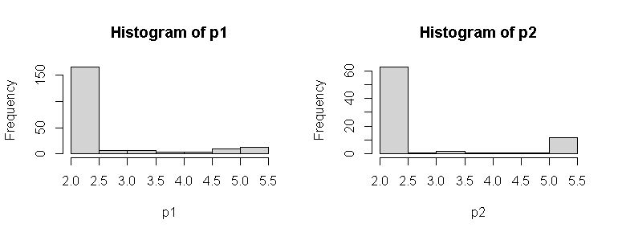

Figure 3. 3: Histogram of Neural Network Model

After calculating the in seven grade scale of model output pred2=ifelse(p2>=4.6,1, ifelse (p2 >=4.8,2, ifelse(p2>=3.8,3, ifelse(p2>=3.4,4, ifelse(p2>=2.9,5, ifelse(p2>=2.5,6,7)))))) condition for model output grades produces the confusion matrix of both sets of training and test sets as.

pred1 1 2 3 4 5 6 7

pred2 1 2 3 4 5 6

1 0 2 3 3 5 0

3 0 2 0 0 0 0

4 0 0 0 1 0 0

5 1 0 0 0 0 0

6 0 1 0 0 0 0

7 12 23 11 9 6 2

1 0 0 1 2 12 3 1

3 0 0 0 4 3 0 0

4 0 0 3 2 0 0 0

5 0 0 4 1 0 0 0

6 0 5 1 1 0 0 0

7 36 63 42 16 9 0 0

The model accuracy using 1-sum(diag(tab1))/sum(tab1) function is calculated 0.9808612 percent accuracy of training data sets of 209 records and the test prediction accuracy formed confusion matrix as using cross diagonal sum of its confusion matrix 1-sum(diag(tab2)) /sum(tab2) is 0.9506173 accuracy respectively indicates the best model with more than 96 percent accuracy in total for student grade prediction.

## **Three Hidden Layers (7,3,2) Neural Network of Original Datasets**

The neural network with original data sets with three hidden layers comprises (7,3,2) in between before predictor variables of GPA prediction with numerical category of eight different grades of student marks of 2019 record. After loading the dataset into r console the preprocessing of data sets with converting as number pattern if all variables of selective datasets. After taking seed values for repeatability the neural network of three hidden layers nn=neuralnet (GPAA~SLC +Plus+Physics+Math+Chemistry+Bio+Parent1+X1+X2+X3+X4+X5+X6, data=data, hidden=c (7,3,2), err.fct="sse", linear. output=FALSE, life sign='full', rep=5, algorithm="prop+", stepmax=10000). Here researcher used default algorithm resilience propagation with five possible repetitions, the error factor is set as the sum of a square and step max is 10000 iteration the correction takes place and default algorithm rprop+ is default activation logistic function displays all the information produces the threshold with steps using cross diagonal among independent variables. The intercept of each independent variables to another indicates as.

threshold 0.00997218 and steps 39.00000000

Intercept.to.1layhid1 0.08576830

SLC.to.1layhid1 2.80337508

Plus.to.1layhid1 -0.31826396

Physics.to.1layhid1 -1.16061096

Math.to.1layhid1 -0.52528117

Chemistry.to.1layhid1 -0.11954057

2layhid3.to.3layhid2 1.022320728

Intercept.to.GPAA 2.888193772

3layhid1.to.GPAA 4.134472504

3layhid2.to.GPAA 3.116428429

The intercept value and the regression coefficient. The plot of neural network as.

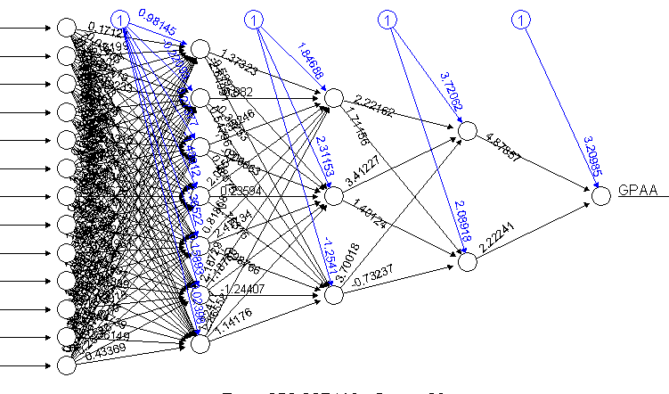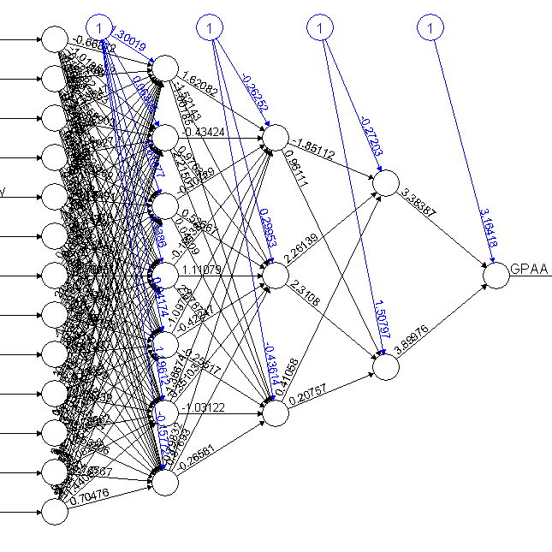

Figure 3. 4: Neural Network Model of (7,3,2) with Original data

After computing the model with selected data, the output of the final GPA is further plotted with the histogram of the eighth-grade display is used for further grading on the output weight of the neural network.

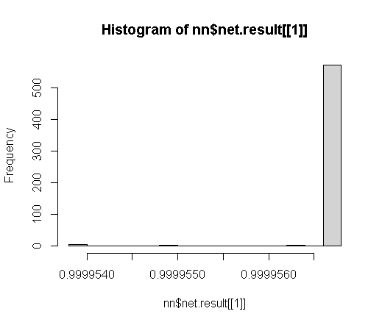

Figure 3. 5: Histogram of Training and Test Data

After histogram the accuracy production using pred1=ifelse (nn$net. result [[1]]>=.9999623,1, ifelse(p3>=.9999620,2, ifelse(p3>=.9999615,3, ifelse(p3>=.9999610,4, ifelse(p3>=.9999605,5,

ifelse(p3>=.9999603,6, ifelse(p3>=.9999600,7,0))))))) is calculated for eight different grade prediction. The table of matrix of confusion display as.

pred1 0 1 2 3 4 5 6 7

2 290 52 93 67 37 35 4 2

The model accuracy using misclassification overall model error is 0.8396552 percentage. The misclassification is again compared original values gives the percent of errors due to random weight initially taken part in model. The GPA values on predictor variables are 1, 3, 2, 3, 2, 0, and 0. The comparison of outputs=cbind (37 35, pred1) is finally predicated with matched and missed matched. Whose output will be further predicated using covariate matrix for testing purpose of outsider data values with 13 matrix data sets as like below.

new. output=neuralnet: compute (nn, covariate = matrix (c (79,0,0,1,1,1,1,1,1,1,1,1,1,

90,1,1,1,1,1,1,1,1,1,1,1,1,

50,1,1,1,1,1,1,1,1,1,0,0,0,

50,0,0,0,0,0,0,0,0,0,0,0,0),

byrow = TRUE, ncol = 13))

Here the intended testing variable use 13 independent variables further predicts output of this model is again evaluated with original data sets to get accurate data sets using covariate function in matrix format, whose output differs implies accurate of model predictions as shown in accuracy in percentage as [1,] 0.9999561 [2,] 0.9999562[3,] 0.9999561 [4,] 0.9999558.

Therefore, the second candidates with having SLC 90 marks and other marks in each data from the above prediction result the highest prediction score as compared with 50 marks in SLC respectively input given to model of prediction.

## **Three Hidden Layers (7,3,2) of Back Propagation**

Back prorogation is the concept of reverse traversing for the purpose of balancing each neuron weight to converse quick requires the learning rate use hypermeter that take larger time to converse quickly. After using the same data result the from the previous model where learning rate and algorithm with backpropagations nn. bp=neuralnet (GPAA~SLC+Plus+Physics +Math+ Chemistry+Bio+Parent1+X1+X2+X3+X4+X5+X6, data=ss, hidden=c (7,3,2), learning rate=0.01, algorithm='backprop' err.fct="sse", linear. output=FALSE). The back prorogation will converse very fast and produced the similar output of each neuron calculation because each iteration of the learning rate in parameters will reduce their respective weight calculation when reverse traversing. This process produces intercept and regression value of each iteration of all input signal.

2layhid2.to.3layhid2 2.310802e+00 2layhid3.to.3layhid2 2.075723e-01

Intercept.to.GPAA 3.164179e+00 3layhid1.to.GPAA 3.383865e+00

3layhid2.to.GPAA 3.899760e+00

The final plot conversed as above however this neural network conversed all others model with increasing hidden numbers but our primary concern is to converse in a single prediction GPA. The histogram of output after neural network conversed to GPA plots the signal output quickly.

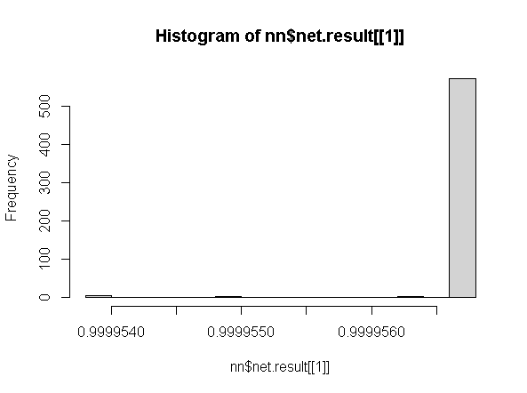

Figure 3. 6: Histogram of Neural Network

The model output from the neuron network is further categorized on histogram with respective eight grades of student score are pred1=ifelse (nn$net. result [[1]]>=.9999566,1, ifelse(p3>=. 9999564,2, ifelse(p3>=.9999562,3, ifelse (p3>=.9999550,4, ifelse (p3> =.9999545,5, ifelse (p3> =.9999542,6, ifelse(p3>=.9999539,7,0))))))) concept of all records and confusion matrix is generated using tab3=table (pred1, ss$GPAA).

pred1 0 1 2 3 4 5 6 7

0 4 0 0 0 0 0 0 0

1 285 50 93 67 37 35 4 2

3 0 1 0 0 0 0 0 0

5 0 1 0 0 0 0 0 0

7 1 0 0 0 0 0 0 0

This process produces the 0.9068966 percent total accuracy using 1-sum(diag(tab3))/sum(tab3) function. Here researcher tries to predicts with model output of other students’ grades based on their pass and fail grade of eight grade variables of new predication based on model. The new. Output=neuralnet: compute (nn. bp, covariate = matrix (c (1,1,1,1,1,1,1,1,1,1,1,1,1,

1,1,1,1,1,1,1,1,1,1,1,1,1,

1,1,1,1,1,1,1,1,1,1,1,1,1,

1,1,6,1,0,0,0,1,1,7,1,1,1),

byrow = TRUE, ncol = 13))

As from this model takes 13 different input signals formed the output after converse in single point model the new. output$net. result with percentage of above input values [,1] [1,] 0.9999185 [2,] 0.9999185[3,] 0.9999185[4,] 0.9999491 percentage accuracy suggest that first three individual has the lowest scored as compared with fourth candidate whose 13 input values are in the range of (0 to 7 grades internal background values respectively. Which produce the accuracy on the basic of input signals ci=t.test (data$GPAA, conf. level=0.90) the lower and upper bound of confidence interval using one sample t-test is data$GPAA t = 19.783, df = 579, p-value < 2.2e-16, and the alternative hypothesis is true mean is not equal to 90 percent confidence interval is 1.264441 and 1.494179 sample estimates mean of x is 1.37931.

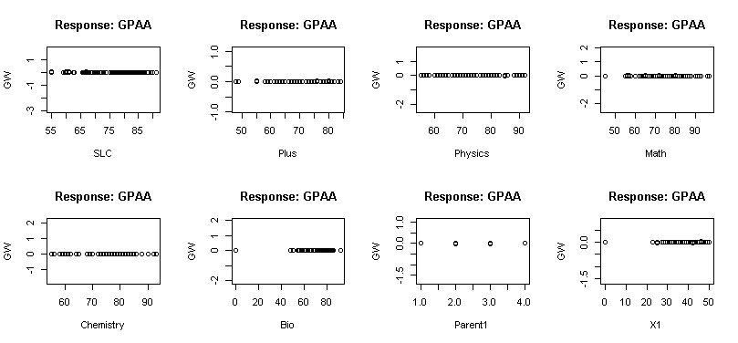 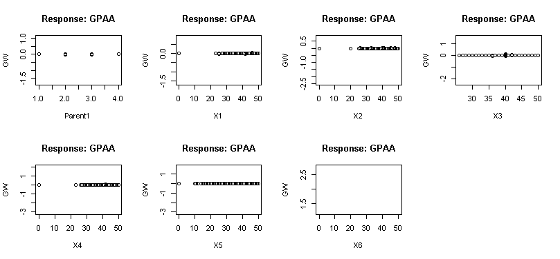

Figure 3. 7: Partial Plots of Input Data

Similarly, the gwplot of selected model plots as follows describes each input variables association to student GPA has normal to the high association of each GPA variable.

## **Four Hidden Layers Neural Network (25,12,6,3)**

After loading data sets of original database the data management before processing is designed to converted into numeric format then model of those student who had passed in grade using four hidden layer neural model( 25,12,6,3) as nn=neuralnet(GPAA~SLC+Plus+Physics+Math+ Chemistry+Bio+Parent1+X1+X2+X3+X4+X5+X6,data=data, hidden=c(25,12,6,3,1), err.fct="sse", linear.output=FALSE, lifesign='full', rep=5, algorithm="rprop+", stepmax=10000) the model produces all the weights and calculation of each weight of intermediator layers neurons of all independent variables as shown below. Which conversed and plots the model.

X4.to.1layhid14 0.639358703 -0.827390874 1.283322720 -1.043906823 1.202692473

X5.to.1layhid14 1.756007988 1.472577250 0.767069483 -1.095895741 0.977462165

X6.to.1layhid14 -0.824373880 0.197512712 1.623300355 0.331505744 1.249461233

Intercept.to.1layhid15 0.010060122 -1.403327848 0.416387618 -1.90072348 -0.074664243.

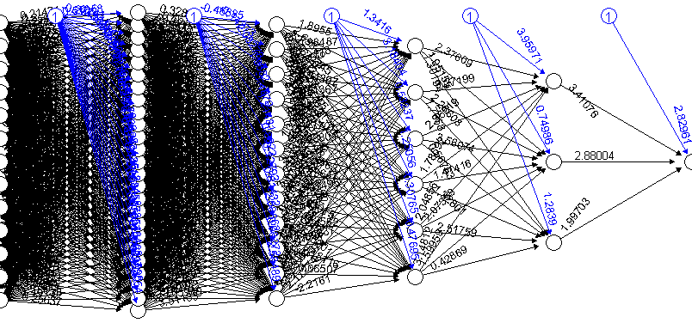

Figure 3. 8: Neural Network of (13, 25,12,6,3,1)

This model converses quickly with five reptation and selects the best model whose reputation is converse in less time with errors for final model design. Then the histogram plot of this output describes as.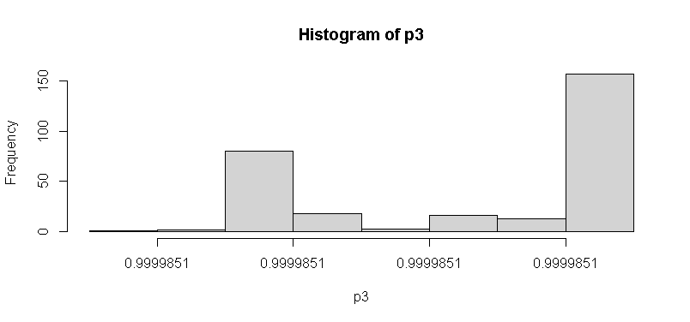

Figure 3. 9: Histogram of Output Neuron

After calculating the predication using pred1=ifelse(p3>=.99998318,1, ifelse(p3>=.99998317,2, ifelse(p3>=.99998316,3, ifelse(p3>=.99998315,4, ifelse(p3>=.99998314,5, ifelse(p3>=.99 998313,6,7)))))). The prediction is further computed with confusion matrix tab3=table (pred1, 37 35) as.

pred1 1 2 3 4 5 6 7

1 52 93 67 37 35 4 2

Whose total accuracy of model is 0.8206897 percent therefore while calculating neuron in between input to output neuron it is always recommended to use the square root of neural output neural network model. So that more accurately output will be taken. Likewise, if we illuminate the variables like school, parent2 and X5 in the model there will be more result accuracy will be achieved.

## **Ordinal Logistic Regression or Proportional Odds Logistic Regression**

The data are the key concept of research prediction whose relation to final predicator variables are always analyze accurately for the better prediction. Therefore, if the variables are in order in terms grades like A is largest than A- and B+ are smaller than previous therefore these orders have extra meaning in terms of their scored in marks with combination of their associative variables of internal score, high school, plus to grades, math, chemistry, physics and bio and so on. The proportional odds logistic regression is applicable only when the predicator variables are in order of either lower to higher or vice versa (Baron, Huang, McEvoy, & Dighe, 2021). After loading the data sets and converting data into data frame and then converting a predicator variable into ordinal data sets the proportional odds logistic regression is applicable. The summary statists display all data minimum, max, 1st quartile, median mean and third quartile summary describes of ordinalGPA variable like 0: 290, 9:92,8:67,10:52,7:37,6:35 and soon 580 samples data. The cross tabulation between ordinalGPA and school information summarize as.

OrdGPA 2 Bachelor Master PHD SLC

0 71 80 40 0 99

4 2 0 0 0 0

5 1 1 0 0 2

6 10 12 5 0 8

7 16 3 2 0 16

8 24 18 13 0 12

9 34 23 11 1 24

10 21 14 8 0 9

GPAa 2 Bachelor Master PHD SLC

A 20 14 6 0 9

A- 35 23 13 1 24

B 16 3 2 0 16

B- 10 12 5 0 8

B+ 24 18 13 0 12

C 2 0 0 0 0

C+ 1 1 0 0 2

F 71 80 40 0 99

OrdGPA Govt Private

0 122 168

4 2 0

5 2 2

6 17 18

7 15 22

8 22 45

9 31 62

10 29 23

These overall summary statics of ordinal variables with high school information and their parent education status might have some association for the prediction of final GPA marks of bachelor grade. After loading tidyverse, migrator variables sub setting predictor variables of SLC, School, Plus, Physics, Math’s, Chemistry, Bio, Parent1, Parent2, X1, X2, X3, X4, X5, X6 into another subset and then the test and training with 80 and 20 percent samples are design of model preparation using MASS package. The full model using the operator and selective model using plus operator is designed. model=polar (OrdGPA~., data=train, Hess=TRUE) model=polr (OrdGPA~SLC+School+Plus+Physics+Math+Chemistry+Bio+Parent1+Parent2+X1+X2+X3+X4+X5+X6, data=train, Hess=TRUE). The predictor variable ordGPA having ordinal grades of student final score use Hess as standard errors of model design. The summary(model) describes one unit increase in the dependent variable will increase/decrease in an independent variable in a log odd scale when all other variables are inconstant. The output of the model describes the coefficient, and intercept with residual deviance and AIC values. The coefficients and intercepts are describing as.

Value Std. Error t value

SLC 0.020529 0.014554 1.4105

Intercepts:

Value Std. Error t value

0|4 9.0478 1.4682 6.1626

4|5 9.0478 1.4682 6.1626

5|6 9.0577 1.4683 6.1688

6|7 9.3345 1.4731 6.3368

7|8 9.6564 1.4792 6.5280

8|9 10.2627 1.4896 6.8897

9|10 11.4894 1.5063 7.6276

Residual Deviance: 1260.503 and AIC: 1304.503

School 0.056678 0.197910 0.2864

Plus 0.003203 0.013182 0.2430

Physics 0.024685 0.017301 1.4268

Math -0.012955 0.012240 -1.0585

Chemistry 0.009139 0.013853 0.6597

Bio -0.002369 0.005495 -0.4311

Parent1 0.149128 0.098467 1.5145

Parent2 -0.090828 0.120487 -0.7538

X1 0.067074 0.018600 3.6061

X2 0.050706 0.021107 2.4024

X3 -0.039066 0.024471 -1.5964

X4 0.058177 0.023314 2.4954

X5 0.014151 0.016951 0.8348

X6 -0.008342 0.014282 -0.5841

From the above output the p value of each variable is again calculated using (ctable=coef(summary(model))) and p=pnorm (abs (ctable [,"t value"]), lower. tail = FALSE) *2 and (ctable=cbind (ctable,"p value"=p)) who’s each variable is again compared with 0.05 for significance test explains each background variable association with standard error terms.

Value Std. Error t value p value

SLC 0.020528719 0.014553911 1.4105294 1.583834e-01

School 0.056677781 0.197909914 0.2863817 7.745858e-01

Plus 0.003203216 0.013181634 0.2430060 8.080008e-01

Physics 0.024685037 0.017301130 1.4267875 1.536412e-01

Math -0.012955390 0.012239605 -1.0584811 2.898362e-01

Chemistry 0.009138730 0.013852838 0.6597009 5.094458e-01

Bio -0.002368935 0.005495364 -0.4310787 6.664111e-01

Parent1 0.149127893 0.098466556 1.5145030 1.298983e-01

Parent2 -0.090828348 0.120486750 -0.7538451 4.509422e-01

X1 0.067073516 0.018599829 3.6061362 3.107901e-04

X2 0.050706475 0.021106955 2.4023586 1.628973e-02

X3 -0.039066173 0.024470654 -1.5964499 1.103884e-01

X4 0.058177296 0.023313624 2.4954205 1.258079e-02

X5 0.014151399 0.016950885 0.8348472 4.038037e-01

X6 -0.008341808 0.014281548 -0.5840969 5.591551e-01

0|4 9.047753683 1.468163930 6.1626318 7.154575e-10

4|5 9.047757009 1.468163930 6.1626340 7.154472e-10

5|6 9.057736518 1.468306361 6.1688329 6.879590e-10

6|7 9.334492486 1.473052290 6.3368372 2.345296e-10

7|8 9.656363560 1.479228342 6.5279736 6.666544e-11

8|9 10.262706381 1.489572042 6.8897013 5.590967e-12

9|10 11.489382060 1.506293652 7.6275845 2.391931e-14

From the above output the school variable with government or private, the plusto aggregate percentage, second parent highest education and X6 internal variables were not significant for developing final model. Therefore, final model won’t include them because whose final values are not significant to ordinal model. The predict command predict the value with probability of 14th independent variables. Thus, the final module of these variables with eliminating unnecessary variables whose p value is not significant using model=polr (OrdGPA~. -Plus-Physics-Bio-Parent2-Chemistry-School-X3-Math-X5, data=train, Hess=TRUE) who’s normalized ctable as.

Value Std. Error t value p value

SLC 0.022995728 0.011265819 2.041194 4.123150e-02

Parent1 0.163611625 0.089496105 1.828142 6.752818e-02

X1 0.057404570 0.017348910 3.308829 9.368719e-04

X2 0.047307092 0.021325452 2.218339 2.653170e-02

X4 0.052032441 0.021533652 2.416331 1.567778e-02

X6 -0.002694399 0.009609504 -0.280389 7.791791e-01

0|4 8.394628668 1.320600710 6.356674 2.061684e-10

4|5 8.394742982 1.320600685 6.356761 2.060521e-10

5|6 8.405051412 1.320749172 6.363851 1.967566e-10

6|7 8.675835010 1.325513644 6.545263 5.939089e-11

7|8 8.992684122 1.332009421 6.751217 1.466105e-11

8|9 9.591942781 1.342928613 7.142556 9.161119e-13

9|10 10.802988102 1.359551302 7.945995 1.926379e-15

To make accurate prediction with neglecting those variables whose p value is greater than 0.05 percent for rejection hypothesis. The confusion matrix of training and test data with accuracy indicates there is large potentiality of model design to get accuracy. The pred=predict (model, train) and (tab=table (pred, train $ OrdGPA)) describes the confusion matrix as.

pred 0 4 5 6 7 8 9 10

pred1 0 4 5 6 7 8 9 10

0 56 2 3 7 7 15 22 7

4 0 0 0 0 0 0 0 0

5 0 0 0 0 0 0 0 0

6 0 0 0 0 0 0 0 0

7 0 0 0 0 0 0 0 0

8 0 0 0 0 0 0 0 0

9 0 0 0 1 0 1 2 2

10 0 0 0 0 0 0 0 0

0 230 0 1 27 29 49 63 36

4 0 0 0 0 0 0 0 0

5 0 0 0 0 0 0 0 0

6 0 0 0 0 0 0 0 0

7 0 0 0 0 0 0 0 0

8 0 0 0 0 0 0 0 0

9 4 0 0 0 1 2 6 7

10 0 0 0 0 0 0 0 0

Similarly, the accuracy is calculated using 1-sum (diag (tab))/sum(tab) function produced 0.4813187 test accuracy and pred1=predict (model, test) and tab2=table (pred1, test$OrdGPA) and 1-sum (diag (tab2))/sum(tab2) is 0.536 percent of test accuracy respectively. Similarly, the ordinal variable based on student GPA marks could be calculated and changed into ordinal variable developed for generate xtable of ordinalGPA sample. From output based on final output at neural network the different grades are further calculated as data$GPAA<-ifelse(data$GPAA >=3.7,10, ifelse(data$GPAA>=3.3,9, ifelse(data$GPAA>=3,8, ifelse(data$GPAA>=2.7,7, ifelse (data$ GPA>=2.3,6, ifelse(data$GPAA>=2.2,5, ifelse(data$GPAA>=1.7,4, ifelse(data$GPAA >=1.3,3, ifelse(data$GPAA>=1,2, ifelse(data$GPAA>=0,1)))))))))) and data$GPAA=data$GPAA(data$GPAA) and tabs(~GPAOr+Prog, data) to get accurate prediction of student data summary.

|  |  |  |  |  |  |  |  |  |  |  |  |  |  |  |
| --- | --- | --- | --- | --- | --- | --- | --- | --- | --- | --- | --- | --- | --- | --- |
| GPAOR | Civil I | Civil III | Civil V | Civil  VII | Civil  VIII | Comp | Elex  III | Elex  V | Elex  VII | Elex  VIII | Elex I | Rural | Soft | Total |
| (F)1 | 24 | 20 | 46 | 40 | 77 | 17 | 13 | 6 | 8 | 12 | 12 | 6 | 9 | 290 |
| (C)4 | 0 | 0 | 0 | 0 | 0 | 1 | 0 | 0 | 0 | 1 | 1 | 0 | 0 | 3 |
| (C+)5 | 0 | 0 | 0 | 2 | 1 | 0 | 0 | 0 | 0 | 0 | 0 | 0 | 1 | 4 |
| (B)6 | 4 | 2 | 2 | 6 | 4 | 4 | 2 | 1 | 2 | 3 | 3 | 0 | 3 | 36 |
| (B-)7 | 0 | 3 | 3 | 9 | 13 | 5 | 0 | 0 | 0 | 1 | 1 | 2 | 2 | 39 |
| (B+)8 | 8 | 4 | 10 | 16 | 19 | 3 | 2 | 2 | 2 | 3 | 3 | 0 | 0 | 72 |
| (A-)9 | 9 | 9 | 13 | 9 | 24 | 3 | 1 | 1 | 3 | 3 | 3 | 4 | 2 | 84 |
| (A)10 | 3 | 2 | 18 | 4 | 16 | 1 | 2 | 2 | 1 | 1 | 1 | 0 | 1 | 52 |
| Total | 48 | 40 | 92 | 86 | 154 | 34 | 20 | 12 | 16 | 24 | 24 | 12 | 18 | 580 |

Table 5: Programs GPA Summary Table

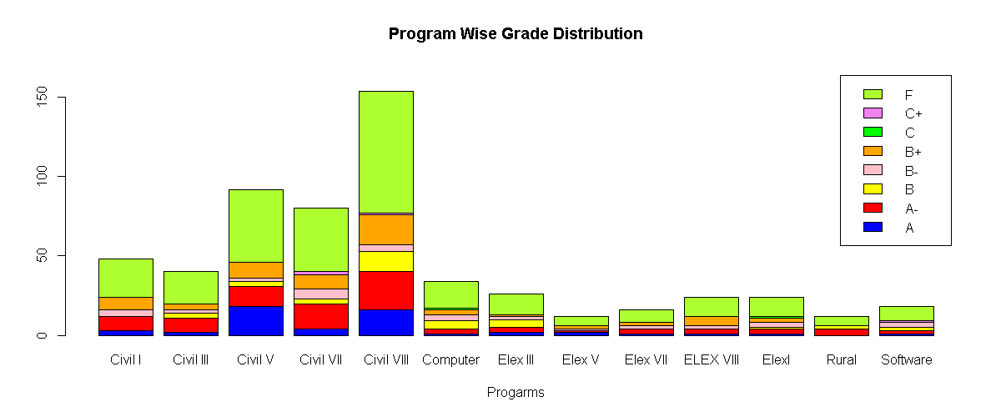

Figure 3. 10: Program wise Grading

From above table and bar diagram the out of 290 passed student there were 52 (A),84(A-), 72 (B+) ,39(B)36(B-),4(C),3(C-) student scored. The civil VIII had highest (28) percentage of Grade A- and lowest in electrical III, V and VII. However Civil and Rural had highest grading (A-) is 33.3 percentage and Civil III had (A-) 22.3 percentage and Civil II, Civil VII and Electrical VII (18.6) percentage.

## **Multi-collinearity Test**

The multiple regression assumes that the two and more X independent variable in regression model are independent of each other contains a unique piece of information to predict Y dependent variables. The Y=B0+B1X1+B2X2…. +€ equation model the multiple regression each independent variable should independent to each other itself (Djaharuddin, 2021). Thus, X1 and X2 should be independent without any correlation among and between for the prediction any Y intercept. For example, when predicting salary, the age and year of experience information should linear association to the salary prediction. Thus, B1 is the change in Y for 1 unit change in X1 when X2 remain constant. Similarly, there were all other multiple associations constant while predicting one unit of change in the independent variable. In many cases, the age and income variable variables neither become constant for the prediction of Y variable in the regression model. When a regression model there is moderate to high intercorrelation among independent variables of X1, X2 and so on this issue is generally known as multi-collinearity. The multicollinearity assumption that two independent variables contain the same essential information to a large extent, one gains little by using both in the regression model. Thus, multicollinearity leads to unstable estimates tends to increase the variances of regression coefficients. The variance of regression coefficient estimators is inflated largely. The B1 may be different from expect in the model. The signs of B1 may be opposite thus sometimes removing data points causes a large change in values and its signs. Similarly, sometimes F statists and t- values may not be matched significantly in model output. Therefore, it is always necessary to access the presence of multicollinearity of independent variables analysis required. Therefore, calculation of correlation coefficient (r) for each pair of X independent variables. The r values are significantly different from zero then independent variables may be collinear. The formula R=covariance (Xi, Xj)/σiσj calculates collinearity. Although the r for any two X variables may be too small their independent variables X1, X2, and X3 may be highly correlated in the model. The VIF is a more rigorous check for collinearity correlation coefficient is calculated using VIF+1/(1-R2) formula. While doing so the individual variable regression is calculated to get R2. The variance inflation factor (VIF) in general thumbs rules with not more than 10 indicate there is no the presence of multicollinearity in the independent variables of the model (Farooq & Saeed, 2021). If the variables with multicollinearity one way are to keep only one of the two independent variables that are highly correlated in the regression model. The standard errors of independent variables may not be matched with each other when checking the bivariate correlation coefficient so how much is high is the question of though thus if the correlation is greater than 0.95 leads the collinearity is another way of detecting. After loading the data, the one dependent and 15 independent variables are sub setting using tidyverse function. Whose correlation is calculated using cor function whose correlation value is a display using round(cor(ss),2) as.

GPA SLC School Plus Physics Math Chem Bio Parent1 Parent2 X1 X2 X3 X4 X5X6

1.00 0.14 0.01 0.12 0.14 0.08 0.12 0.03 0.04 0.03 0.20 0.21 0.12 0.23 0.10 0.02

0.14 1.00 0.27 0.50 0.38 0.37 0.25 0.14 0.12 0.19 0.03 0.09 0.13 0.10 0.02 0.03

0.10 0.02 -0.04 0.02 0.09 0.09 -0.06 -0.11 0.00 -0.05 0.20 0.19 0.35 0.30 1.00 0.71

0.02 0.03 -0.07 -0.03 -0.02 0.00 -0.07 -0.11 -0.05 -0.04 0.06 0.10 0.18 0.20 0.71 1.00

This correlation of variables signifies there is not much difference in corelated values among 15 independent variables therefore the linear model applies on final grade numerical values to FinalPA ~ SLC + Plus + Physics + Math + Chemistry + Bio + Math + Parent1 + Parent2 + X1 + X2 + X3 + X4 + X5 + X6, data = ss) produces residual and intercept as below.

Min 1Q Median 3Q Max

-64.474 -34.745 8.715 33.728 72.414

Values with their respective Coefficients:

Estimate Std. Error t value Pr(>|t|)

(Intercept) -104.22465 22.16565 -4.702 3.24e-06 ***

SLC 0.46512 0.22876 2.033 0.04250 *

Plus 0.04134 0.22112 0.187 0.85175

Physics 0.26832 0.28059 0.956 0.33935

Math -0.18769 0.20337 -0.923 0.35647

Chemistry 0.32322 0.22915 1.410 0.15894

Bio -0.04472 0.09342 -0.479 0.63237

Parent1 0.69456 1.67185 0.415 0.67798

Parent2 -0.23163 1.98707 -0.117 0.90724

X1 0.87150 0.28782 3.028 0.00257 **

X2 0.58289 0.30740 1.896 0.05844.

X3 -0.60727 0.39487 -1.538 0.12463

X4 0.93101 0.37566 2.478 0.01349 *

X5 0.36949 0.28539 1.295 0.19596

X6 -0.24992 0.23806 -1.050 0.29425 ---

The residual standard error is 36.91 on 565 degrees of freedom. The multiple r-squared is 0.1021, and adjusted r-squared is 0.07981 with f-statistic is 4.587 on 14 and 565 DF, p-value is 6.492e-08. The final p values are quite significant only to SLC, X1, X4 internal marks. However, the model p value is not significant. Therefore, the variance inflection vif(model) of the model on SLC Plus Physics Math Chemistry Bio Parent1 Parent2 X1 X2 X3 X4 are 1.540453 1.524346 2.809905 2.093299 2.022705 1.254601 1.244688 1.310918 1.348831 1.522906 1.648026 1.764832 2.504748 2.185253 respectively indicates less than 5. Thus mean (if (model)) is 1.769679 indicates the values less than 5 not more than 10 become implies these data don’t have multi-collinearity among associative variables. Similarly, the plot(ss) plots diagonal correlation matrix of all independent variables implies some variables are in correlation some are not at all.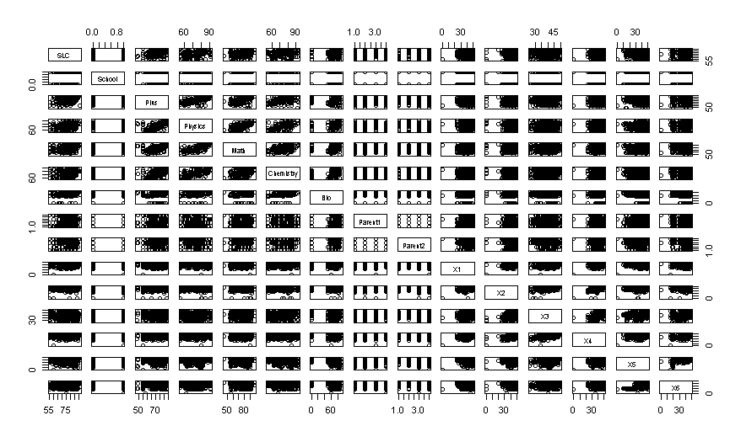

Figure 3 11: Confusion Matrix of 13 Independent Variables

Similarly, the eigen (cor (ss [,6:16])) $value directly calculated the correlation of all independent variable are as 2.7043769 1.9770766 1.4158018 1.2027486 0.8109725 0.6480796 0.5606741 0.5197171 0.4935227 0.4194192 0.2476109 also plots the similar result of no variable having more than 50 percent correlation to one another variables. Similarly, the thumb of rules max(eigen(cor(ss)) $values)/min(eigen(cor(ss)) $values) is 15.44382 is less than 100 so there is not multicollinearity in the data variables. This type of output further conformed validate using kappa(cor(ss), exact=TRUE) produces the same result 15.44382 test.

## **Hypothesis Testing**

Hypothesis testing is an essential procedure in statistics. A hypothesis test evaluates two mutually exclusive statements about a population to determine which statement is best supported by the sample data (Anusiewicz & Patrician, 2021). This finding is statistically significant based on a hypothesis test. The variables used in association with other variables are concerning their significance or not. The null hypothesis and alternative hypothesis are statements regarding the differences or effects that occur in the population. A test of significance is a formal procedure for comparing observed data with a claim of the truth of which is being assessed.

After loading the dataset, the final GPA with respective marks and GPA with eight-level categorical numerical values which had passed grade were analyzed. The t-test with average grade between internal with final grade further tested. The t.test (ss$Int, ss$FinalGPA, alternative ='two. sided’, mu=0) with two-sided tested. Which produces the output Welch two-sample t-test data as ss$Int and ss$FinalGPA t = 9.1437, df = 484.33, p-value < 2.2e-16. And the alternative hypothesis is a true difference in means is not equal to 0. 95 percent confidence interval is 5.479536 8.479085 and sample estimates is mean of x to mean of y 83.25517 of internal marks mean and 76.27586 is final marks mean implies internal marks is 7 marks higher than final marks scored of SOE student. The p-value is significant than the reject null hypothesis is that internal and final marks are large differences between when two side tests. After making factorial variables of the different program of 13 currently running Pokhara University the one-way ANOVA test in various groups data the ANOVA is analysis in group data.

Using ano=aov(sss$FinalGPA~sss$Prog) and summary(ano) produces the result as.

Df Sum Sq Mean Sq F value Pr(>F)

sss$Prog 12 1547 128.92 2.944 0.000715 ***

Residuals 277 12131 43.79

The final GPA marks of13 programs of the school of engineering apply in one-way ANOVA test indicates there is significance when comparing its p values conclude that there is no random chance to become such association between internal and final grade therefore further analysis is taken as Tukey test. Tukey multiple comparisons test of each means within 13 programs 95% family-wise confidence level produces the output with lower and upper range.

diff lwr upr p adj

Civil III-Civil I 0.04166667 -6.654460 6.7377932 1.0000000

Civil V-Civil I 3.32427536 -2.244791 8.8933420 0.7354310

Civil VII-Civil I -1.08333333 -6.793809 4.6271425 0.9999891

Civil VIII-Civil I 0.74945887 -4.420983 5.9199004 0.9999995

Computer-Civil I -4.98774510 -11.998742 2.0232518 0.4630066

Elex III-Civil I -2.22756410 -9.843819 5.3886912 0.9989535

Software-ELEX VIII -4.30555556 -14.058050 5.4469386 0.9603802

Rural-Elex 4.16666667 -6.891622 15.2249556 0.9890248

Software-Elex -1.38888889 -11.141383 8.3636053 0.9999996

Software-Rural -5.55555556 -17.212016 6.1009045 0.9309362

Therefore, final p adjusted values indicate each program wise association of p values have not found significant indicates these variables among various groups have association but not significant with comparing p value with <0.05 confidence.

## **Multi-nominal Logistic Regression**

The multi-nominal logistic regression is applying when a predicative variable is in numeric with dependent more than one categorical target variables has not the order of grade and parent education status may play significant role (Davidson, 2014). For example, the color, red, blue, yellow is the category of three income high, middle and low in order but not specific order. The multinomial or multi probit model was suitable but the assumption behind is the error terms were being equal distribution in all terms of values are being tested value. The multinomial logistic regression is used to predict categorical placement in or the probability of category membership on a dependent variable based on multiple independent variables. The independent variables can be either dichotomous (i.e., binary) or continuous format.

After loading data probity <- read.csv ("D:/dataanalysisfinal/SOE/rcode/Dataanalysiscsv.csv", stringsAsFactors = TRUE) command loads database into r console. The str command display structure of the database. After using tidyverse package for sub setting of data those whose data type in numeric selects using select command. After converting data into a data frame, the predictor variable GPA is converted into a numeric ordinal factor of 0,1,2,3,4,5,6 and 7 (eight levels grades). After using seed value, the sample of 70, 30 percent split of training and test (410,170) respectively. To run multinominal regression the predictor variable needs, relevel based with fail 0 levels. After loading nnet package the multinomial regression with training data set is executes as mymodel = multinom (GPAA ~ SLC + Physics + School + Plus + Physics + Math + Chemistry + Bio + Parent1 + Parent2 + X1 + X2 + X3 + X4 + X5 + X6, data = training). The model weights are 136 (112 variables) with initial value 852.571032, iter 10 value 635.228852, iter 20 value 623.903040, iter 30 value 617.383953 iter 40 value 601.397270, iter 50 value 574.168467, iter 60 value 560.407016, iter 70 value 554.530189, iter 80 value 543.392866, iter 90 value 533.969108, iter 100 value 520.413656. and the final value 520.413656, stopped after 100 iterations. This indicates initially the model has 852 accuracy when it reached 100 iteration it converses and minimized 520 accuracy in model development.

The summary model describes the coefficients and standard errors as.

(Intercept) SLC Physics School Plus Math Chemistry Bio Parent1

1 -10.9127982 0.029127015 -0.07860349 -0.9305316 0.01720708 0.03500580 0.044396725 -0.004091035 0.71126846 2 -10.7562741 0.021874206 0.04449264 -0.1189089 0.03321832 -0.04184734 -0.007991546 0.006490877 0.20853753 3 -9.4884325 0.006798686 0.01526304 0.4489333 -0.01672852 -0.01175935 0.017425611 -0.006293013 0.03648324

After comparing the coefficient of each variable with 0.05 threshold, the model input for the prediction to student GPA is rejected to these variables are more than the p-value. The explanation is when log odds of category base zero when other components rise either + or - negative by the number of respective intercepts. The summary is calculated as z=summary (mymodel) $coefficients / summary (mymodel) $ standard. errors the z value of each variable to its coefficient and standard errors. The probability p=(1-pnorm(abs(z),0,1)) *2 0 means and 1 standard deviation 2 for two tail tests. Which produces each probability of with reference 0 fail value regression. If all values of variables are greater than 0.5 will be drop to create final model. The final model weights are 104 (84 variable) conversed at 524 after 100 iterations. The summary command describes coefficient and standard errors. The prediction final model to training test data of 410 records with residual deviance is 1049.079 and AIC is 1217.079. The prediction of p=predict (mymodel, training) with training data produce the confusion matrix is 0.4560976 accuracy and test accuracy are 0.5823529 is low enough.

p 0 1 2 3 4 5 6 7

p1 0 1 2 3 4 5 6 7

0 65 15 24 22 12 9 2 1

1 1 0 0 0 0 0 0 0

2 4 3 6 3 0 0 0 0

3 0 0 1 0 0 0 0 0

4 0 0 0 0 0 0 0 0

5 0 0 0 0 0 0 0 0

6 1 0 0 0 0 0 0 0

7 1 0 0 0 0 0 0 0

0 212 25 56 39 24 26 0 0

1 0 4 2 2 0 0 0 0

2 3 5 4 1 1 0 0 0

3 0 0 0 0 0 0 0 0

4 2 0 0 0 0 0 0 0

5 1 0 0 0 0 0 0 0

6 0 0 0 0 0 0 2 0

7 0 0 0 0 0 0 0 1

However, the percentage is calculated of each grade is calculated of its diagonal are (n/sum(n)

zero fail is 0.53, 1 A+ is 0.08, 2 A- is 0.15,3 B+ is 0.06,4 B is0.06 and B- is 0 respectively.

And training and test accuracy of each category GPA as

p 0 1 2 3 4 5 6 7

p1 0 1 2 3 4 5 6 7

0 0.90 0.21 0.33 0.31 0.17 0.12 0.03 0.01

1 0.06 0.00 0.00 0.00 0.00 0.00 0.00 0.00

2 0.13 0.10 0.19 0.10 0.00 0.00 0.00 0.00

3 0.00 0.00 0.04 0.00 0.00 0.00 0.00 0.00

4 0.00 0.00 0.00 0.00 0.00 0.00 0.00 0.00

5 0.00 0.00 0.00 0.00 0.00 0.00 0.00 0.00

6 0.50 0.00 0.00 0.00 0.00 0.00 0.00 0.00

7 1.00 0.00 0.00 0.00 0.00 0.00 0.00 0.00

0 0.97 0.11 0.26 0.18 0.11 0.12 0.00 0.00

1 0.00 0.12 0.06 0.06 0.00 0.00 0.00 0.00

2 0.05 0.08 0.06 0.02 0.02 0.00 0.00 0.00

3 0.00 0.00 0.00 0.00 0.00 0.00 0.00 0.00

4 0.08 0.00 0.00 0.00 0.00 0.00 0.00 0.00

5 0.04 0.00 0.00 0.00 0.00 0.00 0.00 0.00

6 0.00 0.00 0.00 0.00 0.00 0.00 1.00 0.00

7 0.00 0.00 0.00 0.00 0.00 0.00 0.00 1.00

Therefore, from the above output, both training and test accuracy of fail student using multinomial is 90 to 97 percent accuracy. The A grade student is 11 to 21 percent, A- is 26 to 33 percent, and so on. Thus, a multinomial test of regression is highly applicable in eight grade prediction of student grade prediction.

## **Hyperparameter Determines the Best Learning**

The machine learning model requires many optimal parameters for design and testing of research data. While designing the model internal configuration, external configuration of many parameters for the implementation of appropriate model. This process starts with testing an incorrect parameter to get a precise parameter called hyperparameter. In many cases, the average statistics and standard deviation were initially adapted with the model design (Rimal, 2021). The weight of input variables produces various value parameters that are used for predicting another level. Similarly, support vector model use, external parameters with regression coefficient are the model parameters generated from data itself are selected (Baecker, et al., 2021). Therefore, hyperparameters are values ​​other than the data generated for the implementation model deployment. In many cases, the external parameters were taken by the model designer choices. Although model designer's judgment on hyperparameters before the model parameters externally plays a vital role in many cases. The hyperparameter established as a heuristic, the self-discovery value automatically from the model. Similarly, in the K-NN model, the k value is established before the model designed. Therefore, the hyperparameters are different for the different cases calculated during the design of the machine learning model. When unique data sets have to be determined, the new learning cos curve is determined. According to Wikipedia in machine learning, hypermeter optimization is the problem of choosing a set of optimal parameters for a learning algorithm that controls the learning process with the value of other parameters learned.

After setting working directory and installation TensorFlow, reticulate, koras and trans inbuilt library in r console. The datasets in working directory required data is grouped into using select (GPAA, SLC, School, Plus, Physics, Math, Chemistry, Bio, Parent1, X1, X2, X3, X4, X5, X6) %>% filter (GPAA>0) tidyverse package then converted into data frame and all variables into numeric type with after converting data sets into matrix format. After normalizing independent 14 variables the data are separate into two test and training sample of those student records 191 for test and 99 for testing purpose. After one hot encoding data of both sets are converted into categorical GPA variable using print (test labels) as.

[,1] [,2] [,3] [,4] [,5] [,6] [,7]

[1,] 0 0 1 0 0 0 0

[2,] 0 0 1 0 0 0 0

After setting single hyperparameter in deep neural network runs=tuning_run ("experiment1.R”, flags=list (dense_units=c (32,64))) using dense neurons either 32 or 64 nodes that suits to the model. The tuning run function in tfruns package with flags of 32 neuron in first runs passes to

FLAGS= flags(flag_integer('dense_units',32)) #hidden layer 32

model =keras_model_sequential () %>%

layer_dense (units=FLAGS$dense_units, activation = 'relu’, input_shape = c (14)) %>%

layer_dropout(rate=0.1) %>%

layer_dense (units=16, activation = 'relu') %>%

layer_dropout(rate=0.1) %>%

layer_dense (units=7, activation='softmax')

While design model the dense layer and dropout layers are designed with proper activation designed were setout before model deployment. The keras_model_sequential library the first dense units use 32 neurons with activation function relu of14 independent variables of student information with dropped with 10 % for overfitting and second layers use 16 nodes with similar activation and dropout information to response GPA 7 categories grades of the dependent variable use SoftMax. Which is compiling using categorical cross-entropy due to dependent variables having seven categories. Then the model %>% compile (loss='categorical_ cross entropy’, optimizer='Adam', metrics='accuracy') is compiled. The model is fitted with training and train levels with dropout 20 % and history=model %>% Then the model is fitted fit (training, train labels, epochs=50, batch_size=32, validation_split=0.2) and plotted using plot (history$metrics$loss, main="Model Loss", xlab = "epoch", ylab="loss", col="blue", type="l") parameters produces.

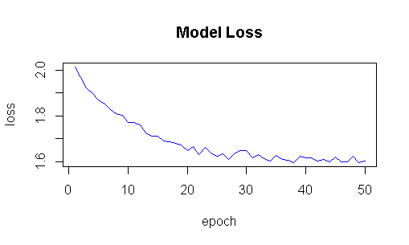

Figure 3. 12: Model Loss Plot

This plot indicates the model have highest loss initial after 20 epoch it will normalized then after each time produces the similar output. The r consoles generate long accuracy and validation loss as below after iteration 2500 iteration and plot as.

Epoch 1/50 5/5 [=] - 2s 384ms/step - loss: 1.9546 - accuracy: 0.1974 - val_loss: 1.9071 - val_accuracy: 0.2821 5/5 [=] - 0s 99ms/step - loss: 1.5732 - accuracy: 0.3684 - val_loss: 1.8060 - val_accuracy: 0.2821.

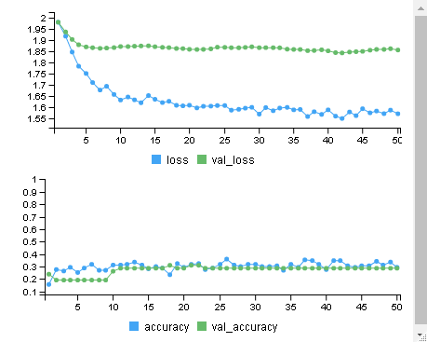

Figure 3. 13: Loss and Accuracy Plot

The deep learning model always generates the loss and accuracy plots indicates the initial both loss and accuracy were very far however at the end the loss and accuracy fitted and uniform at 20 iteration runs more, these loss and accuracy become completely separate and uniformed when model fitting. The head(runs) describes the two rows 2 x 21.

run_dir metric_loss metric_accuracy metric_val_loss metric_val_accuracy

1 runs/2021-01-18T07-59-07Z 1.6034 0.2874 1.8312 0.2857

2 runs/2021-01-18T07-58-40Z 1.5814 0.3174 1.8486 0.2857

flag_dense_units, epochs, epochs_completed, metrics, model, loss_function, optimizer, learning_rate, script, start, end, completed, output, source_code, context, type. runs [, c (5,6)]

metric_val_accuracy flag_dense_units.

1 0.2857 64

2 0.2857 32

This output indicates both results produce the same accurate results however both model validation loss and loss matrix were different. Similarly, when the model with five hyperparameters apply as

nruns=tuning_run ("experiment2.R”, flags=list (dense_units1=c (32,64),

dense_units2=c (16,32), dropout1=c (0.1,0.2),

dropout2=c (0.1,0.2), batch_size=c (32,64)))

FLAGS=flags(flag_integer('dense_units1',32),

flag_integer('dense_units2',16), flag_numeric('dropout1',0.1),

flag_numeric('dropout2',0.1), flag_integer('batch_size',32))

This produces five hyperparameters produces 2^5=32 parameters in each layer and

model =keras_model_sequential () %>%

layer_dense (units=FLAGS$dense_units1, activation = 'relu', input_shape = c (14)) %>%

layer_dropout(rate=FLAGS$dropout1) %>%

layer_dense (units=FLAGS$dense_units2, activation = 'relu') %>%

layer_dropout(rate=FLAGS$dropout2) %>%

layer_dense (units=7, activation='softmax')

As the GPA with response in 7 units grades layers then after is compiled and fitted model %> % compile (loss='dense (', optimizer='adam', metrics='accuracy') the model is fitted with history=model %>% fit (training, trainlabels, epochs=50, batch_size=FLAGS$ batch_size, validation_split=0.2)

The r console produces its run completed times runs/2021-01-18T08-29-15Z, Training run 1/32 (flags = list (32, 32, 0.1, 0.2, 64)) to /2021-01-18T08-29-42Z, indicates the best hyperparameter. Training run 1/32 (flags = list (64, 32, 0.1, 0.2, 64)) to run directory runs/2021-01-18T08-30-08Z.Run completed: runs/2021-01-18T08-31-29Z and training run 32/32 (flags = list (64, 32, 0.2, 0.2, 64)) using run directory runs/2021-01-18T08-31-55Z of both models.

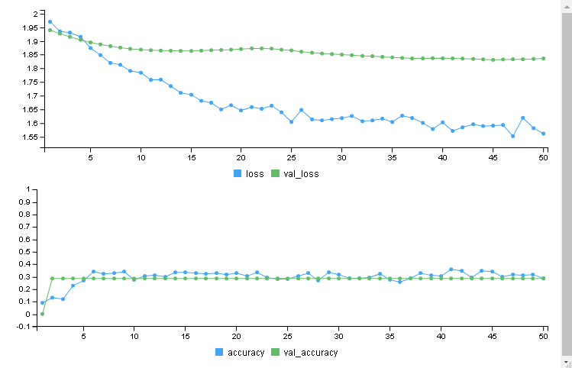

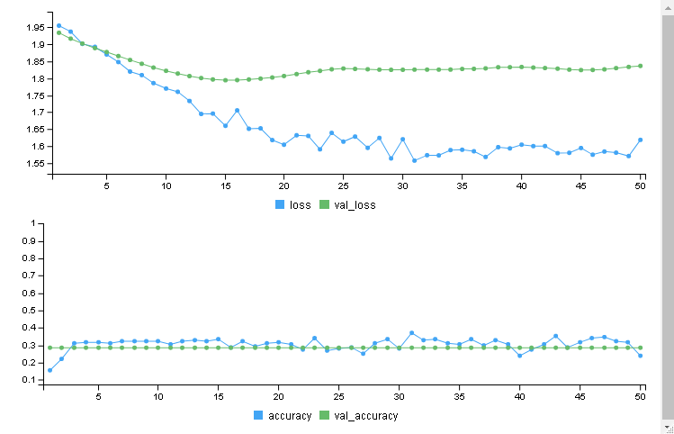

Figure 3. 14: Loss and Accuracy Plot

From the above loss and accuracy plots describes the loss and accuracy in each multilayer with learning rate plots training input student score after 20 epochs. The output describes in each point with corresponding loss and accuracy as epoch 49/50 1/1 [=] - 0s 145ms/step - loss: 1.5709 - accuracy: 0.3174 - val_loss: 1.8337 - val_accuracy: 0. 2857.Epoch 50/50 3/3 [=] - 1s 181ms/step - loss: 1.6186 - accuracy: 0.2395 - val_loss is 1.8367 - val_accuracy is 0.2857

head(nruns) command describes the loss accuracy matrix of each run as

run_dir metric_loss metric_accuracy metric_val_loss metric_val_accuracy

1 runs/2021-01-18T08-31-55Z 1.6186 0.2395 1.8367 0.2857

2 runs/2021-01-18T08-31-29Z 1.5618 0.2874 1.8361 0.2857

3 runs/2021-01-18T08-31-03Z 1.5999 0.3293 1.8445 0.2857

4 runs/2021-01-18T08-30-36Z 1.6283 0.3054 1.8348 0.2857

5 runs/2021-01-18T08-30-08Z 1.5949 0.3174 1.8303 0.2857

6 runs/2021-01-18T08-29-42Z 1.6147 0.2874 1.8178 0.2857

When considering flag_dense_units1, flag_dense_units2, flag_dropout1, flag_dropout2, flag_batch_size, epochs, epochs_completed, metrics, model, loss_function, # optimizer, learning_rate, script, start, end, completed, output, source code, produces the similar output although the matrix accuracy differs.

metric_val_accuracy flag_dense_units1

1 0.2857 64

2 0.2857 32

The get result from the model results=nruns [, c (3,5:10)] command

metric accuracy metric_val_accuracy flag_dense_units1 flag_dense_units2 flag_dropout1 flag_dropout2 flag_batch_size

1 0.3293 0.2857 64 32 0.2 0.2 64

2 0.3054 0.2857 32 32 0.2 0.2 64

From the above output the both models produce the similar accuracy however matrix accuracy is best as compared 64 neuron matrices therefore 32 neurons are recommended hyperparameter.

## **Multilayer Deep Learning Neural Network Perception**

A multilayer neural network perceptron (MLP) is a neural network connecting multiple layers in a directed graph, which means that the signal path through the nodes only goes one way when traversing their weight signals. Each node, apart from the input nodes, has a nonlinear activation function. A MLP is a class of feedforward artificial neural networks (ANN). MLP utilizes a supervised learning technique called backpropagation for training. Its multiple layers and non-linear activation distinguish MLP from a linear perceptron when input data is not linearly separable.

A perceptron is a neural network unit that does certain computations to detect features in the input data. The concept of perceptron was introduced by Frank Rosenblatt in 1957 proposed a perceptron learning rule based on the original MCP neuron. MLP is widely used for solving problems that require supervised learning research into computational neuroscience and parallel distributed processing. The applications of MLP include speech recognition, image recognition, and machine translation. Deep neural networks use sophisticated mathematical modeling to process data in complex ways. A neural network, in general, is a technology built to simulate the activity of the human brain – specifically, pattern recognition and the passage of input through various layers of simulated neural connections (Schirner, et al., 2021). Many experts define deep neural networks as networks that have an input layer, an output layer, and at least one hidden layer in between. Each layer performs specific types of sorting and ordering in a process that some refer to as feature hierarchy. One of the keys uses of these sophisticated neural networks is dealing with unlabeled or unstructured data. The phrase-deep learning is also used to describe these deep neural networks, as deep learning represents a specific form of machine learning where technologies using aspects of artificial intelligence to seek classify and order information in ways that go beyond simple input/output protocols. A deep neural network is trained via backward which uses the chain rule to propagate gradients of the cost function through all of the weights of the network. When a feed-forward network made up of fully connected layers. MLP is one kind of neural network, where the activation function is sigmoid, and the error term in cross-entropy error, and mean square errors are used if the data in regression MSE is selected to address classification problem used cross-entropy and activation use adam, relu as hyper parameters model deployment (Yang, Zhang, Sudjianto, & Zhang, 2021).

**Deep Learning Full Model**

After loading keras, mlbench, dplyr, MASS, magrittr and neural network in r console library the set of student records is read using read,csv and converted into data frame. After converting data set into data$X6=as.numeric(data$X6) numeric of all 13 independent sample variables using tidyverse and filter command ss=data %>%select (GPAA, SLC, School, Plus, Physics, Math, Chemistry, Bio, Parent1, X1, X2, X3, X4, X5, X6) commands. Data%<>% mutate_if (is. factor, as. numeric) #converting all factor variables into numeric pattern of these selected variables. The neural network model of GPAA categorical variables of different GPA grades of 580 student records having 10,5 hidden layers in-between 13 independent variables and GPA using n=neuralnet (GPAA~ SLC+ Plus+ Physics+ Math +Chemistry +Parent1+School+Bio+X1+ X2+X3+X4+X5+X6, data=data, hidden=c (10,5), linear. output=F, lifesign='full’, rep=1) command will conversed in 25 steps with error is 858.00513 in time 0.05 secs. The color map of neural network plot (n, col. hidden='dark-green', col. hidden. synapse = 'dark-green’, show. Weight=T, information=F, fill='light blue') with their respective weight and colors.

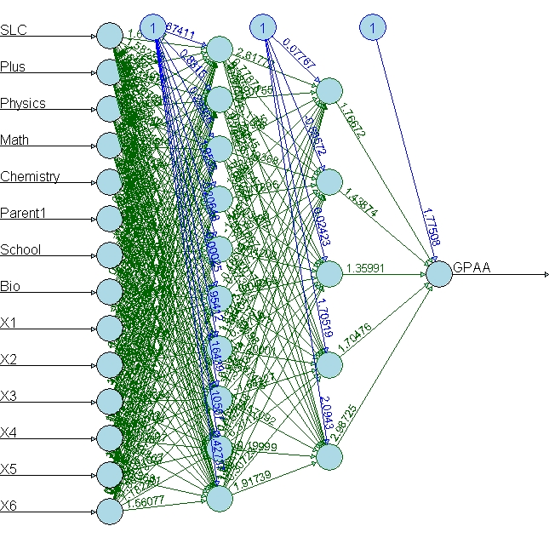

Figure 3. 15: Two Hidden Layer Neural Network (10,5)

After converting selected data into the matrix, the null header name of sample data was converted into 70 30 ratios of training and test using sample and now and training test and target and test and test target further grouped for further validation respectively. After calculating mean into m=colMeans(training)s=apply (training,2, sd) with standard deviation. After normalization of sample data using training=scale (training, center = m, scale = s) the training sample of 401 data sets and 179 of test set using test=scale (test, center = m, scale = s) commands. Similarly, trainLevels=to_categorical(trainingtarget) using keras package and testLevels=to_categorical (testtarget) one hot coding designed the predictor variable with eight different grades as

[,1] [,2] [,3] [,4] [,5] [,6] [,7] [,8]

[1,] 0 0 1 0 0 0 0 0

[2,] 0 0 0 1 0 0 0 0

[3,] 0 1 0 0 0 0 0 0

[4,] 0 0 0 1 0 0 0 0

[5,] 0 0 0 0 0 1 0 0

After data management completion the multiplier neural network model designed using metamodel_ sequential (). The first hidden layer with 10 neurons for 14 independent variables and output units of eight student grades ranges for (0 to 7 grades). Here researcher used layer_dense for the representation of fully connected deep neural network. The activation function of hidden layer is taken as rectified linear unit(relu) produces the output as.

Layer (type) Output Shape Param #

dense_144 (Dense) (None, 10) 150

dense_143 (Dense) (None, 8) 88

There is total 238 parameters composed first hidden layer is 150 (10*14+10) neurons and second layer is 88 (8*10+8) neurons with trainable parameters. When Y is numeric requires a regression problem for prediction student grades thus model compiled with mean squared error with mean absolute error as matrix and optimizer is chosen as adam. When compile model %>% compile (loss='me’, optimizer='rmsprop’, metrics='mae’) and fitted with training and train target with 100 epochs as default batch size for sigmoid function with 20% data validation loss for out of sample. When model fit with training and test data with 100 epoch the model trained history=model %>% fit (training, trainingtarget, epoch=100, batch_size=32, validation_ split=0.2) produces and conversed output as.

Epoch 1/100 10/10 [=] - 0s 41ms/step - loss: 2.4304 - mae: 1.2857 - val_loss: 3.9564 - val_mae: 1.7058. Epoch 99/100 10/10 [=] - 0s 40ms/step - loss: 2.4264 - mae: 1.2836 - val_loss: 3.9638 - val_mae: 1.7084Epoch 100/100

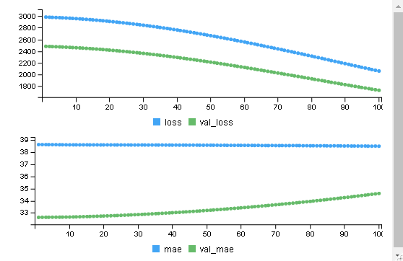 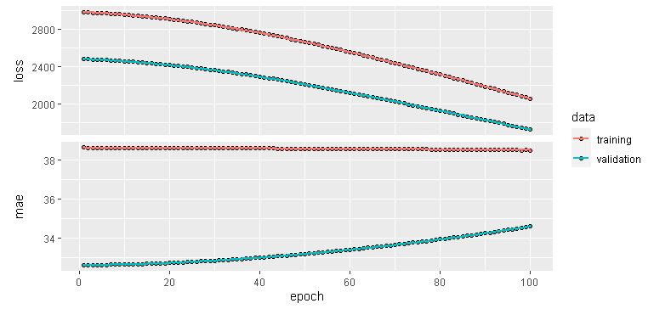

Figure 3. 16: Line Plot Loss and Accuracy

The model then evaluated with test and test target using model1 = model %>% evaluate (test, testtarget) produces the accuracy 2068.0671 and mae is 39.0413. After calculation of probability prediction with train target produced output of test 179 data sets.

[1,] 12.96740 12.62387 16.10693 16.91131 16.38315 15.47020 13.88033 17.34377 7 80

[2,] 12.93746 12.55764 16.06154 16.83131 16.31612 15.40211 13.82991 17.26031 7 65

[3,] 13.00434 12.65035 16.15571 16.94101 16.41579 15.50034 13.92239 17.37495 7 80

**Fine tune improvement using (50,25,8) hidden layers**

The fine tune improvement using 50,25, and 8 hidden layers is evaluated as

model=keras_model_sequential () model%>%

layer_dense (units=50, activation = 'relu', input_shape =c (14)) %>%

layer_dense (units=25, activation = 'relu') %>%

layer_dense(units=8) #default activation Linear activation

The summary(model) produces as

Layer (type) Output Shape Param #

dense_6 (Dense) (None, 50) 750

dense_5 (Dense) (None, 25) 1275

dense_4 (Dense) (None, 8) 208

When using 50,25 and 8 hidden neuron network model produces 2,233 parameters. After compiling and fitting the model model %>% compile (loss='mse’, optimizer='rmsprop', metrics='mae') with mean absolute error. history=model %>% fit (training, trainingtarget, epochs=100, batch_size=32, validation_split=0.2) produces the output as.

Epoch 99/100 10/10 [=] - 0s 45ms/step - loss: 1494.1492 - mae: 38.3408 - val_loss: 1449.1573 - val_mae: 37.7064. Epoch 100/100 10/10 [=] - 0s 40ms/step - loss: 1491.0664 - mae: 38.3034 - val_loss: 1449.8702 - val_mae: 37.7141

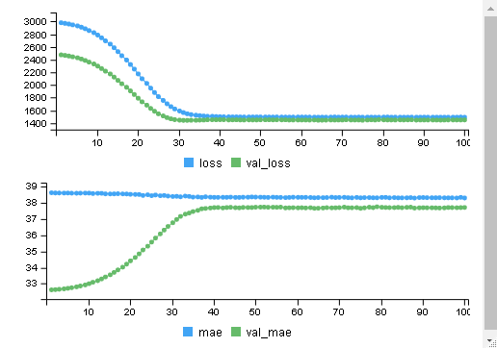 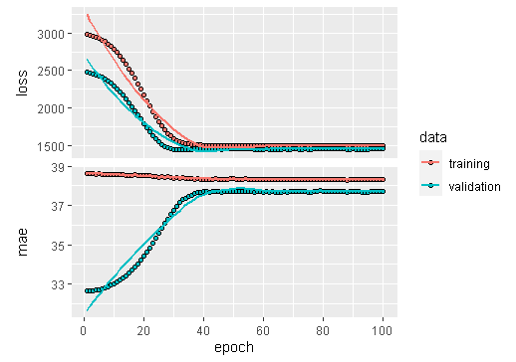

Figure 3. 17: Line Loss and Accuracy Plot

From above two separate model with the test and loss accuracy differs in 20 epoch the 50,25 and 8 model have better output then 10,8 model.

model2 =model%>% evaluate (test, testtarget) is 6/6 [=] - 0s 2ms/step - loss: 1456.6030 - mae: 37.8577 the testing prediction produces the output as.

[97,] 40.18387 40.17848 40.15860 40.18788 40.14605 40.19619 40.14333 40.17792 5 0

[98,] 39.19733 39.19659 39.17329 39.19172 39.18327 39.19217 39.17971 39.18895 0 0

[99,] 39.59184 39.59077 39.58691 39.59027 39.58217 39.59531 39.57391 39.59724 7 0

[100,] 39.70697 39.70531 39.69516 39.70871 39.69139 39.71016 39.68740 39.70543 5 0

This output indicates the model has some miss classification the model predicts of 97 and 100 records as grade fifth B- but actual they are failed grade of all data.

**Fine tune improvement using (100,50,20, 8)**

The fine tune improvement in model is tested using

model=keras_model_sequential() model%>%

layer_dense (units=100, activation = 'relu’, input_shape =c (14)) %>%

layer_dropout(rate=0.4) %>% # 40 % neurons were being ignored while model

layer_dense (units=50, activation = 'relu') %>%

layer_dropout(rate=0.3) %>%

layer_dense (units=20, activation = 'relu') %>%

layer_dropout(rate=0.2) %>%

layer_dense(units=8) #default activation Linear activation

The summary(model) displays further improvement using 100,50,20, 8 four multiple neurons using each dense layer with 40% 50 has 30 % and 20 nodes has 20% drop out layer for eight grade prediction used.

Layer (type) Output Shape Param #

dense_10 (Dense) (None, 100) 1500

dropout_2 (Dropout) (None, 100) 0

dense_9 (Dense) (None, 50) 5050

dropout_1 (Dropout) (None, 50) 0

dense_8 (Dense) (None, 20) 1020

dropout (Dropout) (None, 20) 0

dense_7 (Dense) (None, 8) 168

This large model used total 7,738parameters in between input to output layers. The model compilation and fitting using model %>% compile (loss='mse’, optimizer= optimizer _rmsprop (lr=0.001), metrics='mae') and fitted using history=model %>%

fit (fitted using, epochs=100, batch_size=32, validation_split=0.2) produces the output as.

Epoch 99/100 10/10 [=] - 1s 63ms/step - loss: 2968.0291 - made: 38.6075 - valyls: 2468.6064 - valyls: 32. 6234.Epoch 100/100 10/10 [=] - 1s 53ms/step - loss: 2968.0291 - made: 38.6075 - valyls: 2468.6064 - valyls: 32.6234

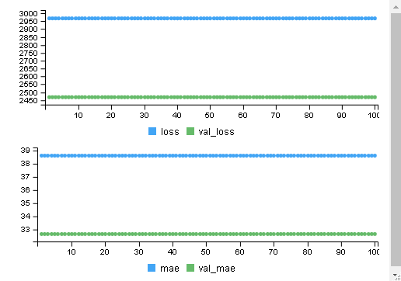 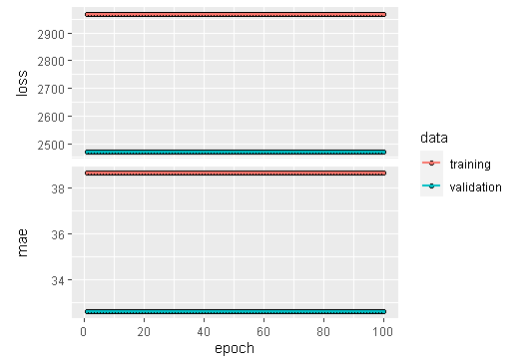

Figure 3. 18: Loss and Accuracy Plot

After evolution of model full model using evaluate (32. 6234.Epoch) produces 6/6 [=] - 0s 2ms/step loss is 3021.1350 and mae is 39.7927.

[1,] 0.2254312 0.1848536 0.2164139 0.1713277 0.20288804 0.18936217 4 80

[2,] 0.1726822 0.1918691 0.1822757 0.1918691 0.19666587 0.18707241 5 65

[3,] 0.2270908 0.1952981 0.2180072 0.1725890 0.20892358 0.17713085 4 80

[4,] 0.2136739 0.2039615 0.2136739 0.1942490 0.22338638 0.19424902 6 0

After cbind evaluation between input and output of probability the output differs indicates misclassification. As the output from absolute mean error produced in single weight sum of 8-layer categorical data of student grades whose matrix categories. The softmax optimization function ð(Z)=Czi/ j=1 to T ∑ e Zj equation of multiclass categorical data output. Those classes describe the valued with its respective marks weighted after one hot encoding.

**Half Multilayer Perception Neural Network**

After loading tidyverse library then selected only those records only have passed result 2019 fall result, therefore sk=data %>% select (GPAA, SLC, School, Plus, Physics, Math, Chemistry, Bio, Parent1, X1, X2, X3, X4, X5, X6) %>% filter (GPAA>0) using select and filter command in r console. Then after converting data into numeric variables of selected 14 variables the neural network with (50,25 ,8) model using multiplier neuron network n=neuralnet (GPAA~ SLC+ Plus +Physics+ Math+Chemistry+Parent1+School+Bio+X1+X2+X3+X4+X5+X6, data=data, hidden=c (50,25,8), linear. output=F, lifesign='full’, rep=1) plots the network as.

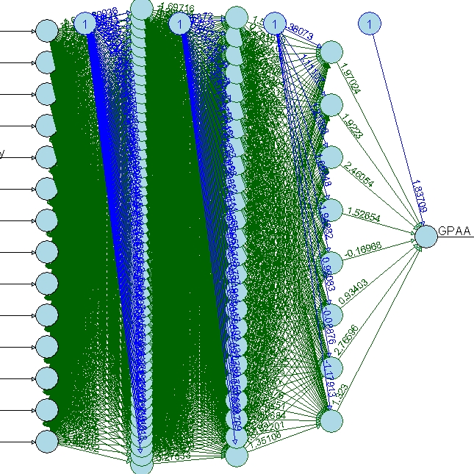

Figure 3. 19: Neural Network (50,25,8) Hidden Layers

After converting data sets into matrix and normalization to all independent variables. The data partitions into 70 to 30 splits respectively whose predicator independent variables in training target and test target variables. After converting one hot encoding of each training target and test target variables. The model with same type with as above (10,7) middle layer model using model=keras_model_sequential () model%>%

layer dense (units=10, activation = 'relu', input_shape =c (14)) %>%

layer_dense(units=7)

The summary summary(model) produces as

Layer (type) Output Shape Param #

dense_12 (Dense) (None, 10) 150

dense_11 (Dense) (None, 7) 77

There were total parameters 227, Epoch 99/100 6/6 [=] - 0s 68ms/step - loss: 4169.6201 - mae: 64.2616 - val_loss: 5660.8081 - Dense) (: 75. 1828.Epoch 100/100 6/6 [==] - 0s 66ms/step - loss: 4147.3901 - mae: 64.0885 - val_loss: 5634.6562 - Dense) (: 75.0082

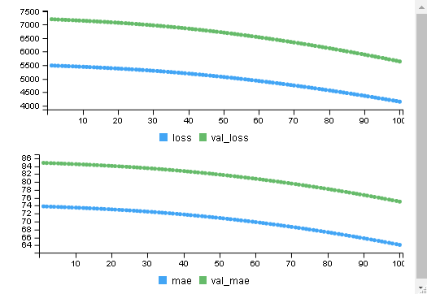 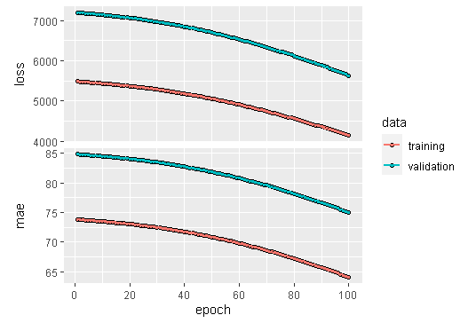

Figure 3. 20: Loss and Accuracy of Model

After model evaluation model1 = model %>% evaluate (test, testtarget) produces 3/3 [=] - 0s 1ms/step loss is 4574.2051 mae is 67.3087. and the prediction with probability with test target value did not matched as below indicates this model needs more improvement.

[17,] 7.126760 9.278822 13.38763 10.49610 7.895380 10.75348 9.174063 2 70

[18,] 6.937192 8.936595 13.04038 10.18655 7.617094 10.48532 8.975990 2 75

From the above output this model has less efficient as compared above model.

**Half Multiple Layer Perception (50,25,7)**

Similarly, when using 50, 25 and 7 hidden layers in this model evaluation using

model=keras_model_sequential() model%>%

layer_dense (units=50, activation = 'relu’, input_shape =c (14)) %>%

layer_dense (units=25, activation = 'relu') %>%

layer_dense(units=7) #default activation Linear activation

The summary(model) produces as.

Layer (type) Output Shape Param #

dense_15 (Dense) (None, 50) 750

dense_14 (Dense) (None, 25) 1275

dense_13 (Dense) (None, 7) 182

This model produces total 2,207 extra parameters

The model compiled using model %>% compile (loss='mse', optimizer='rmsprop’, metrics='mae') # mean absolute error and the history=model %>% fit (training, trainingtarget, epochs=100, batch_size=32, validation_split=0.2).

Epoch 99/100 6/6 [=] - 1s 127ms/step - loss: 36.4075 - mae: 5.0375 - val_loss: 112.4578 - val_mae: 10.3350 Epoch 100/100 6/6 [=] - 0s 83ms/step - loss: 36.2006 - mae: 4.9192 - val_loss: 144.6383 - val_mae: 11.7911

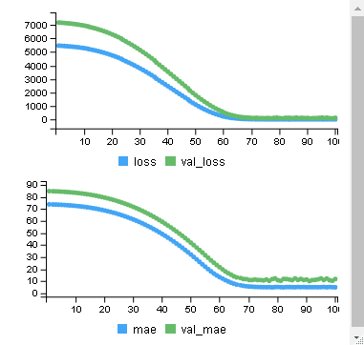 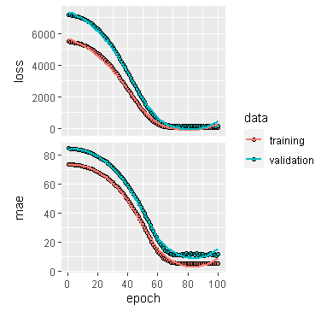

Figure 3. 21: Loss and Accuracy of (10,7) MLP

The model evaluation using model2 =model%>% evaluate (test, testtarget) 3/3 [=] - 0s 2ms/step – loss is 55.2446 and mae is 6.4439 as compared 50,25 and 8 hidden layer the loss and mean absolute errors has dramatically increased however there is some improvement. Because when cbind (prob, pred, testtarget) evaluating we found mismatched its hot encoding output mismatched.

[67,] 72.66821 72.61214 72.61244 72.64782 72.67645 72.62782 72.61175 4 85

[68,] 73.67481 73.68341 73.68901 73.67082 73.67240 73.67391 73.66419 2 85

This model also predicts in appropriate as full model.

**MLP fine tune improvement using (100,50,20,7)**

The more layers hidden layer multiple proception using deep neural network use 100,50,20 and 7 layers is again tested using

model=keras_model_sequential () model%>%

layer_dense (units=100, activation = 'relu’, input_shape =c (14)) %>%

layer dropout(rate=0.4) %>% # 40 % neurons were being ignored while model

layer_dense (units=50, activation = 'relu') %>%

layer dropout(rate=0.3) %>%

layer_dense (units=20, activation = 'relu') %>%

layer dropout(rate=0.2) %>%

layer_dense(units=7) #default activation Linear activation

Layer (type) Output Shape Param #

dense_19 (Dense) (None, 100) 1500

dropout_5 (Dropout) (None, 100) 0

dense_18 (Dense) (None, 50) 5050

dropout_4 (Dropout) (None, 50) 0

dense_17 (Dense) (None, 20) 1020

dropout_3 (Dropout) (None, 20) 0

dense_16 (Dense) (None, 7) 147

This model produces 7,717 parameters in total.

The model compile there is regression problem using model %>% compile (loss='mse’, optimizer=Dense) ((lr=0.001), metrics='mae’) mean absolute error. The

history=model %>% fit (training, trainingtarget, epochs=100, batch_size=32, validation_split=0.2) produces as

Epoch 99/100 6/6 [=] - 0s 76ms/step - loss: 295.4308 - mae: 14.0018 - val_loss: 251.4277 - val_mae: 15. 6809.Epoch 100/100 6/6 [=] - 0s 74ms/step - loss: 279.2279 - mae: 13.2599 - val_loss: 187.8508 - val_mae: 13.5024.

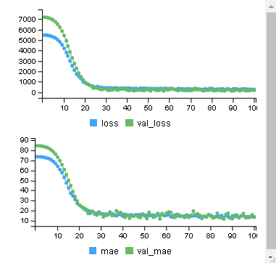 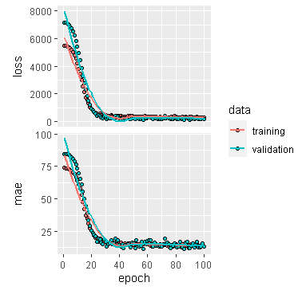

Figure 3. 22: MLP with 100,50,25,7 Network

The model is evaluate using model3 =model%>% evaluate (test, testtarget) 3/3 [=] - 0s 2ms/step – loss is 72.1127 and mae is 7.4754. This indicates there were large improvement of prediction with learning rate 0.01 when removing overfitting data in each step.

[9,] 71.50031 71.08083 70.77480 71.09991 70.96602 71.49794 71.38404 0 65

[10,] 71.65230 71.21544 70.91228 71.24754 71.10027 71.60632 71.53732 0 70

From the above three output comparison using multilayer perception neural network model has improved both loss and mean absolute error to predict student GPA and probability of data indicate misclassification of the model.

# **CHAPTER 4. CONCLUSION and RECOMMENDATION**

## **Performance Measures**

As the final student grade GPA is the collective efforts of their efforts of each semester may predict accurately using artificial neural network a new concept which receives the input weight of each matrix elements of variables (background information) to another complete neuron is calculated its output of previous nodes weight sum. The input information are passes through sigmoid activation function using for producing signal weight to converse GPA student grade. While doing so the researcher tested student database with the full model and half model indicates both and passed student separately. In sometimes the neural network passes the 22-input signal to formed either GPA or fail result using various neurons in between. Based on the dependent variables neural network output is again evaluated with into the number of subdivision grades of student. Due to the presence of some unimportant variable the model produces training and test accuracy and confusion matrix accuracy were summarized as.

|  |  |  |  |  |
| --- | --- | --- | --- | --- |
| Predicator  Variable | No of Input | No of Hidden | Training accuracy | Test Accuracy |
| P/F | 22 Full | 1 | 91 | 81 |
| P/F | 22 Half | 1 | 98 | 95 |
| GPA | 13 Full | 1 | 83 | 86 |
| GPA | 13 Half | 1 | 99 | 82 |
| GPA | 14 Full | 7,3,2 | 83 | 83 |
| GPA | 14 Full | 7,3,2 B | 90 | 90 |
| GPA | 13 Full | 25,12,6,3 | 82 | 82 |
| **Multilayer Perception Deep Neural Network** | | | | |
| Predicator  Variable | No of Input | No Hidden | Model Loss | Mean Accuracy Error |
| GPA(Marks) | Full | (10,8) | 2086.56 | 39.04 |
| GPA(Marks) | Full | (50,25,8) | 1456.60 | 37.85 |
| GPA(Marks) | Full | (100,50,20,8) | 3021.10 | 39.79 |
| GPA(Marks) | Half | (10/7) | 4571.20 | 67.30 |
| GPA(Marks) | Half | (50,25,7) | 55.24 | 6.44 |
| GPA(Marks) | Half | (100,50,20,7) | 72.11 | 7.47 |

Table 6: Neural Network Model Accuracy

(Note: Half model includes only passed student, full model indicates both pass and fail student)

This research completes with design 13 different neural network models whose accuracy and comparison on training and test set samples were presented in the table above explains for the comparison of a selection of the best model. However, based on data input and their weight neural conversed to predicts student grade can be more increased if we reject these variables according to Boruta and random forest methodology suggested data preparation. The last three models of the full model using backpropagations of original data of student scored prediction is more than 90 percent is a good model. The GPA prediction using three hidden layers is best recommended for student grade prediction.

Figure 4. 1: A Full Model Comparison

Similarly, when using a deep neural network with multiplier neural perception, the 50,25 8 full and half model predicts accurately of both students and only passed student different gradings is compared here with using multiclass cross entropy describes below for the recommendation model.

|  |  |  |  |
| --- | --- | --- | --- |
| Hidden Layers | Loss | Mean Accuracy Error | Confusion matrix |
| 10,8 | 2068.0671 | 39.04127 | Actual  Predicted 0 60 65 70 75 80 85 90  7 85 1 13 14 22 32 10 2 |
| 50,25,8 | 1456.6030 | 37.8577 | Actual  Predicted 0 60 65 70 75 80 85 90  0 9 0 0 1 2 1 0 1  1 8 0 3 2 3 4 0 0  3 3 0 1 1 1 2 0 0  4 17 1 3 1 1 9 0 1  5 35 0 4 8 10 7 6 0  6 9 0 2 1 3 8 4 0  7 4 0 0 0 2 1 0 0 |
| 100,50,20,8 | 3021.13501 | 39.79266 | Actual  Predicted 0 60 65 70 75 80 85 90  0 25 1 5 4 8 9 4 1  2 2 0 0 0 0 1 0 0  3 14 0 1 1 4 6 1 0  4 26 0 5 6 6 11 3 1  5 16 0 2 3 2 5 2 0  6 2 0 0 0 2 0 0 0 |

Table 7: Summary Table of Full MLP

From the both above table the loss and mean accuracy error less found when using 50,25,8 model predicts more accurately as compared other model is recommended using full 580 sample datasets.

**Half Multi-Layer Perception Output Comparison**

The following table describes the loss mean accuracy with confusion matrix.

|  |  |  |  |
| --- | --- | --- | --- |
| Hidden Layers | Loss | Mean Accuracy Error | Confusion matrix |
| 10,7 | 4574.20508 | 67.30869 | Actual (89)  Predicted 60 65 70 75 80 85 90  2 1 8 8 19 30 14 1  Actual (209)  Predicted 55 60 65 70 75 80 85 90  2 2 3 27 29 48 63 34 3 |
| 50,25,7 | 55.244598 | 6.443884 | Actual (89)  Predicted 60 65 70 75 80 85 90  0 0 0 0 0 1 2 0  1 0 2 2 6 5 2 0  2 1 5 2 10 15 6 1  4 0 1 3 2 6 3 0  6 0 0 1 1 3 1 0  Actual (209)  Predicted 55 60 65 70 75 80 85 90  0 0 0 0 2 1 7 0 0  1 1 2 6 6 12 11 7 2  2 0 1 14 14 22 32 15 1  4 0 0 4 5 11 8 8 0  6 1 0 3 2 2 5 4 0 |
| 100,50,20,7 | 72.11272 | 7.47543 | Actual (81)  Predicted 60 65 70 75 80 85 90  0 1 8 8 17 28 11 1  5 0 0 0 2 2 3 0  Actual (209)  Predicted 55 60 65 70 75 80 85 90  0 2 3 24 28 43 61 27 3  5 0 0 3 1 5 2 7 0 |

Table 8: Summary Table with Half Perception

From the above summary table of multilayer perception, the confusion matrix produced after using 50,20,8 and 50,20,7. The second model having seven grade of student grade predicts accurately based of each student grade is recommended model.

Figure 4. 2: Deep Neural Network Model Comparison

From the figure the mean square of three full and half model compare and found that 50,15,7 hidden layer model is best suited to our student data whose mean accuracy and loss were least.

## **Correlation and Linear Regression**

On consideration student GPA prediction of bachelor of engineering-grade from the high school grade, plus to grade and their major science scored like (Physics, Math’s, Chemistry, Bio) and their semester internal grade performance scored. The student performance of the university student test using Pearson correlation shows that there is a positive correlation between entry test and Cumulative Grade Point Average (CGPA) between HSSC and CGPA. The correlation coefficients (r) between the entry test with CGPA, HSSC and CGPA are very close indicating both entry test and HSSC are equally important in predicting the CGP. The correlation coefficients are used to measure how strong a relationship is between two variables (Iannaccone, Conte, Cortis, & Fusco, 2021). There are several types of correlation coefficients, but the most popular is Pearson. The Pearson’s correlation is a correlation coefficient commonly used in linear regression. Pearson's correlation is utilized when you have two quantitative variables and if there is a linear relationship between those variables. Our research hypothesis stating that one score affects the other in a certain way. The correlation is affected by the size and the sign of the linear regression is the next step up after correlation. Linear regression models are used to predict the relationship between two variables or factors. The factor that is being predicted is called the dependent variable. The linear regression use lm () assumes that the error terms associated between the observation vector and predictor variables are independent and identically distributed with mean zero and constant variance. Whereas general linear regression uses glm () to generalize the linear model into what is known as the exponential family which allows for the observations to be taken on different random variables like binomial and multinomial etc. When using glm () specify the family that the observations fall under, and in the linear assumption that the random variable is normal (family=Gaussian).

After loading datasets, the average internal and final marks of GPA scored student background information were converted into their respective numbers of only successful of students of 290 sample datasets. The scatter plots are generally viewing before analyzing the data using plot (ss$FinalGPA, ss$Int/2, main="Scatterplot”, ylab = "GPA”, xlab = "Internal", las=1). The correlation between internal and final grade is calculated using cor (ss$Int,ss$FinalGPA,method ="Pearson") function intercept is 0.1183738 which indicates these two variables have a positive but not strong correlation. Similarly, the cor.test (ss$Int, ss$FinalGPA, method = "Pearson”, alt= "greater”, conf. level=.99) while calculating correlation use Pearson with confidence level also produce the similar output. The cor.test function display the output Pearson’s product on ss$Int and ss$FinalGPA variables is 2.0231, df is 288 and p-value is 0.02199 indicates these two variables are significant with 99 percent confidence interval lies in between -0.01838648 to 1.00000000 is 0.1183738 percent. The linear regression between them is calculated using model=lm(ss$FinalGPA~ss$Int) describes its descriptive statists and confident indicates both model and the internal variable is significant whose variability in model is 14 percent.

            Estimate Std. Error t value Pr(>|t|)

(Intercept) 70.12823 3.06518 22.879 <2e-16 ***

ss$Int 0.07384 0.03650 2.023 0.044 * ---

Residual standard error is 6.843 on 288 degrees of freedom, the multiple r-squared is0.01401, adjusted r-squared is 0.01059, the f-statistic is 4.093 on 1 and 288 and model p-value is 0.04399 significant.

After loading the corrplot library the correlation of all independent variables describes the internal marks of 6 subjects has the highest correlation with varying 71 % to 50 % association. The subject Chemistry, Bio, School from and Parent educations have least and -ve association among them which plots describes the overall correlation of research data. The final student GPA mean is 76.25 whereas the internal mean is 80.9 indicates the internal marks of the student are overall higher than the final student grade.

.

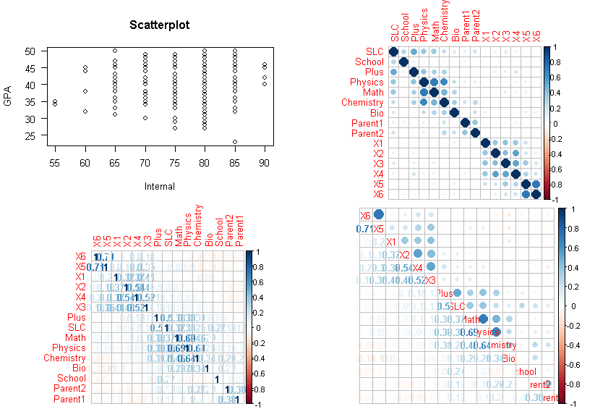

Figure 4. 3: Correlation Plots

Thus, to the correlation between internal and final marks the internal marks need to be reduced up to 7 marks deflection of all internal subjects.

After applying internal and final GPA marks in linear model produce’s the model plots indicate similar results.

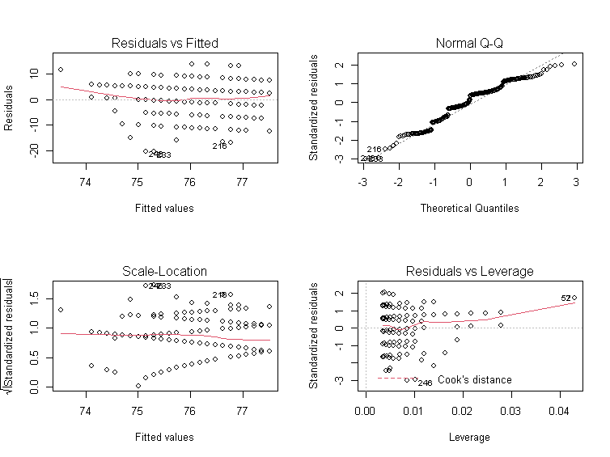

Figure 4. 4: Residual and QQ Plots

After loading the catools package for splitting data into train and test set the sample. split command split data into 80% to 20 percent of 580 student records then the subset (463:117) for model evaluation. After omitting NA values from the database, the predictor variable pf stored 1 for passed student and 0 for fail students is the dependent variable to the model. The general regression model with two binary predictor variables with other 14 independent variables apply general linear regression model with binomial family. The model=glm (pf~SLC+School+Plus +Physics+Math+Chemistry+Bio+Parent1+Parent2+X1+X2+X3+X4+X5+X6, data=train, family="binomial") is used for analysis its coefficient and intercept produce the output using summary model. The coefficients and descriptive statists describe as.

Estimate Std. Error z value Pr(>|z|)

(Intercept) -8.8560840 1.5933912 -5.558 2.73e-08 ***

SLC 0.0336644 0.0157239 2.141 0.03228 *

School -0.1063724 0.2175241 -0.489 0.62483

Plus 0.0063139 0.0143357 0.440 0.65962

Physics 0.0136562 0.0176905 0.772 0.44014

Math -0.0089775 0.0128445 -0.699 0.48459

Chemistry 0.0005617 0.0148844 0.038 0.96990

Bio 0.0013824 0.0059483 0.232 0.81623

Parent1 0.1446625 0.1052733 1.374 0.16939

Parent2 -0.0619289 0.1256502 -0.493 0.62211

X1 0.0638051 0.0195620 3.262 0.00111 **

X2 0.0496246 0.0216459 2.293 0.02187 *

X3 -0.0409040 0.0273335 -1.496 0.13453

X4 0.0562667 0.0254340 2.212 0.02695 *

X5 0.0184650 0.0188549 0.979 0.32742

X6 -0.0165861 0.0161270 -1.028 0.30373

From the above output, the -8.856 is intercepted (B0) with each variable with a respective coefficient to predict student result. The -ve intercept variables whose intercept indicates the -ve association therefore the final model becomes less model=glm (pf~SLC+Plus+Physics +Parent1+X1+X2+X4, data=train, family="binomial") become the model with the training set with eliminating non-significant values. From the above p-value, the internal marks of bachelor’s grade have the highest significance to variables like SLC, plus marks, physics and parent education have a strong association for the prediction to result in binary classification. After calculating prediction train and test with response the confusion matrix cmatrix=table (Actual=train$pf, predicted=res>0.5) is compared with greater than 0.5 percent threshold accuracy. The accuracy is calculated using accuracy= (cmatrix [[1,1]] +cmatrix [ [2,2]])/sum(cmatrix) in training test is 0.6349892 percent and test set is 0.5897436 respectively.

Predicted

Predicted

Actual FALSE TRUE

0 30 25

1 23 39

Actual FALSE TRUE

0 146 89

1 80 148

The first prediction is 463 student records and second 117 of test data sets. Similar prediction is found in the output plots using model.

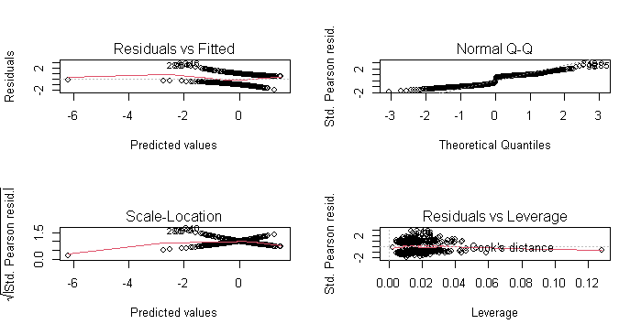

Figure 4. 5: Residual and QQ Plot

Similarly, the program-wise data of each program regression could analyze after converting program data into factor of each program record. The table records of each program are displayed using a table(waterproof) command describes the total sample of program wise records.

Civil I Civil III Civil V Civil VII Civil VIII Comp Elex III Elex V Elex VII ELEX VIII ElexI Rural Software as 48 40 92 80 154 34 26 12 16 24 24 12 18. The model dot matrix function creating tables of dummy variables for use in statistical. Note that there was no header row in the data file, so the variable name had to be added model. Matrix(~parasite-1) then header of converted dummy variables of each program is rewrite names(k)[names(k) == "data$ProgCivil I"] <-"CivilI" like this of all 13 programs of Pokhara University engineering courses. The xtab detail information between GPA with program will be display as.

|  |  |  |  |  |  |  |  |  |  |  |  |  |  |
| --- | --- | --- | --- | --- | --- | --- | --- | --- | --- | --- | --- | --- | --- |
| GPAOR | Civil I | Civil III | Civil V | Civil  VII | Civil  VIII | Comp | Elex  III | Elex  V | Elex  VII | Elex  VIII | Elex I | Rural | Soft |
| (F)0 | 24 | 20 | 46 | 40 | 77 | 17 | 13 | 6 | 8 | 12 | 12 | 6 | 9 |
| (A)1 | 3 | 2 | 18 | 4 | 16 | 1 | 2 | 2 | 1 | 1 | 1 | 0 | 1 |
| (A-)2 | 9 | 9 | 13 | 16 | 24 | 3 | 3 | 1 | 3 | 3 | 3 | 4 | 2 |
| (B+)3 | 8 | 4 | 10 | 9 | 19 | 3 | 1 | 2 | 2 | 6 | 3 | 0 | 0 |
| (B)47 | 0 | 3 | 3 | 3 | 13 | 5 | 5 | 0 | 0 | 0 | 1 | 2 | 2 |
| (B-)5 | 4 | 2 | 2 | 6 | 4 | 4 | 2 | 1 | 2 | 2 | 3 | 0 | 3 |
| (C+6 | 0 | 0 | 0 | 2 | 1 | 0 | 0 | 0 | 0 | 0 | 0 | 0 | 1 |
| (C)7 | 0 | 0 | 0 | 0 | 0 | 1 | 0 | 0 | 0 | 0 | 1 | 0 | 0 |

Table 9: Summary Table by Program

After converting dummy variables of each program data sample is split into test and training sets of 468 and 112 testing sets of 580 observations. Then the liner model with ordinal GPA with 13 programs. mod=lm (OrdGPA~CivilI+CivilIII+CivilV+CivilVII+CivilVIII+Computer+ElexIII +ElexV +ElexVII+ ElexVIII+ ElexI+ Rural+ Software, data=train) is used and display using summary statical as.

Estimate Std. Error t value Pr(>|t|)

(Intercept) 3.68750 1.07109 3.443 0.000628 ***

CivilI 0.72276 1.27197 0.568 0.570161

CivilI 0.04583 1.32631 0.035 0.972448

Civil 1.07566 1.17846 0.913 0.361839

CivilI 0.18015 1.19045 0.151 0.879784

CivilI 0.47083 1.14026 0.413 0.679859

Computer -0.28750 1.32631 -0.217 0.828485

ElexI 0.31250 1.40769 0.222 0.824416

Elex -0.18750 1.72708 -0.109 0.913595

ElexI 0.24583 1.53979 0.160 0.873223

ElexI 0.55060 1.42173 0.387 0.698734

ElexI 0.31250 1.45373 0.215 0.829890

Rural 1.31250 1.72708 0.760 0.447670

Software 1.31250 1.72708 0.760 0.447670

Residual standard error is 4.284 on 463 degrees of freedom. The multiple r-squared is 0.008771 and adjusted r-squared is -0.01692. The f-statistic: 0.3414 on 12 and 463 DF, p-value is 0.9811. The descriptive statists with min, max with coefficient explain with the explain model in average the intercept of each program has change increase or decrease. And the program like Computer, ElexV and Software have -ve association with eliminating these columns for final model. The final p values implies that there is no significance program wise regression model. However, training model accuracy is 0.8802521 and test accuracy is 0.9615385 percent respectively.

## **Conclusion and Recommendation**

After applying various data preprocessing of student data base machine learning algorithms of 580 student marks of Pokhara University School of Engineering students have achieved quite a remarkable prediction performance (varying between 48-99 % accuracy) of using 15 different neural network models. The following useful conclusions have been drawn by this study:

Grade prediction model with 22 independent associative variables predicts 99% accuracy when using a single hidden layer of student can be accurately predicted even with the result of the final exam different grades. Similarly, when using 13 associative attributes input neurons with 7,3,2 three hidden layers predicts (92 to 98 percent accuracy of both half and full student grade prediction. Similarly, when using 7,3,2 with back propagation neural network produce 90 percent accuracy. This implies that the performance of students in various previous records before the final exam is highly correlated to their performance in the final exam except parent education. Another interesting point is that the F grade is the easiest to predict followed by the C grade, while B+ is the most difficult grade prediction from the accuracy measure. Furthermore, the number of students whose grades performance on the final exam is more than final exam. The random forest methodology is used for the test of both classification and regression data management whose output on test and training data sets is achieved 99 percent accuracy validate model. Likewise, the Boruta algorithm is used to eliminate many associative variables to predicts strong associative variables suggested 17 very significant variables out of 22 associative variables.

This grade prediction model helps the management to offer in the upcoming semester more effectively for scoring better grades. This would help students in deciding whether to drop a course or not and lastly, counselors can timely warn students if they are failing. In the future, this model like to extend on more data to score GPA the course, teacher of the course, and with past performance in such courses.

The prediction of student performance is getting difficult day by day. In this research, we have developed an ordinal regression based on 13 programs which will help students in knowing final grade in a particular subject predicts the accuracy. After testing the multicollinearity test on student data, the multinomial test predicts 90 to 97 % accuracy of student grade prediction.

The multilayer neural network produces the more accurate result when using 50,15,7 as compared 10,50,20,7. The mean accuracy using full and half model compared according model. Suggest that 50,25 and 7 hidden model suitable recommend. Similarly, the hypothesis testing on internal and final grade mark has a significant association, the single ANOVA with Tukey test express the similar result that internal marks are 7 (14 % more) more than final scored. Similarly, program-wise result with final GPA of the student fount that civil program has better result than all. To accomplish this research, internal exam marks out of 50 are taken into consideration. Then the marks are converted into 100 (percentage) to have a uniformity benchmark in data management and preparation.

## **Limitation and Delimitation of the Study**

Inclusion and exclusion criteria: Respondents of the selected batch student which were currently being studying were included.

Exclusion criteria: Denials of the sampled participation student were excluded. We note that the reported findings of this study have been based on the dataset of the performance of the undergraduate school of engineering students. The dataset used in the study is limited with GPAs available for students in the particular courses based on result of fall 2019.

## **Ethical Consideration**

This study is going to explore the grade prediction and correlation of internal and final marks of student students. This observational and questionnaire survey study does not require any health-related issues of the respondent, therefore, the researcher himself will take first research consent from the School of Engineering, Pokhara University will be taken then multiple, choice questionnaire, short question answer and open questionnaire will be designed to measure the subject wise measurement of sample data.

# References

Adepoju, G., Ogunjuyigbe, S., & Alawode, K. (2007). Application of Neural Network to Load Forecasting in Nigerian Electrical Power System”. The Pacific Journal of Science and Technology.8(1):68-72.

Agoritsa, P., & George, K. (2019). Grade Prediction with Course and Student Speciic Model.

Agoritsa, P., & Karypis, G. (2016). Grade prediction with models specific to students and courses. *Received: 20 July 2016 / Accepted: 6 September 2016 / Published online: 22 September*.

Anusiewicz, C., & Patrician, P. (2021). Measuring workplace bullying in a US nursing population with the Short Negative Acts Questionnaire. . *Research in Nursing & Health, 44(2), 319-328.*

Baecker, L., Dafflon, J., Costa, P., Garcia‐Dias, R., Vieira, S., Scarpazza, C., & Pinaya, W. (2021). Brain age prediction: A comparison between machine learning models using region‐and voxel‐based morphometric data. . *Human Brain Mapping.*

Baron, J. M., Huang, R., McEvoy, D., & Dighe, A. S. (2021). Use of machine learning to predict clinical decision support compliance, reduce alert burden, and evaluate duplicate laboratory test ordering alerts. . *JAMIA open, 4(1), ooab006.*

Bhardwaj, B. (2011). “Data Mining􀯗: A prediction for performance improvement using classification. *Int. J. Comput. Sci. Inf. Secur., vol.*

Brecko, B. (2004). How family background influences student achievement. In Proceedings of the IRC-2004.

Brijesh Kumar, B., & Saurabh, P. (2012). Data Mining: A prediction for performance improvement using classification. *(IJCSIS) International Journal of Computer Science and Information Security, Vol. 9, No. 4, April 2011, pp 136-140*.

Brijesh Kumar, B., & Saurabha, P. (2011). E preceding of 4th Global summit. *Mining education Data Analyze student performance*.

Brinton, G., & Chiang, M. (2016). *Mining MOOC clickstreams: Video-watching behavior vs. in-video quiz performance.* Signal Process., vol. 64, no. 14, pp. 3677–3692, Jul.

Cohen, W. (1995). Effective rule induction. *Twelves international conference on machine larning*.

Daguang, W., & Xie, Z. (2017). Enhancing Teaching and Learning through. *Enhancing Teaching and Learning through Internal Quality Assurance Xiamen University, China*.

David, G., Rijt, G. v., Filip, D., & Janine, v. d. (2008). Students’ assessment preferences, perceptions. *High Educ (2008) 56:645–658*.

Davidson, J. H. (2014). Predicting persistence for first-time undergraduate adult students at four-year institutions using first-term academic behaviors and outcomes. *The Journal of Continuing Higher Education, 62(2), 78-89.*

Djaharuddin, D. (2021). The Impact of Service Quality and Promotion on Purchasing Decisions on Online Transportation Consumers. . *JURNAL ECONOMIC RESOURCE, 3(2), 52-59.*

El-manzalawy, Y. M. (2008). Machine learning approaches for epitope. *Iowa State University*.

Emaan Abdul, M. (2016). GRADE PREDICTION USING SUPERVISED MACHINE LEARNING TECHNIQUES.

Farooq, M. A., & Saeed, T. (2021). A statistical analysis of the correlates of compliance and defiance of seatbelt use. *Transportation research part F: traffic psychology and behaviour, 77, 117-128.*

Filip, D. a. (2008). Students’ assessment preferences, perceptions. *High Educ (2008) 56:645–658 Open access*.

Fisher, J. (2014). Applied Learning in Online Education:A Comparative Study Employing. *Utah Valley University*.

Hamsa, H., Indiradevi, H., & Kizhakkethottam, J. (2016). Student Academic Performance Prediction Model Using Decision Tree and Fuzzy Genetic. *Procedia Technol., vol. 25, pp. 326–332,*.

Havan, A., & Harshil, M. (2015). Student Performance Prediction using Machine. *International Journal of Engineering Research & Technology (IJERT)*.

Hijazi, S., & Naqvi, R. (2006). Factors Affecting Student’s Performance: A Case of Private Colleges. . *Bangladesh e-Journal of Sociology. Vol. 3, No. 1.*

Iannaccone, A., Conte, D., Cortis, C., & Fusco, A. (2021). Usefulness of Linear Mixed-Effects Models to Assess the Relationship between Objective and Subjective Internal Load in Team Sports. . *International journal of environmental research and public healt*.

John, A., & Manabete, S. (2015). Procedural INflurance on Internal and External Assessment score of Undergraduage. *Journal of Education and Practices*.

Junemann, M. L. (2007). Neural networks to predict schooling failure/success. *Lecture Notes in Computer Science, Nature Inspired Problem-Solving Methods in Knowledge Engineering. Berlin: Sp*.

Kalejaye, B., Folorunso, O., & Usman, L. (2015). PREDICTING STUDENTS’ GRADE SCORES USING TRAINING FUNCTIONS OF ARTIFICIAL NEURAL NETWORK. *Journal of Natural Sciences, Engineering and Technology, Volume 14, 2015 (formerly ASSET Journal Series B)*.

Karamouzis, S. (2000). *Using Analogies to predict Student performance.* In Proc. IASTED’s Artificial Intelligence and soft comp. Banf, Canada, P.355-360.

Lima, K., Mohanan, D. T., & Harichandran, S. (2017). Association of class attendance and academic performance of MBBS. *National Journal of Physiology, Pharmacy and Pharmacology*.

Lorenzen, S., Pham, N., & Alstrup, S. (2017). On predicting student performance using low-rank matrix factorization.

Lykourentzou, G., Mpardis, G., & Nikolopoulos, L. (2009). Early and Dynamic Student Achievement Prediction in E-Learning Courses Using Neural Networks.

Maghari, A. (2017). Students Performance Prediction Using KNN and Naïve Bayesian.

Meier, Y., Xu, A., & Van, M. (2016). Predicting grades. IEEE Transactions.

Miranda, L., & Martin, A. (2013). Analysis of student performnce using genetic Algorithum,. *Computer Ccience Journal*.

Mubarak, A., & Umar, L. (2019). *Student Academic Performance Prediction using Artificial Neural Networks: A Case Study.* China: International Journal of Computer Applications.

Muhammad, A., & Aijaz Ahmed, G. (2007). CORRELATION BETWEEN MARKS OBTAINED BY STUDENTS. *Turkish Online Journal of Distance Education-TOJDE April 2007 ISSN 1302–6488, Volume: 8 Number: 2 Article: 10*.

Naqui, H. S. (2006). Bangledesh E Journals . *Factors affecting student performance*.

Nikolopoulos, V. (2009). Dropout prediction in e-learning courses through the combination of machine learning techniques.

Nnodium, J. (1992). Multiple choice testingin anatomy. *PubMED*, J Med Educ. 1992;26:301–09.

Osmanbegović, E., & Suljić, M. (2012). *Data Mining Approach for Predicting students performances.* J. Econ. Bus., vol. X, no. 1, pp. 3–12,.

Pandey, U., & Pal, S. (2012). A prediction of performer using classification. *International jpurnal of computer science*.

Patel, C. (2017). STUDENT FINAL GRADE PREDICTION. *Indian Journal of Computer Science and Engineering (IJCSE)*.

Ramaswami, M., & Rasthnasbapathy, M. (2010). A CHAID Based Performance Prediction Model in Educatioal Data mining. *International Journal of computer Science*.

Ranjita, S., Sushobhan, P., Ananya, M., Nina, D., & Patralekha, R. (2014). A Study on the Performance of Medical Students in Internal Assessment and its Correlates to Final Examinations of 2nd MBBS Pharmacology Curriculum in a Medical College of Eastern India. *The new examination system reforms- A must. Studies High Educ. 2002;27:221–31.*

Rimal, Y. P. (2021). Hyperparameter Determines the Best Learning Curve on Single, Multi-Layer and Deep Neural Network of Student Grade Prediction of Pokhara University Nepal. *In Journal of Phys*.

Romero, C., & Ventura, S. (2010). *Educational Data Mininig: A reviwe of the state of the art.* IEEE Trans. Syst. Man. Cybern., vol. 40, no. X, pp. 601–619.

Rushika, G., Juilee, K., Pooja, M., Sachee, N., & Priya, R. (2018). Prediction of Crop Yield using Machine Learning. *International Research Journal of Engineering and Technology (IRJET)*.

Saleem, S., Kathiry, N., Al-Osimi, S., & Badr, G. (2015). Mining Educational Data to Predict Students’ Academic Performance’. *, Mach. Learn. Data Min. Pattern Recognition, Mldm 2015, vol. 9166, no. 6, pp. 403–414,*.

Schirner, M., Domide, L., Perdikis, D., Triebkorn, P., Stefanovski, L., Pai, R., & Ritter, P. (2021). Brain Modelling as a Service: . *The Virtual Brain on EBRAINS. arXiv preprint arXiv:2102.05888.*

Shahiri, A., Husain, W., & Rashid, N. (2015). A Review on Predicting Student’s Performance Using Data Mining Techniques. *Procedia Comput. Sci., vol. 72, pp. 414–422,*.

Shoon Lei, W., Zaw Zaw, H., Faridah, Y., & Ibrahim, N. (2014). CANCER RECURRENCE PREDICTION USING. *International Journal of Computational Science and Information Technology (IJCSITY) Vol.2, No.2, May 2014*.

Sidath, A. (2018). *Machine Learning Classifiers.* https://towardsdatascience.com/machine-learning-classifiers-a5cc4e1b0623.

Silva, F. (2018). *Importance performance analysis as tool in evaluating higher edcation*. Retrieved from https://www.researchgate.net/publication/277035463.

Sorour, S., Mine, K., & Hirokawa, S. (2014). *Predicting students’ grades based on free style comments data by artificial neural network. In 2014 IEEE Frontiers in Education Conference (FIE) Proceedings, page 19,.*

Tair, M. M., & Alaa, M. E.-H. (2012). Mining Educational Data to Improve Students’ Performance: A Case Study. . *International Journal of Information and Communication Technology Research, Vol.2 No. 2*.

Verdes, P., Granitto, M., Navone, D., & Ceccatto, H. (2010). FROST PREDICTION WITH MACHINE LEARNING TECHNIQUES. *Instituto de Física Rosario (CONICET-UNR) Argentina*.

Wongkhamdi, T., & Seresangtakul, P. (2010). A Comparison of Classical Discriminant Analysis and Artificial Neural Networks in Predicting Student Graduation Outcomes. *Proc. Second Int. Conf. Knowl. Smart Technol., pp. 29–34,*.

Woodford, C. (2017). *Neural networks*. Retrieved from https://www.explainthatstuff.com/introduction-to-neural-networks.html

Yahya, F., Mohamed, A.-A., & Abdelfatah, A. (2011). Procedures for Evaluating the Teaching Process in computer Discpline.

Yang, T., & Brinton, C. (2017). *Behavior-Based Grade Prediction for MOOCs Via Time Series Neural Networks.* IEEE JOURNAL OF SELECTED TOPICS IN SIGNAL PROCESSING, VOL. 11, NO. 5, AUGUST.

Yang, Z., Zhang, H., Sudjianto, A., & Zhang, A. (2021). An effective SteinGLM initialization scheme for training multi-layer feedforward sigmoidal neural networks. *. Neural Networks.*

Yupei, Z., Yue, Y., Huan, D., Jiaqi, C., & Xuequn, S. (2020). *Graphs Regularized Robust Matrix Factorization and Its Application on Student Grade Prediction.* School of Computer Science, Northwestern Polytechnical University, Xi’an 710129, Shaanxi, China;.

Zacharis, N. (2016). Predicting Student Academic Performance in Blended Learning Using Artificial Neural Networks. *Int. J. Artif. Intell. Appl., vol. 7, no. 5, pp. 17–29,*.

**Annex1: Research Questionnaire**

Respondent Name: Symbol No:

Marks of Student (in Percent)

SLC Total Percent Select High School Education Govt. Private:

+2 Total Percent Physics: Math: Chemistry: Bio:

Please select your parent highest education label (Please Tick)

a) SLC b) +2 c) Bachelor d) Master e) Ph. D

Please select your other family member’s highest education label (if only have)

a) SLC b) +2 c) Bachelor d) Master e) Ph. D

THANK YOU

-----------------------------------------------------------------------------------------

Research Questionnaire

Respondent Name: Symbol No:

Marks of Student (in Percent)

SLC Total Percent Select High School Education Govt. Private:

+2 Total Percent Physics: Math: Chemistry: Bio:

Please select your parent highest education label (Please Tick)

a) SLC b) +2 c) Bachelor d) Master e) Ph. D

Please select your other family member’s highest education label (if only have)

a) SLC b) +2 c) Bachelor d) Master e) Ph. D

THANK YOU

## **Annex2: Photo Gallery**

## **Annex 3: Summary Statists of Sample Data Used**

GPA SLC School Plus Physics

Min. :0.0000 Min. :0.0000 Min. :0.0000 Min. :0.0000 Min. :0.0000

1st Qu.:0.0000 1st Qu.:0.4708 1st Qu.:0.0000 1st Qu.:0.4722 1st Qu.:0.2973

Median :0.2487 Median :0.6771 Median :0.0000 Median :0.6667 Median :0.5405

Mean :0.4073 Mean :0.6088 Mean :0.4138 Mean :0.6031 Mean :0.5165

3rd Qu.:0.8244 3rd Qu.:0.7694 3rd Qu.:1.0000 3rd Qu.:0.7778 3rd Qu.:0.6757

Max. :1.0000 Max. :1.0000 Max. :1.0000 Max. :1.0000 Max. :1.0000

Math Chemistry Bio Parent1 Parent2

Min. :0.0000 Min. :0.0000 Min. :0.0000 Min. :0.0000 Min. :0.0000

1st Qu.:0.4423 1st Qu.:0.3882 1st Qu.:0.6522 1st Qu.:0.0000 1st Qu.:0.6667

Median :0.5962 Median :0.5263 Median :0.7609 Median :0.6667 Median :0.6667

Mean :0.6002 Mean :0.5190 Mean :0.7064 Mean :0.6201 Mean :0.7753

3rd Qu.:0.7692 3rd Qu.:0.7171 3rd Qu.:0.8152 3rd Qu.:1.0000 3rd Qu.:1.0000

Max. :1.0000 Max. :1.0000 Max. :1.0000 Max. :1.0000 Max. :1.0000

X1 X2 X3 X4 X5

Min. :0.0000 Min. :0.0000 Min. :0.0000 Min. :0.0000 Min. :0.0000

1st Qu.:0.7350 1st Qu.:0.7600 1st Qu.:0.4583 1st Qu.:0.7200 1st Qu.:0.7200

Median :0.8400 Median :0.8200 Median :0.6250 Median :0.8000 Median :0.8000

Mean :0.8091 Mean :0.8068 Mean :0.6010 Mean :0.7937 Mean :0.7647

3rd Qu.:0.9000 3rd Qu.:0.9000 3rd Qu.:0.7500 3rd Qu.:0.8800 3rd Qu.:0.8800

Max. :1.0000 Max. :1.0000 Max. :1.0000 Max. :1.0000 Max. :1.0000

X6 X111 X222 X333 X444

Min. :0.0000 Min. :0.0000 Min. :0.0000 Min. :0.0000 Min. :0.0000

1st Qu.:0.6400 1st Qu.:0.0000 1st Qu.:0.6111 1st Qu.:0.0000 1st Qu.:0.0000

Median :0.8000 Median :0.7778 Median :0.7222 Median :0.7222 Median :0.7778

Mean :0.7339 Mean :0.6091 Mean :0.6275 Mean :0.5995 Mean :0.5656

3rd Qu.:0.8800 3rd Qu.:0.8889 3rd Qu.:0.8889 3rd Qu.:0.8889 3rd Qu.:0.8889

Max. :1.0000 Max. :1.0000 Max. :1.0000 Max. :1.0000 Max. :1.0000

## **Annex 4: Program Code Snippet**

########################## Explanation

#Neuralnet concept explain for testing explaining example

data <- read.csv("D:/dataanalysisfinal/SOE/rcode/Dataanalysiscsv.csv", stringsAsFactors = FALSE) # all variable must in numerical representation the predicted variable in either0 or 1 too

str(data)

data=as.data.frame(data)

dim(data)

hist(data$Math)

#For GPA in 1,2,3,4,5,6,7,0 All

library(tidyverse)

ss=data %>% select(GPAA,SLC,School,Plus,Physics,Math,Chemistry,Bio,Parent1,Parent2,

X1,X2,X3,X4,X5,X6)

dim(ss) head(ss)

GPA=ss[,1]

Sr=as.data.frame(apply(ss[,2:16], 2, function(x) (x - min(x))/(max(x)-min(x))))

str(Sr)

SS=data.frame(cbind(GPA,Sr))

hist(SS$Math)

#normalization min-max/min-max

#data$SLC=(data$SLC-min(data$SLC)/max(data$SLC)-min(data$SLC))

#hist(data$SLC)

#data$Plus=(data$Plus-min(data$Plus)/max(data$Plus)-min(data$Plus))

#hist(data$Plus)

#data$Physics=(data$Physics-min(data$Physics)/max(data$Physics)-min(data$Physics))

#data$Math=(data$Math-min(data$Math)/max(data$Math)-min(data$Math))

#data$Chemistry=(data$Chemistry-min(data$Chemistry)/max(data$Chemistry)-min(data$Chemistry))

#data$Bio=(data$Bio-min(data$Bio)/max(data$Bio)-min(data$Bio))

#data$Math2=(data$Math2-min(data$Math2)/max(data$Math2)-min(data$Math2))

#data$int1=(data$int1-min(data$int1)/max(data$int1)-min(data$int1))

#data$int2=(data$int2-min(data$int2)/max(data$int2)-min(data$int2))

#data$int3=(data$int3-min(data$int3)/max(data$int3)-min(data$int3))

#data$int4=(data$int4-min(data$int4)/max(data$int4)-min(data$int4))

#data$int5=(data$int5-min(data$int5)/max(data$int5)-min(data$int5))

#data$int6=(data$int6-min(data$int6)/max(data$int6)-min(data$int6))

#data[,15]=as.numeric(data[,15])-1 #The outout matters when dependent variables in numeric than network converse with SGPA when SGPA become Factor it will converse with its categories like Fail, A grade, B grade and c grade

#data[,1:13]=normalize(data[,1:13]) #normalized all variable at once

head(SS)

levels(as.factor(SS$GPA))

ss$GPA=as.numeric(SS$GPA)

str(SS) set.seed(123)

ind=sample(2,nrow(SS),replace=T,prob=c(.7,.3))

training=SS[ind==1,1:16]

test=SS[ind==2,1:16]

str(SS) str(data$GPA)

set.seed(123)

library(neuralnet)

n=neuralnet(GPA~SLC+School+Plus+Physics+Math+Chemistry+Bio+Parent1+Parent2+

X1+X2+X3+X4+X5+X6, data=training, hidden=c(1),err.fct="sse",

linear.output=FALSE)

plot(n)

output=neuralnet::compute(n,training[,-1]) # to get confusion matrix of 5th use rep=5

output$net.result# is probabilities

head(output$net.result)# similar to probability 0.9999458

hist(output$net.result)

head(training[1,])# first records 0.3907611

#calculation if hidden 1

# 0.8333333 0.77777778 0.67567568 0.8653846 0.39473684 0.7608696 1.0000000 0.80 0.82 0.91666667 0.72 0.72 0.64

in14=-0.13406+ (-0.44306*0.69) + (-9.57289*1) + (0.08044*0.8333333) + (-11.73374*0.8108108) + (1.81571*0.5192308) + (-11.40211*0.7894737) + (-1.33862*0.923913) + (-16.48685*0) + (-6.13984*0.6666667) + (1.17142*0.88) + (0.12294*0.78) + (5.00518*0.5416667) + (-1.24513*0.88) + #training$int6[1])

(-2.49769*0.84) + (6.549*0.84)

in14 #-26.70309

out4=1/(1+exp(-in14)) #2.529267e-12

out4 # must always lines between 1 and 0 because we used sigmoid function

SGPI= 9.82221+(-14.23502*out4)

SGPI #9.82221

SGPAO=1/(1+exp(-SGPI))

SGPAO # 0.9999458 this matched with head first records

#Model evaluation

output=neuralnet: compute (training [, -1])

p1=output$net. Result

p1# the first value is SGPO

par (morrow=c (1,2))

hist(p1)

pred1=ifelse(p1>=0.9,1,ifelse(p1>=.85,2, ifelse(p1>=.75,3, ifelse(p1>=0.65,4,ifelse(p1>=0.55,5, ifelse(p1>=0.45,6, ifelse(p1>=.20,7,0)))))))

tab1=table (pred1, training$GPA)

1-sum(diag(tab1))/sum(tab1)

output=neuralnet: compute (t.test [, -1])

p2=output$net. Result

hist(p2)

pred2=ifelse(p2>=0.9,1, ifelse(p2>=.85,2, ifelse(p2>=.75,3, ifelse(p2>=0.65,4,

ifelse(p2>=0.55,5, ifelse(p2>=0.45,6, ifelse(p2>=.20,7,0)))))))

tab2=table (pred2, test$GPA)

tab2

1-sum(diag(tab2))/sum(tab2)

##############################Only passed std

#For GPA in 1,2,3,4,5,6,7 who were in passed only

data <- read.csv ("D:/dataanalysisfinal/SOE/rcode/Dataanalysiscsv.csv", stringsAsFactors = FALSE)

data=numerical representation(data)

library(tidyverse)

ss=data %>% select (GPAA, GPA, SLC, School, Plus, Physics, Math, Chemistry, Bio, Parent1, Parent2,X1, X2, X3, X4, X5, X6) %>% filter (GPA>0)

dim(ss)

Sr=numerical representation (apply (ss [,2:17], 2, function(x) (x - min(x))/(max(x)-min(x))))

str (Sr)

SS=numerical representation (cbind (Gams [, -1]))

library(neuralnet)

n=neuralnet (GPA~SLC+School+Plus+Physics+Math+Chemistry+Bio+Parent1+Parent2

+X1+X2+X3+X4+X5+X6, data=training, hidden=c (1), err.fct="sse”, linear. output=TRUE)

plot(n)

output=neuralnet: compute(training [,-1]) # to get confusion matrix of 5th use rep=5

output$net.result# is probabilities

head(output$net.result)# similar to probability

head(training[1,])# first records 0.3907611

out4=1/(1+exp(-in14))

out4 # 1 must always lines between 1 and 0 because we used sigmodi function

SGPI= 0.21029+(2.43648*out4)

SGPI #2.64677

SGPAO=1/(1+exp(-SGPI))

SGPAO # 0.9338116 this matched with head first records

#Model evaluation

p1=output$net.result

p1# the first value is SGPO

levels(as.factor(SS$GPA))# "1" "2" "3" "4" "5" "6" "7"

par(mfrow=c(1,2))

hist(p1)

pred1=ifelse(p1>=5.5,1,ifelse(p1>=5,2,ifelse(p1>=4.5,3,ifelse(p1>=4.0,4,

ifelse(p1>=3.5,5,ifelse(p1>=3,6,7))))))

tab1=table(pred1,training$GPA)

1-sum(diag(tab1))/sum(tab1)

output=neuralnet::compute(n,test[,-1])

p2=output$net.result

hist(p2)

pred2=ifelse(p2>=5.5,1,ifelse(p2>=5.0,2, ifelse(p2>=4.5,3,ifelse(p2>=4.0,4,

ifelse(p2>=3.50,5,ifelse(p2>=3.0,6,7))))))

tab2=table(pred2,test$GPA)

#####################################

#Neural Network Result Prediction using Single Layer

data2 <- read.csv("D:/dataanalysisfinal/SOE/rcode/Dataanalysiscsv.csv",stringsAsFactors = FALSE)

# all variable must in numerical representation the predicted variable in either0 or 1 too

str(data2)

library(tidyverse)

ss=data2 %>% select(pf,GPA,SLC,School,Plus,Physics,Math,Chemistry,Bio,Parent1,Parent2,

X1,X2,X3,X4,X5,X6,X111,X222,X333,X444,X555,X666)

head(ss)

set.seed(1234)

ind=sample(2,nrow(SS),replace=T,prob=c(.7,.3))

training=SS[ind==1,1:22]

test=SS[ind==2,1:22]

#SS$pf=as.factor(SS$pf)

library(neuralnet)

n=neuralnet(pf~SLC+Plus+Physics+Math+Chemistry+Bio+Parent1+Parent2

+X1+X2+X3+X4+X5+X6+X111+X222+X333+X444+X555+X666,

data=training, hidden=c(1), err.fct="ce",# for binary classification only

linear.output=FALSE)

plot(n)# the output depends on dependent variable SGPA type i. e numeric or factor too

names(training)

output=neuralnet::compute(n,training[,-1])

p1=output$net.result

levels(as.factor(SS$pf))

par(mfrow=c(1,2))

hist(p1)

library(caret)

pred1=ifelse(p1>=.4887877,1,0)

tab1=table(pred1,training$pf)

1-sum(diag(tab1))/sum(tab1)

output=neuralnet::compute(n,test[,-1])

p2=output$net.result

hist(p2)

pred2=ifelse(p2>=.4887877,1,0)

tab2=table(pred2,test$pf)

1-sum(diag(tab2))/sum(tab2)# the miss classification errors the higher is better

################### Neural Network of All Student GPA Prediction using Single Layer

#Grading 0 for Fail,1 for A grade ,2for A- Grade,3=B+,4, prediction of passed graded only

data2 <- read.csv("D:/dataanalysisfinal/SOE/rcode/SSeeee.csv",stringsAsFactors = FALSE)

# all variable must in numerical representation the predicted variable in either0 or 1 too

data2=as.data.frame(data2)

str(data2)

library(tidyverse)

ss=data2 %>% select(GPAX,GPA,SLC,Plus,Physics,Math,Chemistry,Bio,Parent1,Parent2,

X1,X2,X3,X4,X5,X6,X111,X222,X333,X444,X555,X666)

set.seed(1234)

ind=sample(2,nrow(ss),replace=T,prob=c(.7,.3))

training=ss[ind==1,1:22]

test=ss[ind==2,1:22]

n=neuralnet(GPAX~SLC+Plus+Physics+Math+Chemistry+Bio+Parent1+Parent2+

X1+X2+X3+X4+X5+X6+X111+X222+X333+X444+X555+X666,

data=training, hidden=c(1), err.fct="sse", linear.output=TRUE)

plot(n)# the output depends on dependent variabble SGPA type i. e numeric or factor too

# after seeing repitation minimum errors choose plot(n,rep=1)

output=neuralnet::compute(n,training[,-1]) # to get confusion matrix of 5th use rep=5

output$net.result

head(output$net.result)# similar to probability

output

head(training[1,])# first records

output=neuralnet::compute(n,training[,-1])

p1=output$net.result

par(mfrow=c(1,2))

str(ss)

levels(as.factor(ss$GPAX))

hist(p1)

#nested if else

pred1=ifelse(p1>=2.2,1,ifelse(p1>=1.83,2,ifelse(p1>=1.5,3, ifelse(p1>=1.2,4,ifelse(p1>=.80,5,ifelse(p1>=.5,6,ifelse(p1>=0.1,7,0)))))))

head(training$GPAX)# describes label

tab1=table(pred1,training$GPAX)

hist(p2)

pred2=ifelse(p2>=2.2,1,ifelse(p2>=1.83,2,ifelse(p2>=1.5,3, ifelse(p2>=1.2,4,ifelse(p2>=.80,5,

ifelse(p2>=.5,6,ifelse(p2>=0.1,7,0)))))))

tab2=table(pred2,test$GPAX)

1-sum(diag(tab2))/sum(tab2)# the miss classification errors the higher is better

head(training[,],115) # 115to get all test data

#Neural network with Original data

data <- read.csv("D:/dataanalysisfinal/SOE/rcode/Dataanalysiscsv.csv", stringsAsFactors = FALSE)

#data <- read.csv("D:/dataanalysisfinal/SOE/rcode/SSeeee.csv",stringsAsFactors = FALSE)

str(data)

data$GPAA=as.numeric(data$GPAA)

set.seed(1234)

library(tidyverse)

ss=data %>%

select(GPAA,SLC,Plus,Physics,Math,Chemistry,Bio,Parent1,X1,X2,X3,X4,X5,X6) #%>% filter(GPAA>0)

data=as.data.frame(ss)

library(neuralnet)

set.seed(112)

nn=neuralnet(GPAA~SLC+Plus+Physics+Math+Chemistry+Bio+Parent1+X1+X2+X3+X4+X5+X6, data=data, hidden=c(7,3,2), err.fct="sse", # "sse" hidden layer is sqrt of input

linear.output=FALSE, lifesign='full', rep=5, algorithm="rprop+",

stepmax=10000) # because output variable is categorical so output is True when data in qualitative the default algorithm is rprop+ default activation logistic

nn # describes its converse at with fixed steps the bias terms makes great role to converse with out bias the output become average of input

plot(nn,rep=2)

nn$net.result# output of each replication

output=neuralnet::compute(nn,data[,-1],rep=2)

p3=output$net.result#

hist(nn$net.result[[1]])

pred1=ifelse(nn$net.result[[1]]>=.9999623,1,

ifelse(p3>=.9999620,2, ifelse(p3>=.9999615,3,

ifelse(p3>=.9999610,4, ifelse(p3>=.9999605,5,

ifelse(p3>=.9999603,6,ifelse(p3>=.9999600,7,0) ))))))

#pred1=ifelse(p3>=.8,1,ifelse(p3>=.7,2, ifelse(p3>=.6,3,ifelse(p3>=.5,4,ifelse(p3>=.4,5,ifelse(p3>=.3,6,ifelse(p3>=.1,7,0)))))))

tab3=table(pred1,ss$GPAA)

1-sum(diag(tab3))/sum(tab3)

new.output=neuralnet::compute(nn,covariate = matrix(c(79,0,0,1,1,1,1,1,1,1,1,1,1,

90,1,1,1,1,1,1,1,1,1,1,1,1,

50,1,1,1,1,1,1,1,1,1,0,0,0,

50,0,0,0,0,0,0,0,0,0,0,0,0),

byrow = TRUE,

ncol = 13)) #of four variables

new.output$net.result

#Back prorogation the learning rate is hypermater if we take larger it will converse quickly

nn.bp=neuralnet(GPAA~SLC+Plus+Physics+Math+Chemistry+Bio+Parent1+X1+X2+X3+X4+X5+X6,

data=ss,

hidden=c(7,3,2), learningrate=0.01,

algorithm='backprop',# back prorogation will converse very fast

err.fct="sse", linear.output=FALSE)#

nn.bp# describes its error rate threshold and steps

t.test(ss$GPAA)

plot(nn.bp)# same output. the test variable in matrix the input variable age,pariety indued and spontanous of all alternatives

nn.bp$covariate # describes the input information

#max:75833,1.0513,1.80523,1.89084,2.1164,1.9588,1.0367,0.8717,0.7494,1.49984,1.9816,1.7435,1.977383

#min:-2.96252,-0.9426,-2.41896,-2.51074,-1.7471,-2.0809,-1.8036,-1.6298,-2.4624,-2.33367,-3.1066,-3.068,1.977383

summary(nn.bp$covariate)

nn.bp$covariate

output=neuralnet::compute(nn,data[,-1])

p3=output$net.result#

ifelse(p3>=.6,3,ifelse(p3>=.5,4,ifelse(p3>=.4,5,ifelse(p3>=.3,6,ifelse(p3>=.1,7,0)))))))

tab3=table(pred1,ss$GPAA)

tab3

1-sum(diag(tab3))/sum(tab3)

misClassificationError=mean(ss$GPAA != pred1) # the missclassification is again compared with original values gives percent of errors(remember here the neural net work model may not produce same output when run another time due to random weight initially taken part)

misClassificationError

ss$GPAA

Outputvspred=cbind(ss$GPAA,pred1) # seeing side by side in reality but model produces

new.output=neuralnet::compute(nn.bp,covariate = matrix(c(1,1,1,1,1,1,1,1,1,1,1,1,1,

1,1,1,1,1,1,1,1,1,1,1,1,1,

1,1,1,1,1,1,1,1,1,1,1,1,1,

1,1,6,1,0,0,0,1,1,7,1,1,1),

byrow = TRUE,

ncol = 13)) #of four variables

new.output$net.result# interpretation result with percentage of above input values

#confidence interval

ci=t.test(data$GPAA,conf.level=0.90) # the lower and upper bound of confidence interval

summary(data)

par(mfrow=c(2,4))

library(ggplot2)

gwplot(nn,selected.covariate="SLC",min=-2.96252, max=1.75833)

gwplot(nn,selected.covariate="Plus",min=-0.9426, max=1.0513)

#Deep learning Full model

library(keras)

library(mlbench)

library(dplyr)

library(MASS)

library(magrittr)

library(neuralnet)

library(tensorflow)

data <- read.csv("D:/dataanalysisfinal/UGC/rcode/s1.csv")

data%<>%mutate_if(is.factor,as.numeric)#converting factor to numeric

levels(data$GPAA)

n=neuralnet(GPAA~SLC+Plus+Physics+Math+Chemistry+Parent1+School+Bio+X1+X2+X3+X4+X5+X6, data=data, hidden=c(10,5),

linear.output=F, lifesign='full', rep=1)

plot(n, col.hidden='darkgreen',

col.hidden.synapse = 'darkgreen',

show.weight=T, information=F, fill='lightblue')

data=as.matrix(data)

dimnames(data)=NULL

#normalization

install.packages("dplyr")

install.packages("reticulate")

library(reticulate)

library(plyr)

library(caret)

library(plotly)

library(heatmaply)

data=ss#<- read.csv("D:/dataanalysisfinal/UGC/rcode/s1.csv")

normalize=function(x){

return ((x-mean(x,na.rm=TRUE))/sd(x,na.rm=TRUE)) }

data=as.data.frame(apply(data[2:15],1,normalize)) #1 for columns 2 for row

summary(data)

data[,-5]=scale(data[,-5])# -1 to 1

summary(data) #keras

library(keras)

install_keras()

library(tensorflow)

install_tensorflow()

library(tensorflow)

library(reticulate)

data <- read.csv("D:/dataanalysisfinal/UGC/rcode/s1.csv")

data[,2:15]=normalize(data[,2:15])

summary(data)

#partition

set.seed(1234)

ind=sample(2,nrow(data),replace=T, prob=c(.7,.3))

training=data[ind==1,2:15]

test=data[ind==2,2:15]

trainingtarget=data[ind==1,1]#independent

testtarget=data[ind==2,1]#independent

#hot coding

trainLevels=to_categorical(trainingtarget)

testLevels=to_categorical(testtarget)

print(trainLevels)

#model

model=keras_model_sequential()

model%>%

layer_dense(units=10,activation = 'relu', #10 neuron in hidden layer

input_shape =c(14)) %>%

layer_dense(units=8)#default output activation Linear activation

summary(model)

#10*14+10

#8*10+8

#compile for learning process Y is numeric there is regression problem

model %>% compile(loss='mse',

optimizer='rmsprop', #default

metrics='mae')# mean absolute error

#model %>% compile(loss='categorical_crossentropy', optimizer='rmsprop',metrics='accuracy')# mean absolute error

#fit

histry=model %>%

fit(training,trainingtarget,

epoch=100,

batch_size=32,

validation_split=0.2)#20% data validation loss for outof sample

plot(histry)

#evaluation

model1 = model %>%

evaluate(test,testtarget)

pred=model %>% predict_classes(test)

mean((testtarget-pred)^2)

plot(testtarget,pred)

prob=model %>% predict_proba(test)

table1=table(Predicted=pred,Actual=testtarget)

pred2=model %>% predict_classes(training)

table11=table(Predicted=pred2,Actual=trainingtarget)

cbind(prob,pred,testtarget)

#fine tune improvement(50,25,8)

model=keras_model_sequential()

model%>%

layer_dense(units=50,activation = 'relu', input_shape =c(14)) %>%

layer_dense(units=25,activation = 'relu') %>%

layer_dense(units=8)#default activation Linear activation

summary(model)

#compile Y is numeric there is regression problem

model %>% compile(loss='mse',

optimizer='rmsprop', #default

metrics='mae')# mean absolute error

#fit

histry=model %>%

fit(training,trainingtarget, epochs=100, batch_size=32, validation_split=0.2)

plot(histry)

#evaluation

model2 =model%>%

evaluate(test,testtarget)

pred=model %>% predict_classes(test)

mean((testtarget-pred)^2)

plot(testtarget,pred)

prob=model %>% predict_proba(test)

table2=table(Predicted=pred,Actual=testtarget)

pred2=model %>% predict_classes(training)

table22=table(Predicted=pred2,Actual=trainingtarget)

cbind(prob,pred,testtarget)

#fine tune improvement for improvement using (100,50,20, 8)

model=keras_model_sequential()

model%>%

layer_dense(units=100,activation = 'relu',input_shape =c(14)) %>%

layer_dropout(rate=0.4) %>% # 40 % neurons were being ignored while model

layer_dense(units=50,activation = 'relu') %>%

layer_dropout(rate=0.3) %>%

layer_dense(units=20,activation = 'relu') %>%

layer_dropout(rate=0.2) %>%

layer_dense(units=8)#default activation Linear activation

summary(model)

#compile Y is numeric there is regression problem

model %>% compile(loss='mse',

optimizer=optimizer_rmsprop(lr=0.001), #rmsprop', #default

metrics='mae')# mean absolute error

#fit

history=model %>%

fit(training,trainingtarget,

epochs=100, batch_size=32, validation_split=0.2)

plot(history)

#evaluation

model3 =model%>%

evaluate(test,testtarget)

pred=model %>% predict_classes(test)

mean((testtarget-pred)^2)

plot(testtarget,pred)

prob=model %>% predict_proba(test)

table3=table(Predicted=pred,Actual=testtarget)

pred2=model %>% predict_classes(training)

table33=table(Predicted=pred2,Actual=trainingtarget)

cbind(prob,pred,testtarget)

####################Deep Learning Half Model

library(keras)

library(mlbench)

library(dplyr)

library(MASS)

library(magrittr)

library(neuralnet)

data <- read.csv("D:/dataanalysisfinal/UGC/rcode/s2.csv")

data%<>%mutate_if(is.factor,as.numeric)#converting factor to numeric

levels(data$GPAA)

n=neuralnet(GPAA~SLC+Plus+Physics+Math+Chemistry+Parent1+School+Bio+X1+X2+X3+X4+X5+X6,

data=data, hidden=c(50,25,8), linear.output=F, lifesign='full',

rep=1)

plot(n, col.hidden='darkgreen',

col.hidden.synapse = 'darkgreen',

show.weight=T, information=F,

fill='lightblue')

data=as.matrix(data)

dimnames(data)=NULL

#normalization

data[,2:15]=normalize(data[,2:15])

#partition

set.seed(1234)

ind=sample(2,nrow(data),replace=T, prob=c(.7,.3))

training=data[ind==1,2:15]

test=data[ind==2,2:15]

trainingtarget=data[ind==1,1]#independent

testtarget=data[ind==2,1]#independent

#hot coding

trainLevels=to_categorical(trainingtarget)

testLevels=to_categorical(testtarget)

print(trainLevels)

#model MLP (10,7) Middle layer

model=keras_model_sequential()

model%>%

layer_dense(units=10,activation = 'relu', #10 neuron in hidden layer

input_shape =c(14)) %>%

layer_dense(units=7)#default output activation Linear activation

summary(model)

#compile for learning process Y is numeric there is regression problem

model %>% compile(loss='mse',

optimizer='rmsprop', #default

metrics='mae')# mean absolute error

#model %>% compile(loss='categorical_crossentropy', optimizer='rmsprop',metrics='accuracy')# mean absolute error

#fit

histry=model %>%

fit(training,trainingtarget, epochs=100, batch_size=32,

validation_split=0.2)#20% data validation loss for outof sample

plot(histry)

#evaluation

model1 = model %>%

evaluate(test,testtarget)

pred=model %>% predict_classes(test)

mean((testtarget-pred)^2)

plot(testtarget,pred)

prob=model %>% predict_proba(test)

table1=table(Predicted=pred,Actual=testtarget)

pred2=model %>% predict_classes(training)

table11=table(Predicted=pred2,Actual=trainingtarget)

cbind(prob,pred,testtarget)

#fine tune improvement (50,25,7)

model=keras_model_sequential()

model%>%

layer_dense(units=50,activation = 'relu', input_shape =c(14)) %>%

layer_dense(units=25,activation = 'relu') %>%

layer_dense(units=7)#default activation Linear activation

summary(model)

#compile Y is numeric there is regression problem

model %>% compile(loss='mse',optimizer='rmsprop', metrics='mae')# mean absolute error

histry=model %>%

fit(training,trainingtarget,

epochs=100, batch_size=32, validation_split=0.2)

plot(histry)

#evaluation

model2 =model%>%

evaluate(test,testtarget)

pred=model %>% predict_classes(test)

mean((testtarget-pred)^2)

plot(testtarget,pred)

prob=model %>% predict_proba(test)

pred2=model %>% predict_classes(training)

table22=table(Predicted=pred2,Actual=trainingtarget)

table2=table(Predicted=pred,Actual=testtarget)

cbind(prob,pred,testtarget)

#fine tune improvement (100,50,20,7)

model=keras_model_sequential()

model%>%

layer_dense(units=100,activation = 'relu',input_shape =c(14)) %>%

layer_dropout(rate=0.4) %>% # 40 % neurons were being ignored while model

layer_dense(units=50,activation = 'relu') %>%

layer_dropout(rate=0.3) %>%

layer_dense(units=20,activation = 'relu') %>%

layer_dropout(rate=0.2) %>%

layer_dense(units=7)#default activation Linear activation

summary(model)

#compile Y is numeric there is regression problem

model %>% compile(loss='mse',

optimizer=optimizer_rmsprop(lr=0.001), #rmsprop', #default

metrics='mae')# mean absolute error

history=model %>%

fit(training,trainingtarget, epochs=100, batch_size=32, validation_split=0.2)

plot(history)

#evaluation

model3 =model%>%

evaluate(test,testtarget)

pred=model %>% predict_classes(test)

mean((testtarget-pred)^2)

plot(testtarget,pred)

prob=model %>% predict_proba(test)

table3=table(Predicted=pred,Actual=testtarget)

pred2=model %>% predict_classes(training)

table33=table(Predicted=pred2,Actual=trainingtarget)

cbind(prob,pred,testtarget)